App Icon | App Name | iTunes Description | Curriculum Connection | STLP Rating (Average)
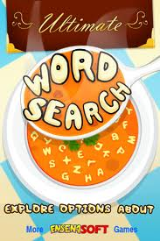 | WordSearchF | Ultimate Word Search has 63 English, Spanish, Portuguese, German and French word categories filled with fun word search puzzles. If you like Word Search puzzles, then this is the game for you! With great background music and 6 different themes including Newspaper, Christmas and Letter Soup to choose from, you can enjoy it the way you like. | Language - Conventions of Standard English | Curriculum Connection:  Authenticity:   Feedback:  Differentiation:  User Friendliness:  Student Motivation:
 | Words Free | Play the free version of Words With Friends -- the game more of your friends are playing than any other word game! | Language - Conventions of Standard English | Curriculum Connection:  Authenticity:  Feedback:  Differentiation:  User Friendliness:  Student Motivation:
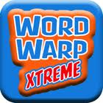 | Word Warp X | We come at you with BIGGER puzzles, a LARGER dictionary, and a TOUGHER game overall! More words for you to come up with! More puzzles to wrap your mind around! It's not just the most expansive word puzzle game in the App Store; it's Word Warp Xtreme!! | Language - Conventions of Standard English | Curriculum Connection:  Authenticity:  Feedback:  Differentiation:  User Friendliness:  Student Motivation:
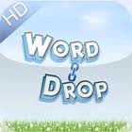 | Word Drop | Want to test your typing prowess and learn new words at the same time? Word Drop is THE game for you. Stick with the app and it will make you a master at speed typing emails, texts etc. With thousands of words in its arsenal you are going to have your hands full all the time. Improve your vocabulary: If you are into games like TextTwist, Jumble, Boggle or Scrabble, this game will give you an edge. The free version of Word Drop has non-intrusive Ads and is functionally an exact copy of the paid version. | Vocabulary Acquisition and Use | Curriculum Connection:  Authenticity:  Feedback:  Differentiation:  User Friendliness:  Student Motivation:
 | Wikipedia | This app is focused on being very simple and very fast. Over time, we'll add features based on requests. | Depending on how the app is used and the assignment given, it could be a tool for teaching all areas of Reading/Language Arts curriculum. | Curriculum Connection:  Authenticity:  Feedback:  Differentiation:  User Friendliness:  Student Motivation:
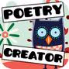 | Verses Poetry | Ever wonder what it would be like to mash-up a Shakespeare poem with a Hip Hop Song? Verses is a new iPhone and iPad app that puts a fresh spin on a cherished classic: refrigerator magnet poetry. We built this app to set your creativity ablaze with Verses's limitless word mixing possibilities that allow you to become a kind of dictionary DJ. | Reading Standards - Literature | Curriculum Connection:  Authenticity:  Feedback:  Differentiation:  User Friendliness:  Student Motivation:
 | Uhangman-F | Ultimate Hangman is a must have hangman game with 4 awesome themes (Doodle Hangman, Chillin' Chalk, Christmas Snowman and Flower Power), 11 great songs and 73 word categories including 7 random modes. | Language - Conventions of Standard English | Curriculum Connection:  Authenticity:  Feedback:  Differentiation:  User Friendliness:  Student Motivation:
 | Story Wheel | “Story Wheel” is an educational game that improves your child’s cognitive abilities. Players record a story by spinning the wheel to get a picture, and then narrate a portion of the story. When done, you can listen to your story with beautifully animated pictures. | Writing | Curriculum Connection:  Authenticity:  Feedback:  Differentiation:  User Friendliness:  Student Motivation:
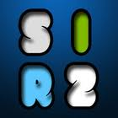 | Spell it Rite 2 | Can you easily identify misspelled words? Can you do it fast? Challenge yourself with 1500 of the most difficult to spell English words. Apart from being fun, Spel It Rite 2 will help you build a better vocabulary by providing word definitions, thesaurus and audible pronunciations. It will track all your mistakes and will re-test you during subsequent game play. And should you become bored of the provided words, you can always purchase some of the extensions from within the game. So let the spelling contest begin! | Language - Conventions of Standard English | Curriculum Connection:  Authenticity:  Feedback:  Differentiation:  User Friendliness:  Student Motivation:
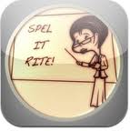 | Spell it Rite | This game has been designed to help you train your ability to recognize misspelled words. The user's objective is to identify typos as fast as possible. For each error, a penalty of 5 seconds is added to the total time. At the end of each round, the user is given the possibility of reviewing his or her results. This version contains over 700 of the most difficult to spell words. | Language - Conventions of Standard English | Curriculum Connection:  Authenticity:  Feedback:  Differentiation:  User Friendliness:  Student Motivation:
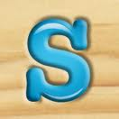 | ShakeSpell | Shake & Spell is a fun and addictive spelling game that will boggle your mind! Shake your iPhone or iPod Touch to scramble the board and begin spelling until the time runs out. Find as many words as you can to make the high score list. Play the daily challenge and compete against the community for the high score each day! Do you have what it takes to compete? | Language - Conventions of Standard English | Curriculum Connection:  Authenticity:  Feedback:  Differentiation:  User Friendliness:  Student Motivation:
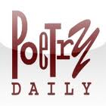 | Poetry Daily | Welcome to Poetry Daily for iPhone! Poetry Daily is an anthology of contemporary poetry. Each day, we bring you a new poem from new books, magazines, and journals, chosen from the work of a wide variety of poets to provide you with a window on the broad range of poetry offered annually by publishers large and small. | Reading Standards - Literature | Curriculum Connection:  Authenticity:  Feedback:  Differentiation:  User Friendliness:  Student Motivation:
 | iTranslate | Create your flashcards and carry them around in convenient digital format. Perfect for studying on the go! This application has powerful features made for the student who's serious about studying. |  | Curriculum Connection:  Authenticity:  Feedback:  Differentiation:  User Friendliness:  Student Motivation:
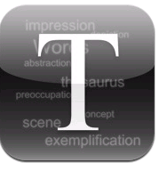 | iThesaurus | Retrieve the synonym for every word. If available you will get antonyms, related terms, similar word and user suggestions too. Tap one of the results to start a quick new search for that term. It keeps a history list of your search terms as well. |  | Curriculum Connection:  Authenticity:  Feedback:  Differentiation:  User Friendliness:  Student Motivation:
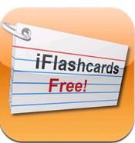 | iFlash FREE | Create your flashcards and carry them around in convenient digital format. Perfect for studying on the go! This application has powerful features made for the student who's serious about studying. | Depending on how the app is used and the assignment given, it could be a tool for teaching all areas of Reading/Language Arts curriculum. | Curriculum Connection:  Authenticity:  Feedback:  Differentiation:  User Friendliness:  Student Motivation:
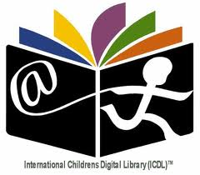 | ICDL | The International Children's Digital Library (ICDL) brings a worldwide collection of free children's books to the iPad. The largest collection of its kind, the ICDL spans the globe with thousands of children's books from over 60 countries, in a wide assortment of beautiful languages with captivating illustrations. Meet the six Mongolian brothers in search of knowledge, the gray Palestinian peacemaker cat that does something most unusual to the other cat's ears, or a version of the Three Little Pigs that you surely have never heard before. |  | Curriculum Connection:  Authenticity:  Feedback:  Differentiation:  User Friendliness:  Student Motivation:
 | Flashcards | Flashcards+ is the world's most popular flashcard app! Designed in association with Harvard University faculty and students, Flashcards+ is an optimized way to learn and retain new information. It allows you to easily create and study flashcards without the hassle of having to buy and write on actual note cards. | Depending on how the app is used and the assignment given, it could be a tool for teaching all areas of Reading/Language Arts curriculum. | Curriculum Connection:  Authenticity:  Feedback:  Differentiation:  User Friendliness:  Student Motivation:
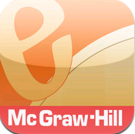 | eFlashcards | McGraw-Hill’s eFlashcard app gives you a quick and easy way to study your key vocabulary terms for a variety of titles. More titles are on the way so check back soon if you don't see yours! | Depending on how the app is used and the assignment given, it could be a tool for teaching all areas of Reading/Language Arts curriculum. | Curriculum Connection:  Authenticity:  Feedback:  Differentiation:  User Friendliness:  Student Motivation:
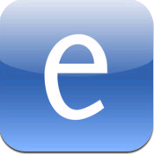 | Edmodo | Edmodo for iPod touch, iPhone, and iPad makes it easy for teachers and students to stay connected and share information. Use your iOS device to send notes, submit assignments, post replies, and check messages and upcoming events while away from the classroom.  Teachers can post last-minute alerts to their students, keep tabs on recent assignment submissions, and grade assignments. Students can view and turn in assignments and check their latest grades. | Depending on how the app is used and the assignment given, it could be a tool for teaching all areas of Reading/Language Arts curriculum. | Curriculum Connection:  Authenticity:  Feedback:  Differentiation:  User Friendliness:  Student Motivation:
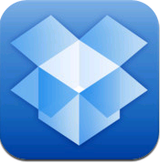 | Dropbox | Read your docs or flip through your albums when you're out and about. Save photos or videos to your Dropbox and share them with friends in just a couple taps. Even if you accidentally leave your iPhone in a taxi, your stuff is always safe on Dropbox.  Features:  ● Always have your stuff with you, no matter where you are.  ● Add files to "Favorites" for fast, offline viewing.  ● Easily save photos and videos to your Dropbox.  ● Share your photos and docs with family and friends.  ● Save email attachments straight to your Dropbox. | Depending on how the app is used and the assignment given, it could be a tool for teaching all areas of Reading/Language Arts curriculum. | Curriculum Connection:  Authenticity:  Feedback:  Differentiation:  User Friendliness:  Student Motivation:
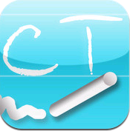 | Think O Meter | The ‘Think-O-Meter’ iPhone app challenges your thinking and helps you develop a Sherlock Holmes-like attention to the evidence at hand. Think through dozens of scenarios and test your ability to separate reliable facts from assumptions, focus on the relevant information, and think critically to get the right answer. |  | Curriculum Connection:  Authenticity:  Feedback:  Differentiation:  User Friendliness:  Student Motivation:
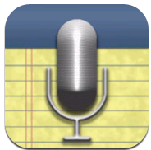 | AudioNotes | Record notes and audio synced with the best note taking app in the App Store! AudioNote combines the functionality of a notepad and voice recorder to create a powerful tool that will save you time while improving the quality of your notes. Perfect for business or students! |  | Curriculum Connection:  Authenticity:  Feedback:  Differentiation:  User Friendliness:  Student Motivation:
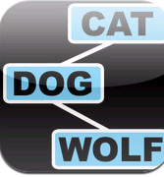 | Associate This | Associate This is a word association game, where the goal of the game is to guess which words, or phrases, are associated to the other words in the game. Every word is associated to at least two other words, and the associations are meant to be things that you come to think of upon hearing the word. |  | Curriculum Connection:  Authenticity:  Feedback:  Differentiation:  User Friendliness:  Student Motivation:
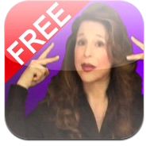 | ASL! | FREE features on how to fingerspell words, numbers, express basic sentences, idioms and learn about Deaf Culture - all for FREE! |  | Curriculum Connection:  Authenticity:  Feedback:  Differentiation:  User Friendliness:  Student Motivation:
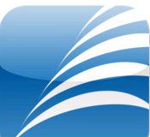 | AR | Accelerated Reader (AR) is the most popular and successful reading product of all time. |  | Curriculum Connection:  Authenticity:  Feedback:  Differentiation:  User Friendliness:  Student Motivation:
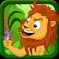 | Aesop’s Fables for Kids | Five fun Aesop's Fables for children are packed in this interactive audio storybook app. With interactive features, animations, cute characters and attractive pictures, this app is the perfect bedtime story book for your little kid. |  | Curriculum Connection:  Authenticity:  Feedback:  Differentiation:  User Friendliness:  Student Motivation:
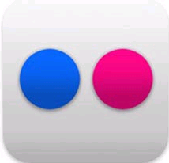 | Flickr | Share your photos. Watch the world. Flickr® for the iPhone enables photo-sharing on the go - from your phone, to the world. |  | Curriculum Connection:  Authenticity:  Feedback:  Differentiation:  User Friendliness:  Student Motivation:
 | Mad Libs | Mad Libs is now available in a fun, new interactive AND digital platform! In this sample version of Vacation Mad Libs you can test your fill-in the-blank skills for FREE on your iPhone or iPod touch. Then, get all the silly stories and crazy word game play in the complete version with the Goofy Mad Libs iPhone App. | Language - Conventions of Standard English | Curriculum Connection:  Authenticity:  Feedback:  Differentiation:  User Friendliness:  Student Motivation:
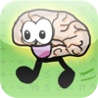 | Brain Tuner Lite | Get your brain in shape with Brain Tuner, a great math game for all ages. It takes less than a minute a day to tune your brain! Like a Brain Age exercise. Players have called Brain Tuner "very addictive" and "lots of fun!" It's a great way to keep on top of your math, and many users have already seen improvements in their speed.
 | Brain Toot | Exercise helps keep the body healthy and fit, and your brain works in a similar manner. As you get older, you lose muscle mass, and your brain function begins to decrease as well. "Brain Toot" is a brain game that will give you a simple and fun way to help challenge and stimulate your brain.
 | Brain Challenge 2 | Brain Challenge 2: Think Again! is the latest entry in the most comprehensive brain training franchise on iPhone and iPod touch, providing a total brain workout. Train your brain in the classic brain exercise categories: Memory, Visual, Logic and Math as well as innovative categories exclusive to Gameloft’s Brain Challenge franchise: Stress Training, Focus and never seen before on iPhone, Visual training.
 | Hangman | Play Hangman on your iPod. Touch the letters to find the word. | Language - Conventions of Standard English | Curriculum Connection:  Authenticity:  Feedback:  Differentiation:  User Friendliness:  Student Motivation:
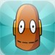 | BrainPop | A New Movie EVERY Day! Learn something different each day with the free BrainPOP Featured Movie App for the iPad, iPhone, and iPod touch! Watch BrainPOP’s daily animated movie, then test your new knowledge with an interactive quiz. BrainPOP’s award-winning educational resources are used by millions of students in thousands of schools across the U.S. and worldwide. Our topics cover Science, Math, Social Studies, English, Technology, Engineering, Arts & Music, and Health - everything from Carnivorous Plants to Abraham Lincoln! All movies are captioned, making it easy to read along. The more you know, the more you know!® | Depending on how the app is used and the assignment given, it could be a tool for teaching all areas of Reading/Language Arts curriculum. | Curriculum Connection:  Authenticity:  Feedback:  Differentiation:  User Friendliness:  Student Motivation:
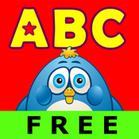 | ABC Phonics Animals Free Lite | Developed by a group of parents - the app mimics and automates how they would go over each flash cards with their own children, focusing in on the alphabet phonetics, spelling, reading, and sounds. The word spellings, letters, sounds, and images in this game reinforces associative learning which may aid in early brain development in young kids and may help your child get a head start in reading. | Phonics and Word Recognition | Curriculum Connection:  Authenticity:  Feedback:  Differentiation:  User Friendliness:  Student Motivation:
 | Dictionary | Easy to use, no fluff dictionary app for your iPod. Helps you find your words when you need to without getting in your way. |  | Curriculum Connection:  Authenticity:  Feedback:  Differentiation:  User Friendliness:  Student Motivation:
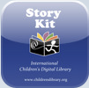 | Story Kit | Create an electronic storybook. Make use of the little gaps in life - on the sofa after dinner, in the back seat of the car, or on a train - to do something creative together.  To create your story:  * Write some text.  * Illustrate by drawing on the screen, taking a photograph of something you see, or drawing on paper and then photographing the paper, or attaching photos from your album.  * Sounds can be recorded for telling your story or as sound effects.  * Layout the elements of your story (text boxes, images, and sound clips) freely by dragging them or pinching to resize.  * Add, reorder, or delete pages from your book. |  | Curriculum Connection:  Authenticity:  Feedback:  Differentiation:  User Friendliness:  Student Motivation:
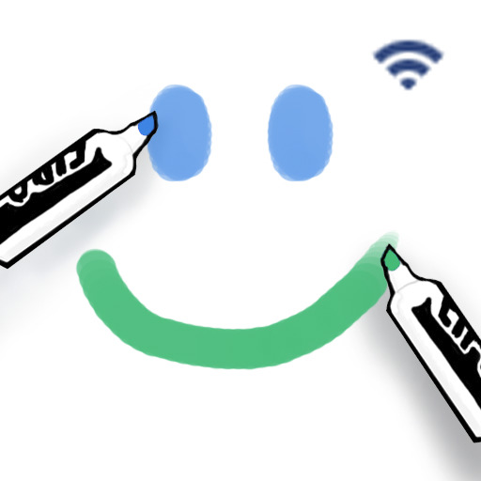 | Whiteboard | Collaborate with friends and family with Whiteboard, the easy-to-use collaborative drawing app for iPhone and iPod touch. Two users can create pictures together over local Wi-Fi or Bluetooth peer-to-peer.  Connect without an access point.  • If both devices are an iPod touch 2nd gen, iPhone 3G, or iPhone 3GS running iOS 3.0 or higher, you can connect using Bluetooth.  1. Turn off Wi-Fi to prevent conflicts. Go to Settings -> Wi-Fi -> OFF.  2. Go back one screen to Settings -> General -> Bluetooth -> ON.  3. Press the Home button and launch Whiteboard.  • You can safely ignore the alert that says "Not Connected to a Wi-Fi Network" -- just tap OK!  4. Wait until BOTH devices see each other in their own list.  5. On ONE of the devices, tap the name of the other device.  6. Wait up to 60 seconds for the connection to establish. The first resolve takes the longest; if you disconnect and reconnect after this, it should be much faster. This is a hardware/OS limitation.  • That's it! Enjoy drawing together over Bluetooth peer-to-peer. | Depending on how the app is used and the assignment given, it could be a tool for teaching all areas of Reading/Language Arts curriculum.
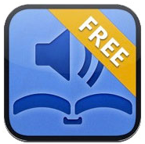 | AudioBooks Lite | Join the more than 1,400,000 people who have used Audiobooks to listen to over 3,535 classic audiobooks for FREE. In addition to all our free content, we also now include a growing collection of premium audiobooks for your enjoyment. Audiobooks is a fantastic way to access all your favorite audiobooks on your iPhone or iPod Touch. This application gives you access to over 20,000 hours worth of great audiobook content. |  | Curriculum Connection:  Authenticity:  Feedback:  Differentiation:  User Friendliness:  Student Motivation:
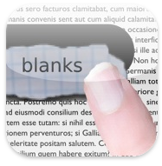 | Blanks | 'Blanks' is a simple application helping you to learn new  English words. It shows you word definition and gives 4 choices as answer.  Select one of the choices by dragging it on the hole in the paper.  If you are correct, a green hock is displayed.  If the selected word does not fit to the definition, you will see a red cross. | Language - Conventions of Standard English | Curriculum Connection:  Authenticity:  Feedback:  Differentiation:  User Friendliness:  Student Motivation:
 | Dictionary.com | The free Dictionary.com app delivers trusted reference content from Dictionary.com and Thesaurus.com. NO INTERNET CONNECTION IS NEEDED TO SEARCH WORDS. The app includes nearly 2,000,000 words, definitions, synonyms and antonyms. It also features audio pronunciation, voice-to-text search and Dictionary.com’s popular Word of the Day and Hot Word blog.
 | Grammar Up | Grammar Up can help learners to improve their grammar, word selection and vocabulary.  Custom timer setting can assist learners to improve response times under exam time constraints.  Research suggests that kids and adults learn most quickly when playing learning games with real-time error-feedback.  Grammar Up provides learners with an opportunity to improve strategies for grammar success. | Language - Conventions of Standard English | Curriculum Connection:  Authenticity:  Feedback:  Differentiation:  User Friendliness:  Student Motivation:
 | Poem Flow | Turn a poem in your hand and the poem flows in a gentle reading animation. The effect is magical, mesmeric, and revealing. You see the poem differently as it quietly reads itself to you. You get 20 great poems to keep and share, and additional poems cost less than a penny a poem. | Reading Standards - Literature | Curriculum Connection:  Authenticity:  Feedback:  Differentiation:  User Friendliness:  Student Motivation:
 | Vocab Lab Lite | Want to ace standardized verbal exams?  Want to study on the car, bus, or in class?  Want to make the best use of every minute you have?  Then Vocab Lab is for you! | Vocabulary Acquisition and Use | Curriculum Connection:  Authenticity:  Feedback:  Differentiation:  User Friendliness:  Student Motivation:
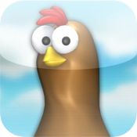 | Chicktionary | Chicktionary is one of the most popular word games on the Internet and now you can hatch up some fun on your iPhone! Each hen bears a letter. The more words you create, the more points you earn! | Language - Conventions of Standard English | Curriculum Connection: 3  Authenticity: 4  Feedback: 4  Differentiation: 4  User Friendliness: 4  Student Motivation: 3
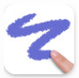 | DoodleBuddy | Doodle Buddy is the most fun you can have with your finger! Finger paint with your favorite colors and drop in playful stamps. Connect with a friend to draw together over the Internet. | Depending on how the app is used and the assignment given, it could be a tool for teaching all areas of Reading/Language Arts curriculum.
 | iTalkRecorder | iTalk Recorder Lite 4.0 is handheld recording the way it should be: simple, robust and searchable. Use iTalk Recorder Lite for lectures, meetings, nature walks, or anywhere you want to be sure you're getting high-quality digital recordings. | Depending on how the app is used and the assignment given, it could be a tool for teaching all areas of Reading/Language Arts curriculum.
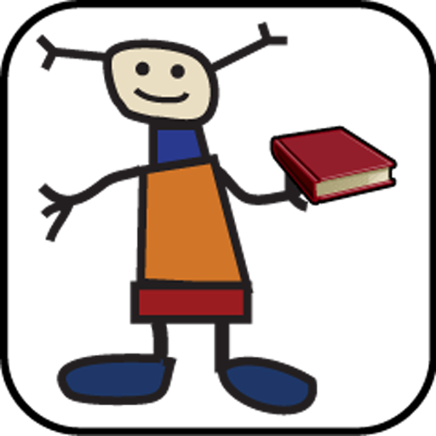 | Kids Book Review | Kids Book Review is the first iPhone app for Children's, Tweens, and YA books. The Sacramento and San Francisco Book Reviews have reviewed almost 800 kids books since September 2008, and they are all available here on this app, along with new book release information, classic titles, and more. |  | Curriculum Connection:  Authenticity:  Feedback:  Differentiation:  User Friendliness:  Student Motivation:
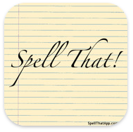 | Spell That! | This app will help your child learn to spell using innovative educational methods and the technology now available on your mobile device. | Language - Conventions of Standard English | Curriculum Connection:  Authenticity:  Feedback:  Differentiation:  User Friendliness:  Student Motivation:
 | Evernote | Creates text, audio, and photo notes.
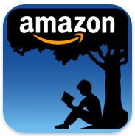 | Kindle | The Kindle app is optimized for the iPad, iPhone, and iPod touch, giving users the ability to read Kindle books on a beautiful, easy-to-use interface. You’ll have access to over 810,000* books in the Kindle Store, including best sellers and new releases. | Range of Reading and Level of Text Complexity
 | nook | Download our FREE Barnes & Noble NOOK for iPhone app and put more than two million titles at your fingertips. FREE samples of every eBook are just a touch away. We’ve designed our NOOK for iPhone to give you the fastest, most comfortable and customizable reading experience there is. | Range of Reading and Level of Text Complexity
 | SimpleMind Xpress | Mind Mapping- Turns your iPod into brainstorming, idea collection, and though structuring device. | Writing | Curriculum Connection:  Authenticity:  Feedback:  Differentiation:  User Friendliness:  Student Motivation:
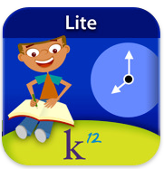 | K12 Timed Reading Practice | Lets readers in grades K-4 practice fluency, the ability to read smoothly and quickly. | Fluency | Curriculum Connection:  Authenticity:  Feedback:  Differentiation:  User Friendliness:  Student Motivation:
 | USA Today | Get the latest news on your iPod. | Informational Texts | Curriculum Connection:  Authenticity:  Feedback:  Differentiation:  User Friendliness:  Student Motivation:
 | Wikipanion | Search Wikipedia. | Depending on how the app is used and the assignment given, it could be a tool for teaching all areas of Reading/Language Arts curriculum. | Curriculum Connection:  Authenticity:  Feedback:  Differentiation:  User Friendliness:  Student Motivation:

