App Icon | App Name | iDescription & Rating | Curriculum Connection | STLP Rating
 | Edmodo | Edmodo for iPod touch, iPhone, and iPad makes it easy for teachers and students to stay connected and share information. Use your iOS device to send notes, submit assignments, post replies, and check messages and upcoming events while away from the classroom. Teachers can post last-minute alerts to their students, keep tabs on recent assignment submissions, and grade assignments. Students can view and turn in assignments and check their latest grades. | Depending on how the app is used and the assignment given, it could be a tool for teaching all areas of Science curriculum. | Curriculum Connection:   Authenticity:  Feedback:  Differentiation:  User Friendliness:  Student Motivation:
 | Wikipedia | Wikipedia is now officially on the iPhone! This is our official application and we are working hard on making the absolute best Wikipedia app out there. This app is focused on being very simple and very fast. | Depending on how the app is used and the assignment given, it could be a tool for teaching all areas of Science curriculum.
 | Weather Bug | Receive live weather conditions, forecast, radar, weather cameras and daily video | The Earth and the Universe: Earth/Space Science-  Weather | Curriculum Connection:  Authenticity:  Feedback:  Differentiation:  User Friendliness:  Student Motivation:
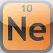 | The Chemical Touch Lite | The Chemical Touch: Lite Edition is a free and easy to use periodic table for your iPhone or iPod touch. Consisting of a simplified version of the periodic table display from the full application, it puts the masses, densities, melting & boiling points, radii, and electronegativities of the elements right at your fingertips. | Structure and Transformations of Matter – Physical Science | Curriculum Connection:  Authenticity:  Feedback:  Differentiation:  User Friendliness:  Student Motivation:
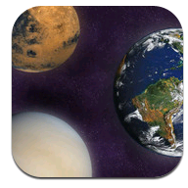 | PlanetFacts | Did you know that Mars has moons? Did you know that there’s lakes of methane on Titan?  “planetFacts Plus” has a beautiful interactive user interface that makes learning about the Solar System fun!  planetFacts Plus” includes tons of facts for the Sun, Mercury, Venus, Earth, Mars, the Asteroid Belt, Ceres, Jupiter, Saturn, Uranus, Neptune, Pluto, Haumea, Make make, Eris, the Kuiper Belt, the Scattered Disc and 41 moons from our Solar System. | The Earth and the Universe: Earth/Space Science-  Movement of Objects in the Sky  Scale within the Solar System  Motion of Objects in the Solar System | Curriculum Connection:  Authenticity:  Feedback:  Differentiation:  User Friendliness:  Student Motivation:
 | Planet Free | 3D guide to the solar system for aspiring astronomers• Sky 2D: locate planets with flat view of sky  • Sky 3D: planetarium style view of the sky• Visibility: find out when planet will be visible• Globe: rotating 3D globe of planets and moon | The Earth and the Universe: Earth/Space Science-  Movement of Objects in the Sky  Scale within the Solar System  Motion of Objects in the Solar System | Curriculum Connection:  Authenticity:  Feedback:  Differentiation:  User Friendliness:  Student Motivation:
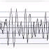 | iSeismo | Start iSeismometer, leave it on your desk, then try tap somewhere. You will realize how sensitive iPhone is!  This is our new project to convert iPhone to seismometer. We created for fun and educational use, such as data collecting device. | The Earth and Universe: Earth/Space Science-  Surface Changes | Curriculum Connection:  Authenticity:  Feedback:  Differentiation:  User Friendliness:  Student Motivation:
 | iEphemeris Lite | iEpemeris displays moon phases, the visible surface of the moon, the distance between earth and moon, the Julian Date, the Sidereal Time, the Right Ascension and the Declination of the Moon | The Earth and the Universe: Earth/Space Science-  Movement of Objects in the Sky  Scale within the Solar System  Motion of Objects in the Solar System
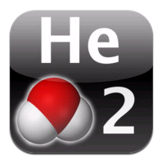 | iElements | The periodic table of the chemical elements is a tabular display of the chemical elements. Although precursors to this table exist, its invention is generally credited to Russian chemist Dmitri Mendeleev in 1869, who intended the table to illustrate recurring ("periodic") trends in the properties of the elements. | Structure and Transformations of Matter – Physical Science | Curriculum Connection:  Authenticity:  Feedback:  Differentiation:  User Friendliness:  Student Motivation:
 | iCell | iCell gives students, teachers, and anyone interested in biology a 3D view inside a cell. Included are examples of three types of cells: animal, plant, and bacteria. Learn about the various parts of the cell, which biologists, biochemists, and DNA researchers at the HudsonAlpha Institute study and use to advance the limits of biotechnology | Unity and Diversity: Biological Science –  Structure and Function of Living Systems  Functions of Cells  Multicellular Organisms  Relationship between Cells, Tissues, and Organs | Curriculum Connection:  Authenticity:  Feedback:  Differentiation:  User Friendliness:  Student Motivation:
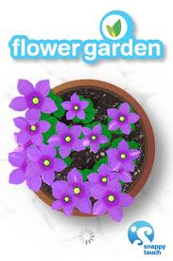 | Flower Garden Free | Enjoy the serenity of nature wherever you are, and never be late sending flowers again! Whether you have green thumbs or just enjoy the tranquil sights and sounds of the garden, Flower Garden gives you a soothing, creative experience to be enjoyed over time and shared with your friends and loved ones. | Unity and Diversity: Biological Science-  Functions of Plants | Curriculum Connection:  Authenticity:  Feedback:  Differentiation:  User Friendliness:  Student Motivation:
 | Flashcards | Flashcards+ is the world's most popular flashcard app! Designed in association with Harvard University faculty and students, Flashcards+ is an optimized way to learn and retain new information. It allows you to easily create and study flashcards without the hassle of having to buy and write on actual note cards. | Depending on how the app is used and the assignment given, it could be a tool for teaching all areas of Science curriculum.
 | Dropbox | Dropbox is a free service that lets you bring all your photos, docs, and videos anywhere. After you install Dropbox on your computer, any file you save to your Dropbox will automatically save to all your computers, your iPhone and iPad and even the Dropbox website! With the Dropbox app, you can take everything that matters to you on the go. | Depending on how the app is used and the assignment given, it could be a tool for teaching all areas of Science curriculum.
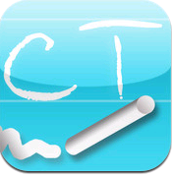 | Critical Thinking | Did you know critical thinking is the skill of most increasing importance in the workplace over the next 5 years – surpassing innovation or the application of information technology?. | Structure and Transformation of Matter  Motion and Forces  The Earth and the Universe  Unity and Diversity  Biological Change  Energy Transformations  Interdependence
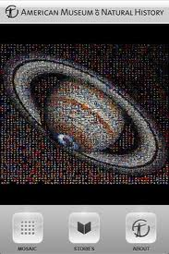 | Cosmic | Take a ride with the Museum’s astrophysicists through our Solar System, the Milky Way Galaxy, and beyond. Cosmic Discoveries is the first app to collect over 1000 stunning astronomic images and was launched as part of a year-long series of events to help commemorate the tenth anniversary of the opening of the Museum’s Rose Center for Earth and Space, a New York City icon and one of the world’s most revered science and educational institutions | The Earth and the Universe: Earth/Space Science-  Movement of Objects in the Sky  Scale within the Solar System  Motion of Objects in the Solar System | Curriculum Connection:  Authenticity:  Feedback:  Differentiation:  User Friendliness:  Student Motivation:
 | Stars | No description | The Earth and the Universe: Earth/Space Science-  Movement of Objects in the Sky  Scale within the Solar System  Motion of Objects in the Solar System | Curriculum Connection:  Authenticity:  Feedback:  Differentiation:  User Friendliness:  Student Motivation:
 | 101 Science | In the popular book, 101 Things Everyone Should Know About Science, kids, ages 8-12, are challenged with questions about Biology, Chemistry, Physics, Earth Science and General Science. Now, you can take all the fun of science from the book anywhere! With this quiz application, you can test your science knowledge on the go! | Structure and Transformation of Matter  Motion and Forces  The Earth and the Universe  Unity and Diversity  Biological Change  Energy Transformations  Interdependence | Curriculum Connection:  Authenticity:  Feedback:  Differentiation:  User Friendliness:  Student Motivation:
 | Virtual Tour | The Library of Congress is the world's largest library and the largest body of knowledge under a single roof. Whether you're onsite, at home, in a classroom or elsewhere, this app will give you a virtual tour that mirrors the Library of Congress Experience, an award-winning group of exhibitions and features that has drawn record numbers of visitors | Depending on how the app is used and the assignment given, it could be a tool for teaching all areas of Science curriculum. | Curriculum Connection:  Authenticity:  Feedback:  Differentiation:  User Friendliness:  Student Motivation:
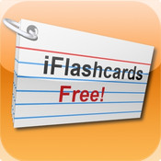 | iFlash FREE | Create your flashcards and carry them around in convenient digital format. Perfect for studying on the go! This application has powerful features made for the student who's serious about studying. | Depending on how the app is used and the assignment given, it could be a tool for teaching all areas of Science curriculum.
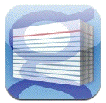 | gFlash+ | Our new improved version of gFlashPro is here, and we think it's the best flashcard app around! Learn anything from chemistry to ancient history, study for a professional certification, or take a minute to relax and enjoy some trivia, anywhere and anytime. | Depending on how the app is used and the assignment given, it could be a tool for teaching all areas of Science curriculum.
 | Geared | ★ #1 Paid Game in 20 countries! ★  ★ Play the game 12 Million people love! ★ | Motion and Forces: Physical Science-  Motion  Position  Forces  Motion and Friction | Curriculum Connection:  Authenticity:  Feedback:  Differentiation:  User Friendliness:  Student Motivation:
 | Flicker Search | Search engine | Depending on how the app is used and the assignment given, it could be a tool for teaching all areas of Science curriculum.
 | eFlashcards |  | Depending on how the app is used and the assignment given, it could be a tool for teaching all areas of Science curriculum.
 | Dinosaurs | DINOSAURS: American Museum of Natural History Collections contains a mosaic of more than 1000 images from the Museum's archive, woven together to create a striking image of the world’s most famous dinosaur, the Tyrannosaurus rex. | Biological Change –  Fossils | Curriculum Connection:  Authenticity:  Feedback:  Differentiation:  User Friendliness:  Student Motivation:
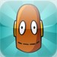 | BrainPop | For even more access to BrainPOP’s award-winning content, choose an optional in-app subscription and enable kids to explore more than 750 Science, Math, Social Studies, English, Engineering & Tech, Arts & Music, and Health subjects right on their mobile devices. All movies are close captioned, so it’s easy for them to read along. | Videos available for nearly all standards! | Curriculum Connection:  Authenticity:  Feedback:  Differentiation:  User Friendliness:  Student Motivation:
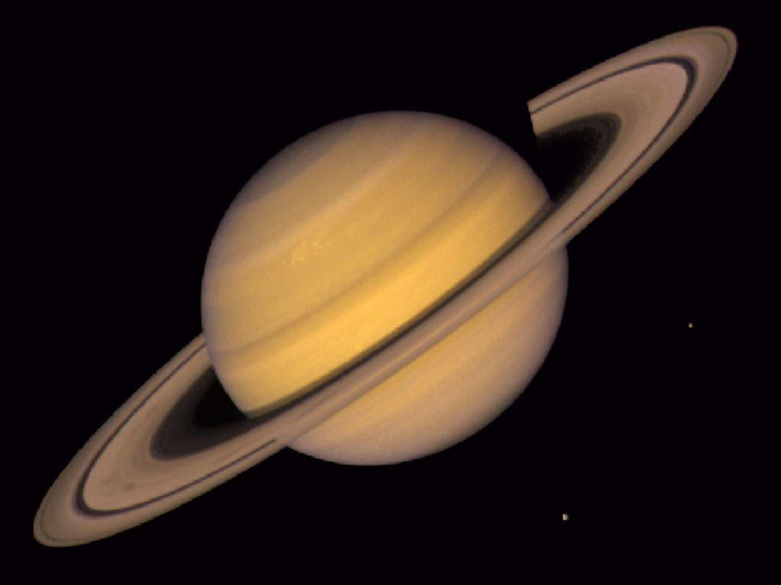 | Planets | A 3D guide to the solar system for aspiring astronomers. | The Earth and the Universe: Earth/Space Science-  Movement of Objects in the Sky  Scale within the Solar System  Motion of Objects in the Solar System | Curriculum Connection:  Authenticity:  Feedback:  Differentiation:  User Friendliness:  Student Motivation:
 | Discovery News | No description | Depending on how the app is used and the assignment given, it could be a tool for teaching all areas of Science curriculum.
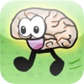 | Brain Tuner Lite | Get your brain in shape with Brain Tuner, a great math game for all ages. It takes less than a minute a day to tune your brain! Like a Brain Age exercise. Players have called Brain Tuner "very addictive" and "lots of fun!" It's a great way to keep on top of your math, and many users have already seen improvements in their speed. | Structure and Transformation of Matter  Motion and Forces  The Earth and the Universe  Unity and Diversity  Biological Change  Energy Transformations  Interdependence | Curriculum Connection:  Authenticity:  Feedback:  Differentiation:  User Friendliness:  Student Motivation:
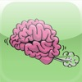 | Brain Toot | Exercise helps keep the body healthy and fit, and your brain works in a similar manner. As you get older, you lose muscle mass, and your brain function begins to decrease as well. "Brain Toot" is a brain game that will give you a simple and fun way to help challenge and stimulate your brain. | Structure and Transformation of Matter  Motion and Forces  The Earth and the Universe  Unity and Diversity  Biological Change  Energy Transformations  Interdependence | Curriculum Connection:  Authenticity:  Feedback:  Differentiation:  User Friendliness:  Student Motivation:
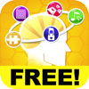 | Brain Challenge 2 | Brain Challenge 2: Think Again! is the latest entry in the most comprehensive brain training franchise on iPhone and iPod touch, providing a total brain workout. Train your brain in the classic brain exercise categories: Memory, Visual, Logic and Math as well as innovative categories exclusive to Gameloft’s Brain Challenge franchise: Stress Training, Focus and never seen before on iPhone, Visual training. | Structure and Transformation of Matter  Motion and Forces  The Earth and the Universe  Unity and Diversity  Biological Change  Energy Transformations  Interdependence | Curriculum Connection:  Authenticity:  Feedback:  Differentiation:  User Friendliness:  Student Motivation:
 | Dictionary | Easy to use, no fluff dictionary app for your iPod. Helps you find your words when you need to without getting in your way. | Structure and Transformation of Matter  Motion and Forces  The Earth and the Universe  Unity and Diversity  Biological Change  Energy Transformations  Interdependence
 | Dictionary.com | The free Dictionary.com app delivers trusted reference content from Dictionary.com and Thesaurus.com. NO INTERNET CONNECTION IS NEEDED TO SEARCH WORDS. The app includes nearly 2,000,000 words, definitions, synonyms and antonyms. It also features audio pronunciation, voice-to-text search | Depending on how the app is used and the assignment given, it could be a tool for teaching all areas of Science curriculum.
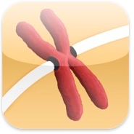 | Mitosis | Mitosis walks you through the process of cell division, and explains everything that happens along the way. | Unity and Diversity: Biological Science –  Structure and Function of Living Systems  Functions of Cells  Multicultural Organisms  Relationship between Cells, Tissues, and Organs | Curriculum Connection:  Authenticity:  Feedback:  Differentiation:  User Friendliness:  Student Motivation:
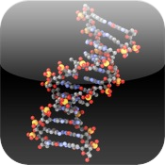 | Molecules | Molecules are an application for viewing three-dimensional renderings of molecules and manipulating them using your fingers. | Structure and Transformations of Matter – Physical Science | Curriculum Connection:  Authenticity:  Feedback:  Differentiation:  User Friendliness:  Student Motivation:
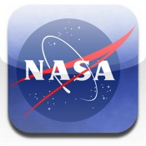 | NASA Lunar | Welcome to the NASA Lunar Electric Rover (LER) Simulator. You don’t need a driver’s license, but you still need to buckle up as the LER Simulator gives you a glimpse of what it might be like to support the activities of a functioning Lunar Outpost. | The Earth and the Universe: Earth/Space Science-  Movement of Objects in the Sky  Scale within the Solar System  Motion of Objects in the Solar System | Curriculum Connection:  Authenticity:  Feedback:  Differentiation:  User Friendliness:  Student Motivation:
 | The Weather Channel | Full screen maps, extended forecasts, severe weather alerts, and more! | Structure and Transformations of Matter – Physical Science
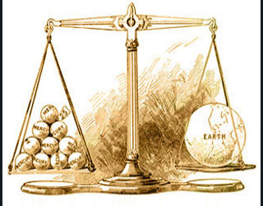 | Weight On… | Your Weight on Planets is a weight measuring utility, which gets the weight from the user and computes the weight in other planets in the solar system. | Structure and Transformation of Matter : Physical Science  Physical Properties  The Earth and the Universe: Earth/Space Science | Curriculum Connection:  Authenticity:  Feedback:  Differentiation:  User Friendliness:  Student Motivation:
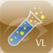 | Science Glossary | A glossary of scientific terms and short biographies that support our science education website, | Depending on how the app is used and the assignment given, it could be a tool for teaching all areas of Science curriculum. | Curriculum Connection:  Authenticity:  Feedback:  Differentiation:  User Friendliness:  Student Motivation:
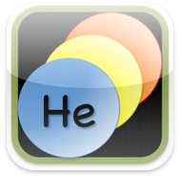 | Periodic Table of Elements | With this application, one can look up information on 117 different elements. | Structure and Transformations of Matter – Physical Science | Curriculum Connection:  Authenticity:  Feedback:  Differentiation:  User Friendliness:  Student Motivation:
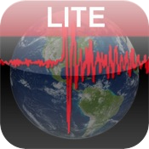 | Earthquake | Track and follow earthquakes around the world in real time! | The Earth and Universe: Earth/Space Science-  Surface Changes | Curriculum Connection:  Authenticity:  Feedback:  Differentiation:  User Friendliness:  Student Motivation:
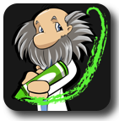 | Touch Physics | Draw shapes with a crayon that come to life moving according to physical laws. | Structure and Transformation of Matter : Physical Science  Physical Properties | Curriculum Connection:  Authenticity:  Feedback:  Differentiation:  User Friendliness:  Student Motivation:
 | Wikipanion | Search Wikipedia. | Depending on how the app is used and the assignment given, it could be a tool for teaching all areas of Science curriculum

