Welding Technology
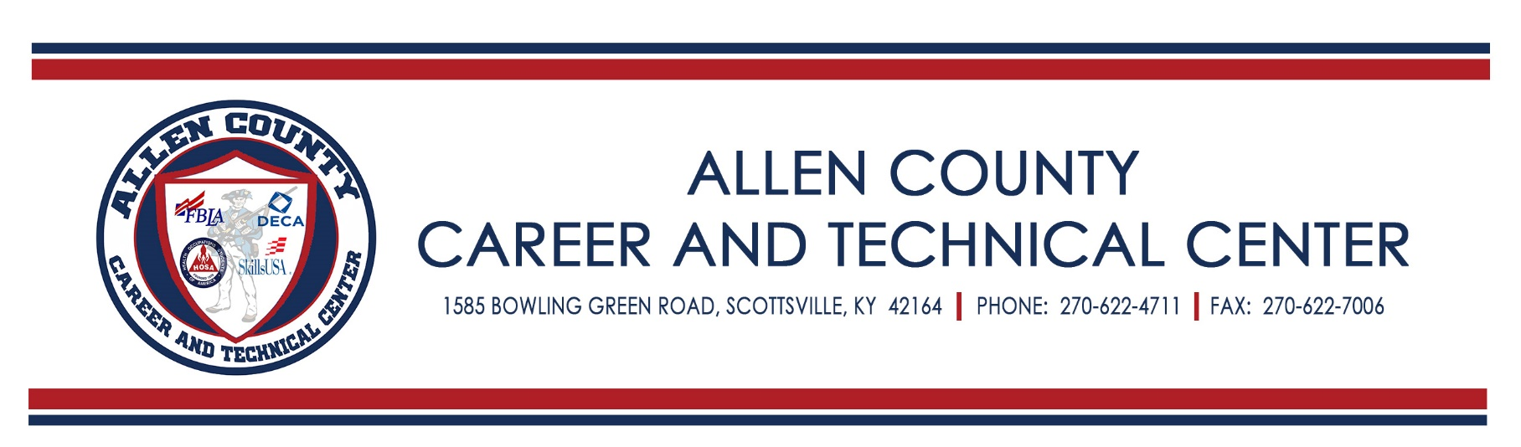
Community Education Registration

Name ________________________________________________________________________

Address ______________________________________________________________________

City, State, Zip ________________________________________________________________

Phone Number ________________________________________________________________

Email Address ________________________________________________________________

Payment Included (Checks payable to ACCTC) YES NO

Would you be willing to be enrolled into the other course if yours fails to have enough students? YES NO

Introduction to Shielded Metal Arc Welding (Stick Welding) $200.00

This course is designed to teach students the identifications, inspections, and maintenance of Shielded Metal Arc Welding electrodes: principles of Shielded Metal Arc Welding and the effects of variables on the Shielded Metal Arc Welding process to weld plate. The lab course teaches the practical application and manipulative skills of Shielded Metal Arc Welding and the proper safety situations needed in this process to perform fillet welds in all positions.

Introduction to Gas Metal Arc Welding (MIG Welding) $200.00

This course is designed to teach students the identification, inspections, and maintenance of Gas Metal Arc Welding machines; identification, selection, and storage of Gas Metal Arc Welding electrodes; principles of the Gas Metal Arc Welding process; and the effects of variables on the Gas Metal Arc Welding process. Theory and applications of related processes such as FCAW, SAW and metallurgy are also included. The lab course teaches the practical application and manipulative skills of Gas Metal Arc Welding and the proper safety situations needed in this process. Ferrous metals will be covered, as well as various joint designs on plate in all positions.

Course Details:

- Each class is limited to 15 students, with a class minimum of 10.
- This class is offered at the following location:
Allen County Career and Technical Center Room 126
1585 Bowling Green Road
Scottsville, KY 42164
270-622-4711

- Class Schedule:

November 6th – December 11th
Tuesday & Thursday
5:00 p.m. – 8:00 p.m.

- Instructor:

Matt Keith
AWS Certified CWI/CWE
Allen County Career & Technical Center
1585 Bowling Green Road
Scottsville, KY 42164
270-622-4711
matt.keith@allen.kyschools.us

- Registration forms are available to be picked up at:

Monday – Friday 7:30 a.m. – 3:00 p.m.
Allen County Career & Technical Center
1585 Bowling Green Road
Scottsville, KY 42164
270-622-4711

- Cost: $200.00
Payment is due upon registration. Checks should be made payable to the ACCTC.
Cost of class includes:
Class Tuition
Use of classroom & lab
Materials (Steel, electrodes, shielding gas, ect…)

