Framework for teaching

Charlotte Danielson
(adapted for Kentucky Department of Education)

6.14.2012

The Framework for Teaching is a research-based set of components of instruction, aligned to the INTASC standards, and grounded in a constructivist view of learning and teaching. The complex activity of teaching is divided into multiple standards clustered into five domains of teaching responsibility:
- Planning and Preparation
- Classroom Environment
- Instruction
- Professional Responsibilities
- Student Growth (For Consideration)
It is important to realize that this Framework takes into account the Kentucky Teacher Standards, the Kentucky Board of Education’s Program of Studies, Common Core Academic Standards, and the Kentucky Department of Education’s Characteristics of Highly Effective Teaching and Learning.

DRAFT: Domain 5

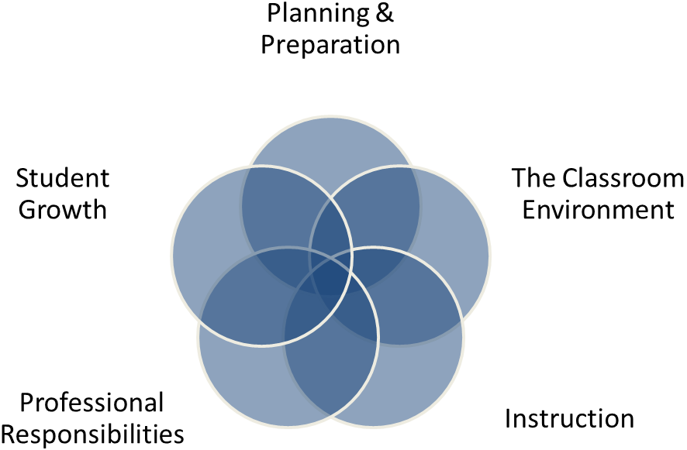
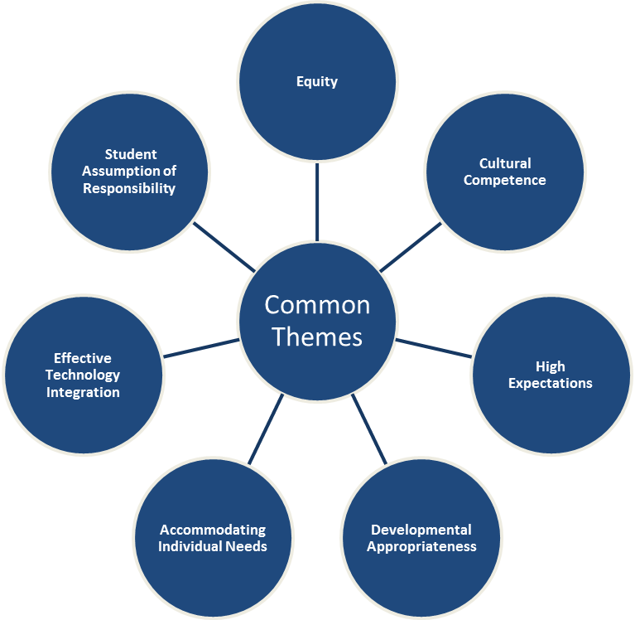
FRAMEWORK FOR TEACHING DOMAINS & COMMON THEMES:
INTRODUCTION:
The Framework for Teaching organizes the multiple measures that comprise Kentucky's proposed Teacher Professional Growth and Effectiveness System. This framework is designed to support student achievement and professional best-practice through the domains of Planning and Preparation, Classroom Environment, Instruction, Professional Responsibilities, and Student Growth. The Framework also includes many themes that run throughout the document. These themes include ideas such as equity, cultural competence, high expectations, developmental appropriateness, accommodating individual needs, effective technology integration, and student assumption of responsibility. The Kentucky Teaching Standards, Kentucky Department of Education's Characteristics of Highly Effecting Teaching and Learning, along with research from many of the top educator appraisal specialists and researchers are the foundation for this system. The Framework for Teaching provides structure and feedback for continuous improvement through individual goals that target student and professional growth, thus supporting overall school improvement. Teacher performance will be rated for each component according to four performance levels: Ineffective, Developing, Accomplished, and Exemplary. It is important to know that the expected performance level is “Accomplished” which is bolded in the framework, but a good rule of thumb is that it is expected for a teacher to “live in Accomplished but occasionally visit Exemplary”. Exemplary is purposefully designed to be difficult to achieve. The summative rating will be a holistic representation of performance, combining data from multiple measures across each domain.

1A - Knowledge of Content and Pedagogy  - Knowledge of Content and the Structure of the Discipline  - Knowledge of Prerequisite Relationships  - Knowledge of Content-Related Pedagogy | In order to guide student learning, accomplished teachers have command of the subjects they teach. They must know how the discipline has evolved into the 21st century, incorporating such issues as global awareness and cultural diversity, as appropriate. Accomplished teachers understand the internal relationships within the disciplines they teach, knowing which concepts and skills are prerequisite to the understanding of others. They are also aware of typical student misconceptions in the discipline and work to dispel them. But knowledge of the content is not sufficient; in advancing student understanding, teachers are familiar with the particularly pedagogical approaches best suited to each discipline.  Component  Domain  Domain 1: Planning & Preparation
 | Ineffective |  | Developing |  | Accomplished |  | Exemplary
 | - In planning and practice, teacher makes content errors or does not correct errors made by students.  Element(s)  - Teacher’s plans and practice display little understanding of prerequisite relationships important to student’s learning of the content.  - Teacher displays little or no understanding of the range of pedagogical approaches suitable to student’s learning of the content.  COMMON LANGUAGE |  | - Teacher is familiar with the important concepts in the discipline but displays lack of awareness of how these concepts relate to one another.  - Teacher’s plans and practice indicate some awareness of prerequisite relationships, although such knowledge may be inaccurate or incomplete.  - Teacher’s plans and practice reflect a limited range of pedagogical approaches to the discipline or to the students. |  | - Teacher displays solid knowledge of the important concepts in the discipline and the ways they relate to one another.  - Teacher’s plans and practice reflect accurate understanding of prerequisite relationships among topics and concepts.  - Teacher’s plans and practice reflect familiarity with a wide range of effective pedagogical approaches to the discipline. |  | - Teacher displays extensive knowledge of the important concepts in the discipline and the ways they relate both to one another and to other disciplines.  - Teacher’s plans and practice reflect understanding of prerequisite relationships among topics and concepts and provide a link to necessary cognitive structures needed by students to ensure understanding.  - Teacher’s plans and practice reflect familiarity with a wide range of effective pedagogical approaches in the discipline, anticipating student misconceptions.  Performance Level
Critical Attributes | - Teacher makes content errors.  - Teacher does not consider prerequisite relationships when planning.  - Teacher’s plans use inappropriate strategies for the discipline. |  | - Teacher is familiar with the discipline but does not see conceptual relationships.  Indicators  - Teacher’s knowledge of prerequisite relationships is inaccurate or incomplete.  - Lesson and unit plans use limited instructional strategies, and some may not be suitable to the content.  Essential guidance for observers |  | - The teacher can identify important concepts of the discipline and their relationships to one another.  - The teacher consistently provides clear explanations of the content.  - The teacher answers student questions accurately and provides feedback that furthers their learning.  - The teacher seeks out content-related professional development. |  | In addition to the characteristics of “accomplished”:  - Teacher cites intra- and interdisciplinary content relationships.  - Teacher is proactive in uncovering student misconceptions and addressing them before proceeding.
Possible Examples | - The teacher says “the official language of Brazil is Spanish, just like other South American countries.”  - The teacher says, “I don’t understand why the math book has decimals in the same unit as fractions.”  - The teacher has students copy dictionary definitions each week to help his students learn to spell difficult words. |  | - The teacher plans lessons on area and perimeter independently of one another, without linking the concepts together.  - The teacher plans to forge ahead with a lesson on addition with regrouping, even though some students have not fully grasped place value.  - The teacher always plans the same routine to study spelling: pretest on Monday, copy the words 5 times each on Tuesday and Wednesday, test on Friday.  Framework Overview |  | - The teacher’s plan for area and perimeter invites students to determine the shape that will yield the largest area for a given perimeter.  - The teacher realizes her students are not sure how to use a compass, so she plans to practice that before introducing the activity on angle measurement.  Illustrates the meaning of framework language  - The teacher plans to expand a unit on civics by having students simulate a court trial. |  | - In a unit on 19th century literature, the teacher incorporates information about the history of the same period.  - Before beginning a unit on the solar system, the teacher surveys the class on their beliefs about why it is hotter in the summer than in the winter.
Domain 1  Planning & Preparation |  | Domain 2  Classroom Environment |  | Domain 3  Instruction |  | Domain 4  Professional Responsibilities |  | Domain 5  Student Growth
- Demonstrating Knowledge of Content and Pedagogy  - Knowledge of Content and the Structure of the Discipline  - Knowledge of Prerequisite Relationships  - Knowledge of Content-Related Pedagogy  - Demonstrating Knowledge of Students  - Knowledge of Child and Adolescent Development  - Knowledge of the Learning Process  - Knowledge of Students’ Skills, Knowledge, and Language Proficiency  - Knowledge of Students’ Interests and Cultural Heritage  - Knowledge of Students’ Special Needs  - Selecting Instructional Outcomes  - Value, Sequence, and Alignment  - Clarity  - Balance  - Suitability for Diverse Learners  - Demonstrating Knowledge of Resources  - Resources for Classroom Use  - Resources to Extend Content Knowledge and Pedagogy  - Resources for Students  - Designing Coherent Instruction  - Learning Activities  - Instructional Materials and Resources  - Instructional Groups  - Lesson and Unit Structure  - Designing Student Assessment  - Congruence with Instructional Outcomes  - Criteria and Standards  - Design of Formative Assessments  - Use for Planning |  | - Creating an Environment of Respect and Rapport  - Teacher Interaction with Students  - Student Interactions with One Another  - Establishing a Culture for Learning  - Importance of the Content  - Expectations for Learning and Achievement  - Student Pride in Work  - Managing Classroom Procedures  - Management of Instructional Groups  - Management of Transitions  - Management of Materials and Supplies  - Performance of Non-Instructional Duties  - Supervision of Volunteers and Paraprofessionals  - Managing Student Behavior  - Expectations  - Monitoring of Student Behavior  - Response to Student Misbehavior  - Organizing Physical Space  - Safety and Accessibility  - Arrangement of Furniture and Use of Physical Resources |  | - Communicating with Students  - Expectations for Learning  - Directions and Procedures  - Explanation of Content  - Use of Oral and Written Language  - Using Questioning and Discussion Techniques  - Quality of Questions  - Discussion Techniques  - Student Participation  - Engaging Students in Learning  - Activities and Assignments  - Grouping of Students  - Instructional Materials and Resources  - Structure and Pacing  - Using Assessment in Instruction  - Assessment Criteria  - Monitoring of Student Learning  - Feedback to Students  - Student Self-Assessment and Monitoring of Progress  - Demonstrating Flexibility and Responsiveness  - Lesson Adjustment  - Response to Students  - Persistence |  | - Reflecting on Teaching  - Accuracy  - Use in Future Teaching  - Maintaining Accurate Records  - Student Completion of Assignments  - Student Progress in Learning  - Non-Instructional Records  - Communicating with Families  - Information About the Instructional Program  - Information About Individual Students  - Engagement of Families in the Instructional Program  - Participating in a Professional Community  - Relationships with Colleagues  - Involvement in a Culture of Professional Inquiry  - Service to the School  - Participation in School and District Projects  - Growing and Developing Professionally  - Enhancement of Content Knowledge and Pedagogical Skill  - Receptivity to Feedback from Colleagues  - Service to the Profession  - Demonstrating Professionalism  - Integrity and Ethical Conduct  - Service to Students  - Advocacy  - Decision Making  - Compliance with School and District Regulations |  | - Student Growth  - Student Growth Goal Setting Results  - Rigorous Student Growth Goals  - Student Growth Goal Setting Process  - Student Growth Percentiles

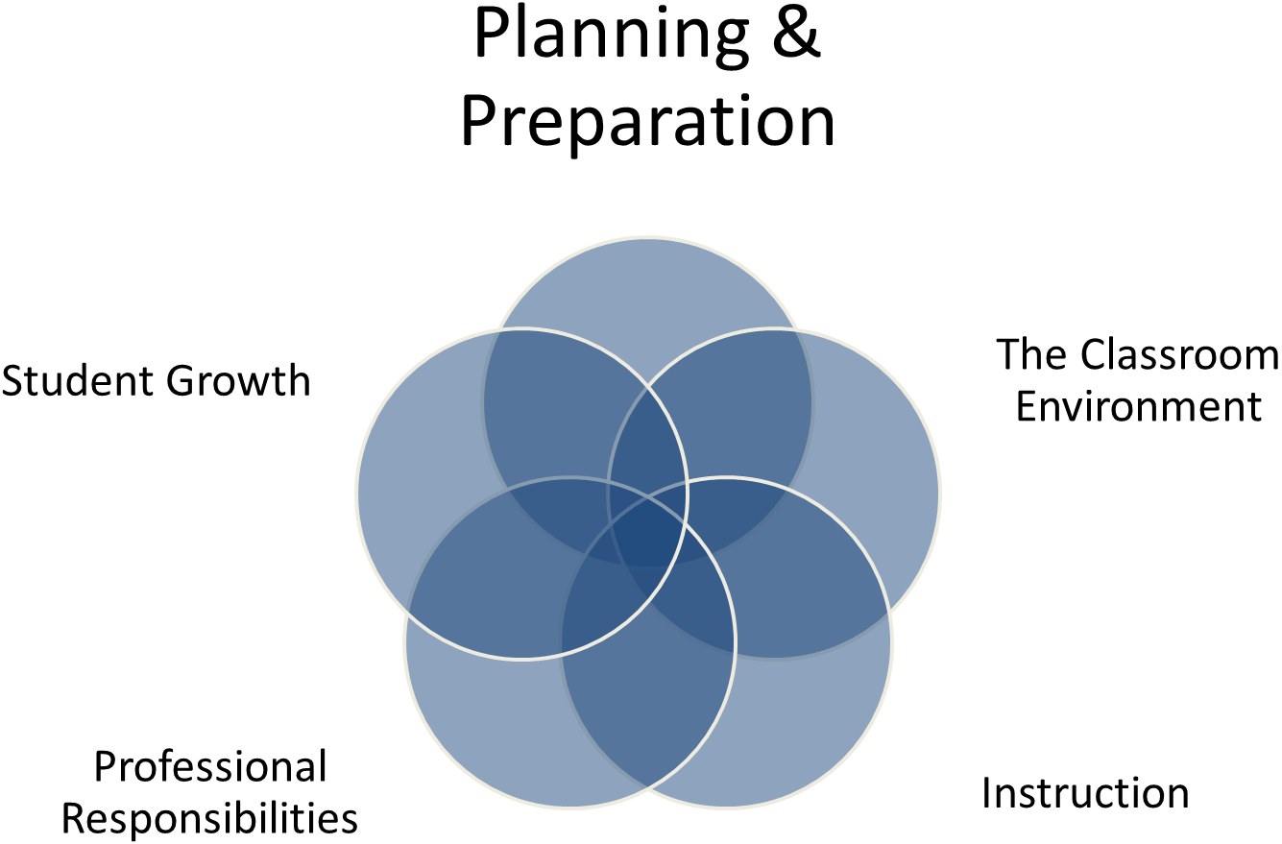
1A - Knowledge of Content and Pedagogy  - Knowledge of Content and the Structure of the Discipline  - Knowledge of Prerequisite Relationships  - Knowledge of Content-Related Pedagogy | In order to guide student learning, accomplished teachers have command of the subjects they teach. They must know how the discipline has evolved into the 21st century, incorporating such issues as global awareness and cultural diversity, as appropriate. Accomplished teachers understand the internal relationships within the disciplines they teach, knowing which concepts and skills are prerequisite to the understanding of others. They are also aware of typical student misconceptions in the discipline and work to dispel them. But knowledge of the content is not sufficient; in advancing student understanding, teachers are familiar with the particularly pedagogical approaches best suited to each discipline.  Domain 1: Planning & Preparation
 | Ineffective | Developing | Accomplished | Exemplary
 | - In planning and practice, teacher makes content errors or does not correct errors made by students.  - Teacher’s plans and practice display little understanding of prerequisite relationships important to student’s learning of the content.  - Teacher displays little or no understanding of the range of pedagogical approaches suitable to student’s learning of the content. | - Teacher is familiar with the important concepts in the discipline but displays lack of awareness of how these concepts relate to one another.  - Teacher’s plans and practice indicate some awareness of prerequisite relationships, although such knowledge may be inaccurate or incomplete.  - Teacher’s plans and practice reflect a limited range of pedagogical approaches to the discipline or to the students. | - Teacher displays solid knowledge of the important concepts in the discipline and the ways they relate to one another.  - Teacher’s plans and practice reflect accurate understanding of prerequisite relationships among topics and concepts.  - Teacher’s plans and practice reflect familiarity with a wide range of effective pedagogical approaches to the discipline. | - Teacher displays extensive knowledge of the important concepts in the discipline and the ways they relate both to one another and to other disciplines.  - Teacher’s plans and practice reflect understanding of prerequisite relationships among topics and concepts and provide a link to necessary cognitive structures needed by students to ensure understanding.  - Teacher’s plans and practice reflect familiarity with a wide range of effective pedagogical approaches in the discipline, anticipating student misconceptions.
Critical Attributes | - Teacher makes content errors.  - Teacher does not consider prerequisite relationships when planning.  - Teacher’s plans use inappropriate strategies for the discipline. | - Teacher is familiar with the discipline but does not see conceptual relationships.  - Teacher’s knowledge of prerequisite relationships is inaccurate or incomplete.  - Lesson and unit plans use limited instructional strategies, and some may not be suitable to the content. | - The teacher can identify important concepts of the discipline and their relationships to one another.  - The teacher consistently provides clear explanations of the content.  - The teacher answers student questions accurately and provides feedback that furthers their learning.  - The teacher seeks out content-related professional development. | In addition to the characteristics of “accomplished”:  - Teacher cites intra- and interdisciplinary content relationships.  - Teacher is proactive in uncovering student misconceptions and addressing them before proceeding.
Possible Examples | - The teacher says “the official language of Brazil is Spanish, just like other South American countries.”  - The teacher says, “I don’t understand why the math book has decimals in the same unit as fractions.”  - The teacher has students copy dictionary definitions each week to help his students learn to spell difficult words. | - The teacher plans lessons on area and perimeter independently of one another, without linking the concepts together.  - The teacher plans to forge ahead with a lesson on addition with regrouping, even though some students have not fully grasped place value.  - The teacher always plans the same routine to study spelling: pretest on Monday, copy the words 5 times each on Tuesday and Wednesday, test on Friday. | - The teacher’s plan for area and perimeter invites students to determine the shape that will yield the largest area for a given perimeter.  - The teacher realizes her students are not sure how to use a compass, so she plans to practice that before introducing the activity on angle measurement.  - The teacher plans to expand a unit on civics by having students simulate a court trial. | - In a unit on 19th century literature, the teacher incorporates information about the history of the same period.  - Before beginning a unit on the solar system, the teacher surveys the class on their beliefs about why it is hotter in the summer than in the winter.

1B - Demonstrating Knowledge of Students  - Knowledge of Child and Adolescent Development  - Knowledge of the Learning Process  - Knowledge of Students’ Skills, Knowledge, and Language Proficiency  - Knowledge of Students’ Interests and Cultural Heritage  - Knowledge of Students’ Special Needs | Teachers don’t teach content in the abstract; they teach it to students. In order to ensure student learning, therefore, teachers must know not only their subject content and its related pedagogy but the students to whom they wish to teach that content. In ensuring student learning, teachers must appreciate what recent research in cognitive psychology has confirmed: namely, that students learn through active intellectual engagement with content. While there are patterns in cognitive, social, and emotional developmental stages typical of different age groups, students learn in their individual ways and may come with gaps or misconceptions that the teacher needs to uncover in order to plan appropriate learning activities. In addition, students have lives beyond school, lives that include athletic and musical pursuits, activities in their neighborhoods, and family and cultural traditions. Students whose first language is not English, as well as students with other special needs, must be considered when planning lessons and identifying resources that will ensure their understanding.  Domain 1: Planning & Preparation
 | Ineffective | Developing | Accomplished | Exemplary
 | - Teacher demonstrates little or no understanding of how students learn and little knowledge of students’ backgrounds, cultures, skills, language proficiency, interests, and special needs and does not seek such understanding. | - Teacher indicates the importance of understanding how students learn and the students’ backgrounds, cultures, skills, language proficiency, interests, and special needs, and attains this knowledge about the class as a whole. | - Teacher understands the active nature of student learning and attains information about levels of development for groups of students.  - The teacher also purposefully seeks knowledge from several sources of students’ backgrounds, cultures, skills, language proficiency, interests, and special needs and attains this knowledge about groups of students. | - Teacher actively seeks knowledge of students’ levels of development and their backgrounds, cultures, skills, language proficiency, interests, and special needs from a variety of sources. This information is acquired for individual students.
Critical Attributes | - Teacher does not understand child development characteristics and has unrealistic expectations for students.  - Teacher does not try to ascertain varied ability levels among students in the class.  - Teacher is not aware of student interests or cultural heritages.  - Teacher takes no responsibility to learn about students’ medical or learning disabilities. | - Teacher cites developmental theory but does not seek to integrate it into lesson planning.  - Teacher is aware of the different ability levels in the class but tends to teach to the “whole group”.  - The teacher recognizes that children have different interests and cultural backgrounds but rarely draws on their contributions or differentiates materials to accommodate those differences.  - The teacher is aware of medical issues and learning disabilities with some students but does not seek to understand the implications of that knowledge. | - The teacher knows, for groups of students, their levels of cognitive development.  - The teacher is aware of the different cultural groups in the class.  - The teacher has a good idea of the range of interests of students in the class.  - The teacher has identified “high”, “medium”, and “low” groups of students within the class.  - The teacher is well informed about students’ cultural heritage and incorporates this knowledge into lesson planning.  - The teacher is aware of the special needs represented by students in the class. | In addition to the characteristics of “accomplished”:  - The teacher uses ongoing methods to assess students’ skill levels and designs instruction accordingly.  - The teacher seeks out information about their cultural heritage from all students.  - The teacher maintains a system of updated student records and incorporates medical and/or learning needs into lesson plans.
Possible Examples  Possible Examples (cont.) | - The lesson plan includes a teacher presentation for an entire 30-minute period to a group of 7-year-olds.  - The teacher plans to give her ELL students the same writing assignment she gives the rest of the class.  - The teacher plans to teach his class Christmas carols, despite the fact that he has four religions represented among his students. | - The teacher’s lesson plan has the same assignment for the entire class, in spite of the fact that one activity is beyond the reach of some students.  - In the unit on Mexico, the teacher has not incorporated perspectives from the three Mexican-American children in the class.  - Lesson plans make only peripheral reference to students’ interests.  Domain 1: Planning & Preparation  - The teacher knows that some of her students have IEPs, but they’re so long that she hasn’t read them yet. | - The teacher creates an assessment of students’ levels of cognitive development.  - The teacher examines previous year’s cumulative folders to ascertain the proficiency levels of groups of students in the class.  - The teacher administers a student interest survey at the beginning of the school year.  - The teacher plans activities based on student-interest.  - The teacher knows that five of her students are in the Garden Club; she plans to have them discuss horticulture as part of the next biology lesson.  - The teacher realizes that not all of his students are Christian and so he plans to read a Hanukkah story in December.  - The teacher plans to ask her Spanish-speaking students to discuss their ancestry as part of their social studies unit on South America. | - The teacher plans his lesson with three different follow-up activities, designed to meet the varied ability levels of his students.  - The teacher plans to provide multiple project options; students will self-select the project that best meets their individual approach to learning.  - The teacher encourages students to be aware of their individual reading levels and make independent reading choices that will be challenging but not too difficult.  - The teacher attends the local Mexican heritage day, meeting several of his students’ extended families.  - The teacher regularly creates adapted assessment materials for several students with learning disabilities.

1C - Setting Instructional Outcomes  - Value, Sequence, and Alignment  - Clarity  - Balance  - Suitability for Diverse Learners | Teaching is a purposeful activity; even the most imaginative activities are directed towards certain desired learning. Therefore, establishing instructional outcomes entails identifying exactly what students will be expected to learn; the outcomes describe not what students will do but what they will learn. The instructional outcomes should reflect important learning and must lend themselves to various forms of assessment so that all students are able to demonstrate their understanding of the content. Insofar as the outcomes determine the instructional activities, the resources used, their suitability for diverse learners, and the methods of assessment employed, they hold a central place in Domain 1.  Domain 1: Planning & Preparation  Learning outcomes are of a number of different types: factual and procedural knowledge, conceptual understanding, thinking and reasoning skills, and collaborative and communication strategies. In addition, some learning outcomes refer to dispositions; not only is it important for students to learn to read, but educators also hope that they will like to read. In addition, experienced teachers are able to link their learning outcomes with others both within their discipline and in other disciplines.
 | Ineffective | Developing | Accomplished | Exemplary
 | - Outcomes represent low expectations for students and lack of rigor, and not all of them reflect important learning in the discipline.  - Outcomes are stated as activities rather than as student learning.  - Outcomes reflect only one type of learning and only one discipline or stand and are suitable for only some students. | - Outcomes represent moderately high expectations and rigor.  - Some reflect important learning in the discipline and consist of a combination of outcomes and activities.  - Outcomes reflect several types of learning, but teacher has made no attempt at coordination or integration.  - Most of the outcomes are suitable for most of the students in the class in accordance with global assessments of student learning. | - Most outcomes represent rigorous and important learning in the discipline.  - All the instructional outcomes are clear, are written in the form of student learning, and suggest viable methods of assessment.  - Outcomes reflect several different types of learning and opportunities for coordination.  - Outcomes take into account the varying needs of groups of students. | - All outcomes represent rigorous and important learning in the discipline.  - The outcomes are clear, are written in the form of student learning, and permit viable methods of assessment.  - Outcomes reflect several different types of learning and, where appropriate, represent opportunities for both coordination and integration.  - Outcomes take into account the varying needs of individual students.
Critical Attributes | - Outcomes lack rigor.  - Outcomes do not represent important learning in the discipline.  - Outcomes are not clear or are stated as activities.  - Outcomes are not suitable for many students in the class. | - Outcomes represent a mixture of low expectations and rigor.  - Some outcomes reflect important learning in the discipline.  - Outcomes are suitable for most of the class. | - Outcomes represent high expectations and rigor.  - Outcomes are related to the “big ideas” of the discipline.  - Outcomes are written in terms of what students will learn rather than do.  - Outcomes represent a range: factual, conceptual understanding, reasoning, social, management, and communication.  - Outcomes are suitable to groups of students in the class and are differentiated where necessary. | In addition to the characteristics of “accomplished”:  - Teacher plans make reference to curricular frameworks or blueprints to ensure accurate sequencing.  - Teacher connects outcomes to previous and future learning.  - Outcomes are differentiated to encourage individual students to take educational risks.
Possible Examples  Possible Examples (cont.) | - A learning outcome for a fourth-grade class is to make a poster illustrating a poem.  - All the outcomes for a ninth-grade history class are factual knowledge.  - The topic of the social studies unit involves the concept of revolutions, but the teacher expects his students to remember only the important dates of battles.  - Though there are a number of ELL students in the class, the outcomes state that all writing must be grammatically correct.  Domain 1: Planning & Preparation | - Outcomes consist of understanding the relationship between addition and multiplication and memorizing facts.  - The outcomes are written with the needs of the “middle” group in mind; however, the advanced students are bored, and some lower-level students are struggling. | - One of the learning outcomes is for students to appreciate the aesthetics of 18th century English poetry.  - The outcomes for the history unit include some factual information, as well as a comparison of the perspectives of different groups in the events leading to the Revolutionary War.  - The teacher reviews the project expectations and modifies some goals to be in line with students’ IEP objectives. | - The teacher encourages his students to set their own goals; he provides them a taxonomy of challenge verbs to help them strive for higher expectations.  - Students will develop a concept map that links previous learning goals to those they are currently working on.  - Some students identify additional learning.

1D - Demonstrating Knowledge of Resources  - Resources for Classroom Use  - Resources to Extend Content Knowledge and Pedagogy  - Resources for Students | Student learning is enhanced by a teacher’s skillful use of resources; some of these are provided by the school as “official” materials; others are secured by teachers through their own initiative. Resources fall into several different categories: those used in the classroom by students, those available beyond the classroom walls to enhance student learning, those for teachers to further their own professional knowledge and skill, and those that can provide noninstructional assistance to students. Teachers recognize the importance of discretion in the selection of resources, choosing those that align directly with the learning outcomes and that will be of most use to the students. Accomplished teachers also ensure that the selection of materials and resources is appropriately challenging for every student; texts, for example, are available at various reading levels to guarantee all students access to the content and successfully demonstrate understanding of the learning outcomes. Furthermore, expert teachers look beyond the school for resources to bring their subjects to life and to assist students who need help in both their academic and nonacademic lives.  Domain 1: Planning & Preparation
 | Ineffective | Developing | Accomplished | Exemplary
 | - Teacher is unaware of school or district resources for classroom use, for the expansion of his or her own knowledge, or for students. | - Teacher displays basic awareness of school or district resources available for classroom use, for the expansion of his or her own knowledge, and for students, but no knowledge of resources available more broadly. | - Teacher displays awareness of resources – not only through the school and district but also through sources external to the school and on the Internet – available for classroom use, for the expansion of his or her own knowledge, and for students. | - Teacher displays extensive knowledge of resources – not only through the school and district but also in the community, through professional organizations and universities, and on the Internet—for classroom use, for the expansion of is or her own knowledge, and for students.
Critical Attributes | - The teacher uses only district-provided materials, even when more variety would assist some students.  - The teacher does not seek out resources available to expand his or her own skill.  - Although aware of some student needs, the teacher does not inquire about possible resources. | - The teacher uses materials in the school library but does not search beyond the school for resources.  - The teacher participates in content-area workshops offered by the school but does not pursue other professional development.  - The teacher locates materials and resources for students that are available through the school but does not pursue any other avenues. | - Texts are at varied levels.  - Texts are supplemented by guest speakers and field experiences.  - Teacher facilitates Internet resources.  - Resources are multipdisciplinary.  - Teacher expands knowledge with professional learning groups and organizations.  - Teacher pursues options offered by universities.  - Teacher provides lists of resources outside the class for students to draw on. | In addition to the characteristics of “accomplished”:  - Texts are matched to student skill level.  - The teacher has ongoing relationship with colleges and universities that support student learning.  - The teacher maintains log of resources for student reference.  - The teacher pursues apprenticeships to increase discipline knowledge.  - The teacher facilitates student contact with resources outside the classroom.
Possible Examples | - For their unit on China, the students acquired all of their information from the district-supplied textbook.  - Mr. J is not sure how to teach fractions but doesn’t know how he’s expected to learn it by himself.  - A student says, “It’s too bad we can’t go to the nature center when we’re doing our unit on environment.” | - For a unit on ocean life, the teacher really needs more books, but the school library has only three for him to borrow.  - The teacher knows she should learn more about teaching literacy, but the school offered only one professional development day last year.  - The teacher thinks his students would benefit from hearing about health safety from a professional; he contacts the school nurse to visit his classroom. | - The teacher provides her 5th graders a range of nonfiction texts about the American Revolution; no matter their reading level, all students can participate in the discussion of important concepts.  - The teacher took an online course on literature to expand her knowledge of great American writers.  - The teacher distributes a list of summer reading materials that would help prepare his 8th graders’ transition to high school. | - The teacher is not happy with the out-of-date textbook; his students will critique it and write their own text for social studies.  - The teacher spends the summer at Dow Chemical learning or about current research so that she can expand her knowledge base for teaching chemistry.  - The teacher matches students in her Family and Consumer Science class with local businesses; the students spend time shadowing employees to understand how their classroom skills might be used on the job.

1E - Designing Coherent Instruction  - Learning Activities  - Instructional Materials and Resources  - Instructional Groups  - Lesson and Unit Structure | Designing coherent instruction is the heart of planning, reflecting the teacher’s knowledge of content and the students in the class, the intended outcomes of instruction, and the available resources. Such planning requires that educators have a clear understanding of the state, district, and school expectations for student learning, and the skill to translate these into a coherent plan. It also requires that teachers understand the characteristics of the students they teach and the active nature of student learning. Educators must determine how best to sequence instruction in a way that will advance student learning through the required content. It further requires the thoughtful construction of lessons that contain cognitively engaging learning activities, the incorporation of appropriate resources and materials, and the intentional grouping of students. Proficient practice in this component recognizes that a well-designed instruction plan addresses the learning needs of various groups of students; one size does not fit all. At the distinguished level the teacher plans instruction that takes into account the specific learning needs of each student and solicits ideas from students on how best to structure the learning.  Domain 1: Planning & Preparation
 | Ineffective | Developing | Accomplished | Exemplary
 | - The series of learning experiences is poorly aligned with the instructional outcomes and does not represent a coherent structure.  - The activities are not designed to engage students in active intellectual activity and have unrealistic time allocation. Instructional groups do not support the instructional outcomes and offer no variety. | - Some of the learning activities and materials are suitable to the instructional outcomes and represent a moderate cognitive challenge but with no differentiation for different students. Instructional groups partially support the instructional outcomes, with an effort by the teacher at providing some variety.  - The lesson or unit has a recognizable structure; the progression of activities is uneven, with most time allocations reasonable. | - Teacher coordinates knowledge of content, of students, and of resources, to design a series of learning experiences aligned to instructional outcomes and suitable to groups of students.  - The learning activities have reasonable time allocations; they represent significant cognitive challenge, with some differentiation for different groups of students.  - The lesson or unit has a clear structure, with appropriate and varied use of instructional groups. | - Plans represent the coordination of in-depth content knowledge, understanding of different students’ needs, and available resources (including technology), resulting in a series of learning activities designed to engage students in high-level cognitive activity.  - Learning activities are differentiated appropriately for individual learners. Instructional groups are varied appropriately with some opportunity for student choice.  - The lesson’s or unit’s structure is clear and allows for different pathways according to diverse student needs.
Critical Attributes | - Learning activities are boring and/or not well aligned to the instructional goals.  - Materials are not engaging or do not meet instructional outcomes.  - Instructional groups do not support learning.  - Lesson plans are not structured or sequenced and are unrealistic in their expectations. | - Learning activities are moderately challenging.  - Learning resources are suitable, but there is limited variety.  - Instructional groups are random or only partially support objectives.  - Lesson structure is uneven or may be unrealistic in terms of time expectations. | - Learning activities are matched to instructional outcomes.  - Activities provide opportunity for higher-level thinking.  - Teacher provides a variety of appropriately challenging materials and resources.  - Instructional student groups are organized thoughtfully to maximize learning and build on student strengths.  - The plan for the lesson or unit is well structured, with reasonable time allocations. | In addition to the characteristics of “accomplished”:  - Activities permit student choice.  - Learning experiences connect to other disciplines.  - Teacher provides a variety of appropriately challenging resources that are differentiated for students in the class.  - Lesson plans differentiate for individual student needs.
Possible Examples  Possible Examples (cont.) | - The teacher plans to have his 9th graders color in the worksheet after memorizing the parts of a microscope.  - Despite having a textbook that is 15 years old, the teacher plans to use that as the sole resource for his communism unit.  - The teacher organizes her class in rows, seating the students alphabetically; she plans to have students work all year in groups of four selected on the basis of where they are sitting.  - The teacher’s lesson plans are written on sticky notes in his grade book; they indicate lecture, activity, or test. | - After the minilesson the teacher plans to have the whole class play a game to reinforce the skills she taught.  - The teacher has found an atlas to use as a supplemental resource during the geography unit.  - The teacher always lets students select their own working groups because they behave better when they can choose whom they want to sit with.  Domain 1: Planning & Preparation  - The teacher’s lesson plans are nicely formatted, but the timing for many activities is too short to actually cover the concepts thoroughly. | - The teacher reviews her learning activities with a reference to high-level “action verbs” and rewrites some of the activities to increase the challenge level.  - The teacher creates a list of historical fiction titles that will expand her students’ knowledge of the age of exploration.  - The teacher plans for students to complete projects in small groups; he carefully selects group members based on their ability level and learning style.  - The teacher reviews lesson plans with her principal; they are well structured with pacing times and activities clearly indicated. | - The teacher’s unit on ecosystems lists a variety of high level activities in a menu; students choose those that suit their approach to learning.  - While completing their projects, the teacher’s students will have access to a wide variety of resources that she has coded by reading level so they can make the best selections.  - After the cooperative group lesson, students will reflect on their participation and make suggestions for new group arrangements in the future.  - The lesson plan clearly indicates the concepts taught in the last few lessons; the teacher plans for his students to link the current lesson’s outcomes to those they previously learned.

1F - Designing Student Assessments  - Congruence with Instructional Outcomes  - Criteria and Standards  - Design of Formative Assessments  - Use for Planning | Good teaching requires both assessment of learning and assessment for learning. Assessments of learning ensure that teachers know that students have learned the intended outcomes. These assessments must be designed in such a manner that they provide evidence of the full range of learning outcomes; that is, to assess reasoning skills and factual knowledge, different methods are needed. Furthermore, such assessments may need to be adapted to the particular needs of individual students; an ESL student, for example, may need an alternative method of assessment to allow demonstration of understanding. Assessment for learning enables a teacher to incorporate assessments directly into the instructional processes, and to modify or adapt instruction as needed to ensure student understanding. Such assessments, although used during instruction, must be designed as part of the planning process. Such formative assessment strategies are ongoing and may be used by both teachers and students to monitor progress towards the understanding of the learning outcomes.  Domain 1: Planning & Preparation
 | Ineffective | Developing | Accomplished | Exemplary
 | - Assessment procedures are not congruent with instructional outcomes; the proposed approach contains no criteria or standards.  - Teacher has no plan to incorporate formative assessment in the lesson or unit nor any plan to use assessment results in designing future instruction. | - Some of the instructional outcomes are assessed through the proposed approach, but others are not.  - Assessment criteria and standards have been developed, but they are not clear.  - Approach to the use of formative assessment is rudimentary, including only some of the instructional outcomes.  - Teacher intends to use assessment results to plan for future instruction for the class as a whole. | - Teacher's plan for student assessment is aligned with the instructional outcomes; assessment methodologies may have been adapted for groups of students.  - Assessment criteria and standards are clear. Teacher has a well-developed strategy for using formative assessment and has designed particular approaches to be used.  - Teacher intends to use assessment results to plan for future instruction for groups of students. | - Teacher's plan for student assessment is fully aligned with the instructional outcomes and has clear criteria and standards that show evidence of student contribution to their development.  - Assessment methodologies have been adapted for individual students, as needed.  - The approach to using formative assessment is well designed and includes student as well as teacher use of the assessment information. Teacher intends to use assessment results to plan future instruction for individual students.
Critical Attributes | - Assessments do not match instructional outcomes.  - Assessments have no criteria.  - No formative assessments have been designed.  - Assessment results do not affect future plans. | - Only some of the instructional outcomes are addressed in the planned assessments.  - Assessment criteria are vague.  - Plans refer to the use of formative assessments, but they are not fully developed.  - Assessment results are used to design lesson plans for the whole class, not individual students. | - All the learning outcomes have a method for assessment.  - Assessment types match learning expectations.  - Plans indicate modified assessments for some students as needed.  - Assessment criteria are clearly written.  - Plans include formative assessments to use during instruction.  - Lesson plans indicate possible adjustments based on formative assessment data. | In addition to the characteristics of "accomplished":  - Assessments provide opportunities for student choice.  - Students participate in designing assessments for their own work.  - Teacher-designed assessments are authentic with real-world application, as appropriate.  - Students develop rubrics according to teacher-specified learning objectives.  - Students are actively involved in collecting information from formative assessments and provide input.
Possible Examples  Possible Examples (cont.) | - The teacher marks papers on the foundation of the U.S. constitution on the basis of grammar and punctuation; for every mistake, the grade drops from an A to a B, a B to a C, etc.  - After the students present their research on globalization, the teacher tells them their letter grade. When students ask how he has arrived at the grade, he responds, "After all these years in education, I just know what grade to give."  - The teacher says, "What's the difference between formative assessment and the test I give at the end of the unit?"  - The teacher says, "The district gave me this entire curriculum to teach, so I just have to keep moving." | - The district goal for the Europe unit is for students to understand geopolitical relationships. The teacher plans to have the students memorize all the country capitals and rivers.  - The teacher's students receive their tests back; each one is simply marked with a letter grade at the top.  - The plan indicates that the teacher will pause to "check for understanding" but without a clear indication of how that is to be done.  Domain 1: Planning & Preparation  - A student says, "If half the class passed the test, why are we all reviewing the material again?" | - Mr. K knows that his students will write a persuasive essay on the state assessment; he plans to have them write a variety of persuasive essays as preparation.  - Ms. M has worked on a writing rubric for her research assessment; she has drawn on multiple sources to be sure the levels of expectation are clearly defined.  - Mr. C creates a short questionnaire to distribute to his students at the end of class; on the basis of their responses, he will organize them into different groups during the next lesson's activities.  - Based on the previous morning's formative assessment, Ms. D plans to have 5 students to work on a more challenging project while she works with 6 other students to reinforce the concept. | - To teach persuasive writing, Ms. H plans to have her class research and write to the principal on an issue that is important to the students; the use of cell phones in class.  - Mr. J's students will write a rubric for their final project on the benefits of solar energy; Mr. J has shown them several sample rubrics, and they will refer to those as they create a rubric of their own.  - After the lesson Mr. L asks students to rate their understanding on a scale of 1 to 5; the students know that their rating will indicate their activity for the next lesson.  - Mrs. T has developed a routine for her class: students know that if they are struggling with a math concept, they will sit in a small group with her during workshop time.

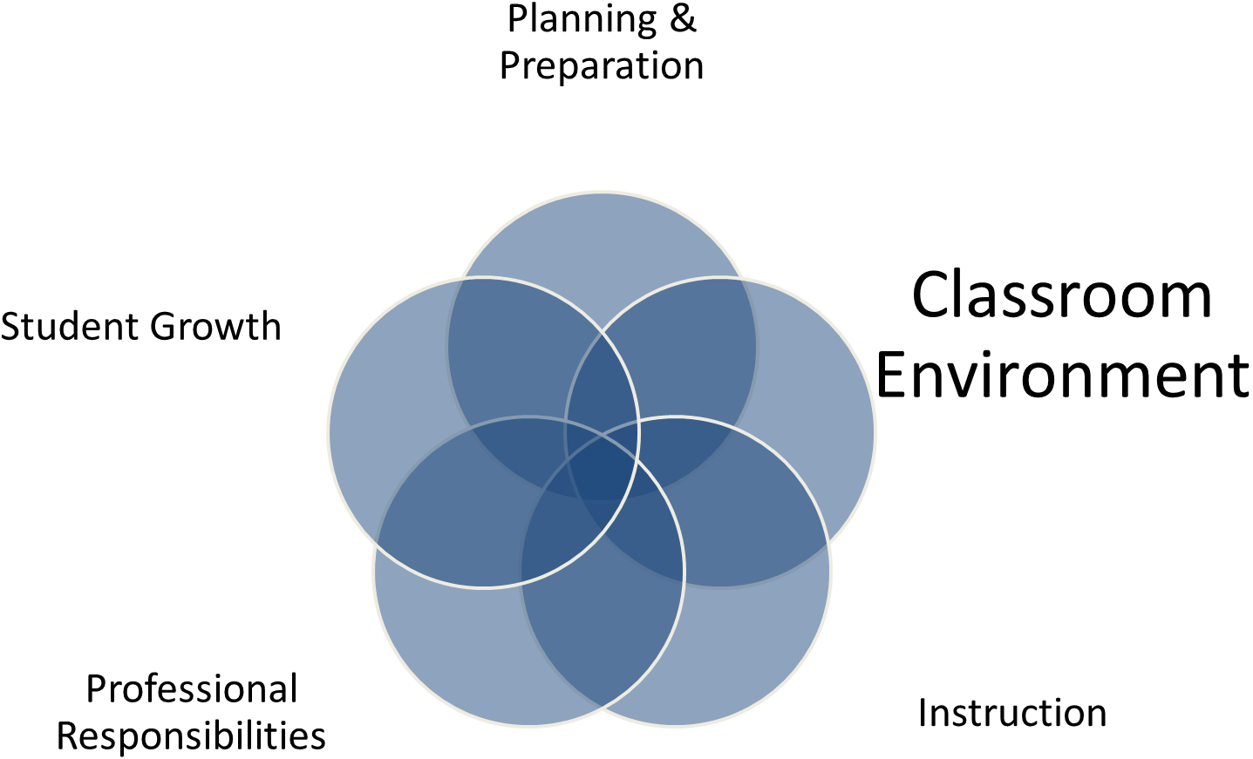

2A - Creating an Environment of Respect and Rapport  - Teacher Interaction with Students  - Student Interactions with One Another | An essential skill of teaching is that of managing relationships with students and ensuring that those among students are positive and supportive. Teachers create an environment of respect and rapport in their classrooms by the ways they interact with students and by the interaction they encourage and cultivate among students. An important aspect of respect and rapport relates to how the teacher responds to students and how students are permitted to treat one another. Patterns of interactions are critical to the overall tone of the class. In a respectful environment, all students feel valued and safe.  Domain 2: The Classroom Environment
 | Ineffective | Developing | Accomplished | Exemplary
 | - Patterns of classroom interactions, both between the teacher and students and among students, are mostly negative, inappropriate, or insensitive to students' ages, cultural backgrounds, and developmental levels. Interactions are characterized by sarcasm, put-downs, or conflict.  - Teacher does not deal with disrespectful behavior. | - Patterns of classroom interactions, both between the teacher and students and among students, are generally appropriate but may reflect occasional inconsistencies, favoritism, and disregard for students' ages, cultures, and developmental levels.  - Students rarely demonstrate disrespect for one another.  - Teacher attempts to respond to disrespectful behavior, with uneven results. The net result of the interactions is neutral, conveying neither warmth nor conflict. | - Teacher-student interactions are friendly and demonstrate general caring and respect. Such interactions are appropriate to the ages of the students.  - Students exhibit respect for the teacher. Interactions among students are generally polite and respectful.  - Teacher responds successfully to disrespectful behavior among students. The net result of the interactions is polite and respectful, but impersonal. | - Classroom interactions among the teacher and individual students are highly respectful, reflecting genuine warmth and caring and sensitivity to students as individuals.  - Students exhibit respect for the teacher and contribute to high levels of civil interaction between all members of the class. The net result of interactions is that of connections with students as individuals.
Critical Attributes | - Teacher uses disrespectful talk towards students; student's body language indicates feelings of hurt or insecurity.  - Students use disrespectful talk towards one another with no response from the teacher.  - Teacher displays no familiarity with or caring about individual students' interests or personalities. | - The quality of interactions between teacher and students, or among students, is uneven, with occasional disrespect.  - Teacher attempts to respond to disrespectful behavior among students, with uneven results.  - Teacher attempts to make connections with individual students, but student reactions indicate that the efforts are not completely successful or are unusual. | - Talk between teacher and students and among students is uniformly respectful.  - Teacher responds to disrespectful behavior among students.  - Teacher makes superficial connections with individual students. | In addition to the characteristics of "accomplished":  - Teacher demonstrates knowledge and caring about individual students' lives beyond school.  - When necessary, students correct one another in their conduct toward classmates.  - There is no disrespectful behavior among students.  - The teacher's response to a student's incorrect response respects the student's dignity.
Possible Examples  Possible Examples (cont.) | - A student slumps in his/her chair following a comment by the teacher.  - Students roll their eyes at a classmate's idea; the teacher does not respond.  - Many students talk when the teacher and other students are talking; the teacher does not correct them.  - Some students refuse to work with other students.  - Teacher does not call students by their names. | - Students attend passively to the teacher, but tend to talk, pass notes, etc. when other students are talking.  - A few students do not engage with others in the classroom, even when put together in small groups.  - Students applaud halfheartedly following a classmate's presentation to the class.  - Teacher says: "Don't talk that way to your classmates," but student shrugs his/her shoulders. | - Teacher greets students by name as they enter the class or during the lesson.  - The teacher gets on the same level with students, kneeling, for example, beside a student working at a desk.  - Students attend fully to what the teacher is saying.  - Students wait for classmates to finish speaking before beginning to talk.  - Students applaud politely following a classmate's presentation to the class.  - Students help each other and accept help from each other.  Domain 2: The Classroom Environment  - Teacher and students use courtesies such as "please," "thank you," "excuse me."  - Teacher says: "Don't talk that way to your classmates," and the insults stop. | - Teacher inquires about a student's soccer game last week-end (or extracurricular activities or hobbies).  - Students hush classmates causing a distraction while the teacher or another student is speaking.  - Students clap enthusiastically after one another's presentations for a job well done.  - The teacher says: "That's an interesting idea, Josh, but you're forgetting..."

2B - Establishing a Culture for Learning  - Importance of the Content  - Expectations for Learning and Achievement  - Student Pride in Work | A “culture of learning” refers to the atmosphere in the classroom that reflects the educational importance of the work undertaken by both students and teacher. It describes the norms that govern the interactions among individuals about the activities and assignments, the value of hard work and perseverance, and the general tone of the class. The classroom is characterized by high cognitive energy and by a sense that what is happening there is important and that it is essential to get it right. There are high expectations for all students. The classroom is a place where the teacher and students value learning and hard work.  Domain 2: The Classroom Environment
 | Ineffective | Developing | Accomplished | Exemplary
 | - The classroom culture is characterized by a lack of teacher or student commitment to the learning and/or little or no investment of student energy into the task at hand. Hard work is not expected or valued.  - Medium or low expectations for student achievement are the norm, with high expectations for learning reserved for only one or two students | - The classroom culture is characterized by little commitment to learning by teacher or students.  - The teacher appears to be only going through the motions, and students indicate that they are interested in completion of a task, rather than quality.  - The teacher conveys that student success is the result of natural ability rather than hard work; high expectations for learning are reserved for those students thought to have a natural aptitude for the subject. | - The classroom culture is a cognitively busy place where learning is valued by all, with high expectations for learning being the norm for most students.  - The teacher conveys that with hard work students can be successful.  - Students understand their role as learners and consistently expend effort to learn.  - Classroom interactions support learning and hard work. | - The classroom culture is a cognitively vibrant place, characterized by a shared belief in the importance of learning.  - The teacher conveys high expectations for learning by all students and insists on hard work.  - Students assume responsibility for high quality by initiating improvements, making revisions, adding detail, and/or helping peers.
Critical Attributes | - The teacher conveys that the reasons for the work are external or trivializes the learning goals and assignments.  - The teacher conveys to at least some students that the work is too challenging for them  - Students exhibit little or no pride in their work.  - Class time is devoted more to socializing than to learning. | - Teacher’s energy for the work is neutral, indicating neither a high level of commitment nor “blowing it off”.  - The teacher conveys high expectations for only some students.  - Students comply with the teacher’s expectations for learning, but they don’t indicate commitment on their own initiative for the work.  - Many students indicate that they are looking for an “easy path”. | - The teacher communicates the importance of learning and the assurance that with hard work all students can be successful in it.  - The teacher demonstrates a high regard for student abilities.  - Teacher conveys an expectation of high levels of student effort.  - Students expend good effort to complete work of high quality. | In addition to the characteristics of “accomplished”:  - The teacher communicates a genuine passion for the subject.  - Students indicate that they are not satisfied unless they have complete understanding.  - Students questions and comments indicate a desire to understand the content rather than, for example, simply learn a procedure for getting the correct answer.  - Students recognize the efforts of their classmates.  - Students take initiative in improving the quality of their work.
Possible Examples  Possible Examples (cont.) | - The teacher tells students that they’re doing lessons because it’s on the test, in the book, or mandated by the district.  - Teacher says to a student: “Why don’t you try this easier problem?”  - Students turn in sloppy or incomplete work.  - Students don’t engage in work, and the teacher ignores it.  - Students have not completed their homework, and the teacher does not respond.  - Almost all of the activities are busy work. | - Teacher says: “Let’s get through this.”  - Teachers says: “I think most of you will be able to do this.”  - Students consult with one another to determine how to fill out a worksheet but do not encourage each other to questions their ideas.  - Teacher does not encourage students who are struggling.  - Only some students get down to work after an assignment is given or after entering the room.  Domain 2: The Classroom Environment | - Teacher says: “This is important: you’ll need to speak grammatical English when you apply for a job.”  - Teacher says: “This idea is really important! It’s central to our understanding of history.”  - Teacher says: “Let’s work on this together: it’s hard, but you all will be able to do it well.”  - Teacher hands a paper back to a student, saying, “I know you can do a better job on this.” The student accepts the comment without complaint.  - Students get down to work right away when an assignment is given or after entering the room. | - The teacher says: “It’s really fun to find the patterns for factoring polynomials.”  - Student asks a classmate to explain a concept or procedure since s/he didn’t quite follow the teacher’s explanation.  - Students question one another on answers.  - Student asks the teacher whether s/he can redo a piece of work since s/he now sees how it could be strengthened.  - Students work even when the teacher isn’t working with them or directing their efforts.

2C - Managing Classroom Procedures  - Management of Instructional Groups  - Management of Transitions  - Management of Materials and Supplies  - Performance of Non-Instructional Duties  - Supervision of Volunteers and Paraprofessionals | A smoothly functioning classroom is a prerequisite to good instruction and high levels of student engagement. Teachers establish and monitor routines and procedure for the smooth operation of the classroom and the efficient use of time. Hallmarks of a well-managed operation of the classroom are that instructional groups are used effectively, noninstuctional tasks are completed efficiently, and transitions between activities and management of materials and supplies are skillfully done in order to maintain momentum and maximize instructional time. The establishment of efficient routines, and success in teaching students to employ them, may be inferred from the sense that the class “runs itself”.  Domain 2: The Classroom Environment
 | Ineffective | Developing | Accomplished | Exemplary
 | - Much instructional time is lost through inefficient classroom routines and procedures.  - There is little or no evidence that the teacher is managing instructional groups, transitions, and /or the handling of materials and supplies effectively.  - There is little evidence that students know or follow established routines. | - Some instructional time is lost through only partially effective classroom routines and procedures.  - The teacher’s management of instructional groups, transitions, and/or the handling of materials and supplies is inconsistent, the result being some disruption of learning.  - With regular guidance and prompting¸ students follow established routines. | - There is little loss of instructional time because of effective classroom routines and procedures.  - The teacher’s management of instructional groups and the handling of materials and supplies are consistently successful.  - With minimal guidance and prompting students follow established classroom routines. | - Instructional time is maximized because of efficient routine and procedures.  - Students contribute to the management of instructional groups, transitions, and the handling of materials and supplies.  - Routines are well understood and may be initiated by students.
Critical Attributes | - Students not working with the teacher are not productively engaged or are disruptive to the class.  - There are no established procedures for distributing and collecting materials.  - Procedures for other activities are confused or chaotic. | - Small groups are only partially engaged while not working directly with the teacher.  - Procedures for transitions and for distribution/collection of materials seem to have been established, but their operation is rough.  - Classroom routines function unevenly. | - The students are productively engaged during small-group work.  - Transitions between large- and small-group activities are smooth.  - Routines for distribution and collections of materials and supplies work efficiently.  - Classroom routines function smoothly. | In addition the characteristics of “accomplished”:  - Students take the initiative with their classmates to ensure that their time is used productively.  - Student themselves ensure that transitions and other routines are accomplished smoothly.  - Students take initiative in distributing and collecting materials efficiently.
Possible Examples  Possible Examples (cont.) | - When moving into small groups, students are confused about where they are supposed to go, whether they should take their chair, etc.  - There are long lines for materials and supplies, or distributing supplies is time consuming.  - Students bump into one another lining up or sharpening pencils.  - Roll taking consumes much time at the beginning of the lesson, and students are not working on anything during the process.  - Most students ask what they are to do or look around for clues from others. | - Some students not working with the teacher are not productively engaged in learning.  - Transitions between large- and small-group activities are rough, but they are accomplished.  - Students are not sure what to do when materials are being distributed or collected.  - Students ask some clarifying questions about procedures.  - The attendance or lunch count consumes more time than it would need if the procedure were more routinized. | - Students get started on an activity while the teacher takes attendance.  - Students move smoothly between large-and small-group activities.  - The teacher has an established timing device, such as counting down to signal students to return to their desks.  - Teacher has an established attention signal, such as raising a hand, or dimming the lights.  - One member of each small group collects materials for the table.  - There is an established color-coded system indicating where materials should be stored.  - In small-group work, students have established roles, they listen to one another summarize different vies, etc.  Domain 2: The Classroom Environment  - Cleanup at the end of a lesson is fast and efficient. | - Students direct classmates in small groups not working directly with the teacher o be more efficient in their work.  - A student reminds classmates of the roles that they are to play within the group.  - A student redirects a classmate to the table s/he should be at following a transition.  - Students propose an improved attention signal.  - Students independently check themselves into class on the attendance board.

2D - Managing Student Behavior  - Expectations  - Monitoring of Student Behavior  - Response to Student Misbehavior | In order for student to be able to engage deeply with content, the classroom environment must be orderly; the atmosphere must feel businesslike and productive, without being authoritarian. In a productive classroom, standards of conduct are clear to students; they know what they are permitted to do and what they can expect of their classmates. Even when their behavior is being corrected, students feel respected; their dignity is not undermined. Skilled teachers regard positive student behavior not as an end in itself, but as a prerequisite to high levels of engagement in content.  Domain 2: The Classroom Environment
 | Ineffective | Developing | Accomplished | Exemplary
 | - There appear to be no established standards of conduct and little or no teacher monitoring of student behavior.  - Students challenge the standards of conduct.  - Response to students’ misbehavior is repressive or disrespectful of student dignity | - Standards of conduct appear to have been established, but their implementation is inconsistent.  - Teacher tries, with uneven results, to monitor student behavior and respond to student misbehavior.  - There is inconsistent implementation of the standards of conduct. | - Student behavior is generally appropriate.  - The teacher monitors student behavior against established standards of conduct.  - Teacher response to student misbehavior is consistent, proportionate, respectful to students, and effective. | - Student behavior is entirely appropriate.  - Students take an active role in monitoring their own behavior and that of other students against standards of conduct.  - Teachers’ monitoring of student behavior is subtle and preventative.  - Teacher’s response to student misbehavior is sensitive to individual student needs and respects students’ dignity.
Critical Attributes | - The classroom environment is chaotic, with no apparent standards of conduct.  - The teacher does not monitor student behavior.  - Some students violate classroom rules, without apparent teacher awareness.  - When the teacher notices student misbehavior, s/he appears helpless to do anything about it. | - Teacher attempts to maintain order in the classroom but with uneven success; standards of conduct, if they exist, are not evident.  - Teacher attempts to keep track of student behavior, but with no apparent system.  - The teacher’s response to student misbehavior is inconsistent, at times very harsh, other times lenient. | - Standards of conduct appear to have been established.  - Student behavior is generally appropriate.  - The teacher frequently monitors student behavior.  - Teacher’s response to student misbehavior is effective.  - Teacher acknowledges good behavior. | In addition to the characteristics of “accomplished”:  - Student behavior is entirely appropriate; there is no evidence of student misbehavior.  - The teacher monitors student behavior without speaking—just moving about.  - Students respectfully intervene as appropriate with classmates to ensure compliance with standards of conduct.
Possible Examples | - Students are talking among themselves, with no attempt by the teacher to silence them.  - An object flies through the air, without teacher notice.  - Students are running around the room, the result being a chaotic environment.  - Their phones and other electronics distract students; but, the teacher does nothing. | - Classroom rules are posted, but neither teacher nor students refer to them.  - The teacher repeatedly asks students to take their seats, they ignore him/her.  - Teacher says to one student: “Where’s your late pass? Go to the office.” To another: “You don’t have a late pass? Come in and take your seat; you’ve missed enough already.” | - Upon a nonverbal signal from the teacher, students correct their behavior.  - The teacher moves to every section of the classroom; keeping a close eye on student behavior.  - The teacher gives a student a hard look, and the student stops talking to his/her neighbor. | - A student suggests a revision in one of the classroom rules.  - The teacher notices that some students are talking among themselves and without a word moves nearer to them, the talking stops.  - The teacher asks to speak to a student privately about misbehavior.  - A student reminds his/her classmates of the class rule about chewing gum.

2E - Organizing Physical Space  - Safety and Accessibility  - Arrangement of Furniture and Use of Physical Resources | The use of the physical environment to promote student learning is a hallmark of an experienced teacher. Its use varies, of course, with the age of the students: in a primary classroom, centers and reading corners may structure class activities, while with older students, the position of chairs and desks can facilitate, or inhibit, rich discussion. Naturally, classrooms must be safe (no dangling wires or dangerous traffic patterns), and all students must be able to see and hear what’s going on so they can participate actively. Both the teacher and students make effective use of computer (and other) technology.  Domain 2: The Classroom Environment
 | Ineffective | Developing | Accomplished | Exemplary
 | - The physical environment is unsafe, or many students don’t have access to learning resources.  - There is poor coordination between the lesson activities and the arrangement of furniture and resources, including computer technology. | - The classroom is safe, and essential learning is accessible to most students.  - The teacher’s use of physical resources, including computer technology, is moderately effective.  - Teacher makes some attempt to modify the physical arrangement to suit learning activities, with partial success. | - The classroom is safe, and learning is accessible to all students; teacher ensures that the physical arrangement is appropriate to the learning activities.  - Teacher makes effective use of physical resources, including computer technology. | - The classroom is safe, and learning is accessible to all students, including those with special needs.  - Teacher makes effective use of physical resources, including computer technology.  - The teacher ensures that the physical arrangement is appropriate to the learning activities.
Critical Attributes | - There are physical hazards in the classroom, endangering student safety.  - Many students can’t see or hear the teacher or the board.  - Available technology is not being used, even if its use would enhance the lesson. | - The physical environment is safe, and most students can see and hear.  - The physical environment is not an impediment to learning but does not enhance it.  - The teacher makes limited use of available technology and other resources | - The classroom is safe, and all students are able to see and hear.  - The classroom is arranged to support the instructional goals and learning activities.  - The teacher makes appropriate use of available technology. | In addition to the characteristics of “accomplished”:  - Modifications are made to the physical environment to accommodate students with special needs.  - There is total alignment between the goals of the lesson and the physical environment.  - Students take the initiative to adjust the physical environment.  - Teachers and students make extensive and imaginative use of available technology.
Possible Examples | - There are electrical cords placed in unsafe locations around the classroom.  - There is a pole in the middle of the room; some students can’t see the board.  - A white board is in the classroom, but it is facing the wall, indicating that it is rarely, if ever, used. | - The teacher ensures that dangerous chemicals are stored safely.  - The classroom desks remain in two semicircles, even though the activity for small groups would be better served by moving the desks to make tables for a portion of the lesson.  - The teacher tries to use a computer to illustrate a concept but requires several attempts to make it work. | - There are established guidelines concerning where backpacks are left during class to keep the pathways clear; students comply.  - Desks are moved to make tables so students can work together, or in a circle for class discussion.  - The use of an Internet connection enriches the lesson. | - Students ask whether they can shift the furniture to better suit the differing needs of small-group work and large-group discussion.  - A student closes the door to shut out noise in the corridor or lowers a blind to block the sun from a classmate’s eyes.  - A student suggests an application of the white board for an activity.

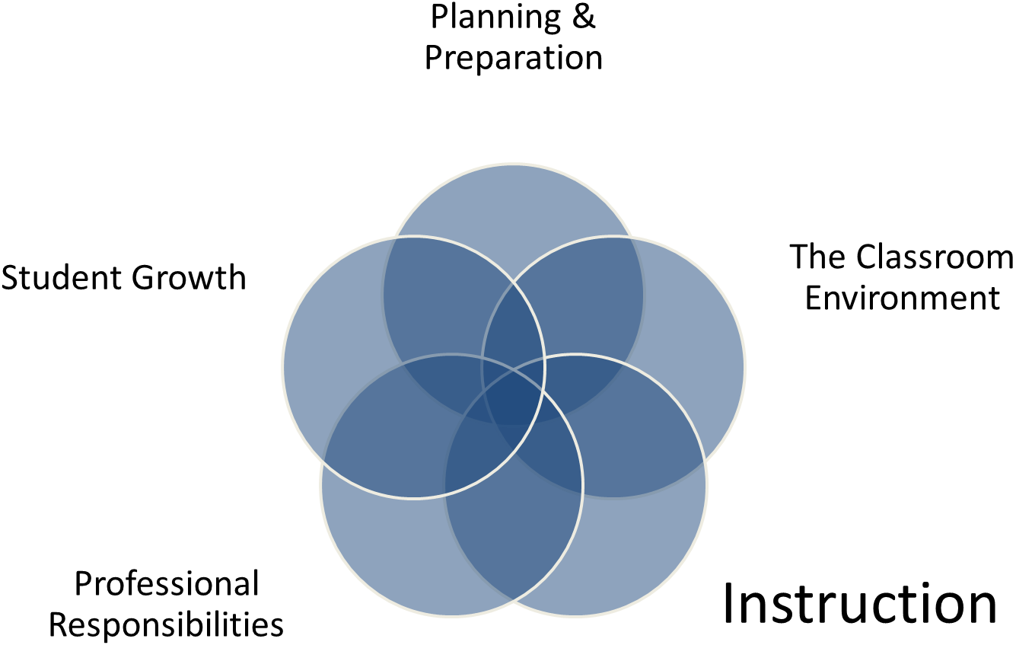

3A - Communicating with students  - Expectations for Learning  - Directions and Procedures  - Explanation of Content  - Use of Oral and Written Language | Teachers communicate with students for several independent, but related purposes. First they convey that teaching and learning are purposeful activities; they make that purpose clear to students. They also provide clear directions for classroom activities, so that students know what it is that they are to do. When teachers present concepts and information, those presentations are made with accuracy, clarity, and imagination; when expanding upon the topic is appropriate to the lesson, skilled teachers embellish their explanations with analogies or metaphors, linking them to students’ interests and prior knowledge. Teachers occasionally withhold information from students (for example in an inquiry-based science lesson) to encourage them to think on their own, but what information they do convey is accurate and reflects deep understanding. And the teacher’s use of language is vivid, rich and error free, affording the opportunity for students to hear language well used and to extend their own vocabularies. Teacher presents complex concepts in ways that provide scaffolding and access to students.  Domain 3: Instruction
 | Ineffective | Developing | Accomplished | Exemplary
 | - The instructional purpose of the lesson is unclear to students, and the directions and procedures are confusing.  - The teacher’s explanation of the content contains major errors.  - The teacher’s spoken or written language contains errors.  - The teacher’s spoken or written language contains errors of grammar or syntax  - The teacher’s vocabulary is inappropriate, vague, or used incorrectly, leaving students confused. | - The teacher’s attempt to explain the instructional purpose has only limited success, and/or directions and procedures must be clarified after initial student confusion.  - The teacher’s explanation of the content may contain minor errors; some portions are clear; other portions are difficult to follow.  - The teacher’s explanation consists of a monologue, with no invitation to the students for intellectual engagement.  - Teacher’s spoken language is correct; however, his or her vocabulary is limited, or not fully appropriate to the students’ ages or backgrounds. | - The teacher clearly communicates instructional purpose of the lesson, including where it is situated within the broader learning, and explains procedures and directions clearly.  - Teacher’s explanation of content is well scaffolded, clear and accurate, and connects with students’ knowledge and experience.  - During the explanation of content, the teacher invites student intellectual engagement.  - Teacher’s spoken and written language is clear and correct and uses vocabulary appropriate to the students’ ages and interests. | - The teacher links the instructional purpose of the lesson to the students’ interests; the directions and procedures are clear and anticipate possible student misunderstanding.  - The teacher’s explanation of content is thorough and clear, developing conceptual understanding through artful scaffolding and connecting with students’ interest.  - Students contribute to extending the content and help explain concepts to their classmates.  - The teacher’s spoken and written language is expressive, and the teacher finds opportunities to extend students’ vocabularies.
Critical Attributes | - At no time during the lesson does the teacher convey to the student what they will be learning.  - Students indicate through their questions that they are confused about the learning task.  - The teacher makes a serious content error that will affect students’ understanding of the lesson.  - Students indicate through body language or questions that they don’t understand the content being presented.  - Teacher’s communications include errors of vocabulary or usage.  - The teacher’s vocabulary is inappropriate to the age or culture of the students. | - The teacher refers in passing to what the students will be learning, or has written it on the board with no elaboration or explanation.  - The teacher must clarify the learning task so that student can complete it.  - The teacher makes no serious content errors but may make a minor error.  - The teacher’s explanation of the content consists of monologue or is purely procedural, with minimal participation by students.  - Vocabulary and usage are correct but unimaginative.  - Vocabulary is too advanced or too juvenile for the students. | - The teacher states clearly, at some point during the lesson, what the students will be learning.  - If the tactic is appropriate, the teacher models the process to be followed in the task.  - Students engage with the learning task, indicating that they understand what they are to do.  - The teacher makes no content errors.  - The teacher’s explanation of content is clear and invites student participation and thinking.  - The teacher’s vocabulary and usage are correct and completely suited to the lesson.  - The teacher’s vocabulary is appropriate to the students’ ages and levels of development.  Domain 3: Instruction | In addition to the characteristics of “accomplished”:  - The teacher points out possible areas of misunderstanding.  - Teacher explains content clearly and imaginatively, using metaphors and analogies to bring content to life.  - All students seem to understand the presentation.  - The teacher invites student to explain the content to the class or to classmates.  - Teacher uses rich language, offering brief vocabulary lessons where appropriate.
Possible Examples | - A student asks: “What are we supposed to be doing? But the teacher ignores the question.  - The teacher states that to add fractions they must have the same numerator.  - Students have a quizzical look on their faces; some may withdraw from the lesson.  - Students become disruptive, or talk among themselves in an effort to follow the lesson.  - The teacher uses technical terms with an elementary class without explaining their meanings.  - The teacher tends to say “ain’t.” | - The teacher mispronounces some common words.  - The teacher says: “And oh, by the way, today we’re going to factor polynomials.”  - A student asks: “What are we supposed to be doing?” and the teacher clarifies the task.  - Students ask, “What do I write here?” in order to complete a task.  - Having asked students only to listen, the teacher says: “Watch me while I show you how to. . .”  - A number of students do not seem to be following the explanation.  - Students are inattentive during the teacher’s explanation of content. | - The teacher says, “By the end of today’s lesson, you’re all going to be able to factor different types of polynomials.”  - In the course of a presentation of content, the teacher asks students: “Can anyone think of an example of that?”  - The teacher uses a board or projection device so students can refer to it without requiring the teacher’s attention. | - The teacher says: “Here’s a spot where some students have difficulty . . . be sure to read it carefully.”  - The teacher asks a student to explain the task to other students.  - When help is needed a student offers clarification about the learning task to classmates.  - The teacher explains passive solar energy by inviting student to think about the temperature in a closed car on a cold but sunny day or by the water in a hose that has been sitting in the sun.  - The teacher says: “Who would like to explain this idea to us?”  - The teacher pauses during an explanation of civil rights movement to remind students that the prefix “in” as in “inequality,” means “not” and the prefix “un” means the same thing.

3B - Questioning and Discussion Techniques  - Quality of Questions  - Discussion Techniques  - Student Participation | Questioning and discussion are the only instructional strategies specifically referred to in the framework for teaching; this fact reflects their central importance to teachers’ practice. But in the framework it is important that questioning and discussion are used as techniques to deepen student understanding are being used rather than serving as recitation or a verbal quiz. Good teachers use divergent as well as convergent questions, framed in such a way that they invite students to formulate hypotheses, make connections, or challenge previously held views. Students’ responses to questions are valued; effective teachers are especially adept at responding to and building upon student responses and making use of their ideas. High- quality questions encourage student to make connections among concepts or events previously believed to be unrelated, and arrive at new understandings of complex material. Effective teachers also pose questions for which they do not know the answers. Even when a question has limited number of correct responses, the question, being non-formulaic, is likely to promote thinking by students. Class discussions are animated, engaging all students in important issues and in using their own language to deepen and extend their understanding. These discussions may be based on questions formulated by the students themselves.  Domain 3: Instruction  Not all questions must be at high cognitive level in order for a teacher’s performance to be rated at a high level; that is, when exploring a topic, a teacher might begin with a series of questions of low cognitive challenge to provide a review, or to ensure that everyone in the class is “on board.” Furthermore, if the questions are at a high level, but only a few students participate in the discussion, the teacher’s performance on the component cannot be judged to be at a high level. In addition, in lessons involving student in small-group work, the quality of the student’s questions and discussion in their small groups may be considered part of this component.  In order for students to formulate high-level questions, they must have learned how to do so. Therefore, high-level questions from students, either in the full class, or in small group discussions, provide evidence that these skills have been taught.
 | Ineffective | Developing | Accomplished | Exemplary
 | - Teacher’s questions are of low cognitive challenge, require single correct responses, and are asked in rapid succession.  - Interaction between teacher and students is predominantly recitation style, with the teacher mediating all questions and answers.  - A few students dominate the discussion. | - Teacher’s questions lead students through a single path of inquiry, with answers seemingly determined in advance.  - Alternatively, the teacher attempts to frame some questions designed to promote student thinking and understanding, but only a few students are involved.  - Teacher attempts to engage all students in the discussion and to encourage them to respond to one another, but with uneven results. | - Although the teacher may use some low-level questions, he or she asks the students questions designed to promote thinking and understanding.  - Teacher creates a genuine discussion among students, providing adequate time for students to respond and stepping aside when appropriate.  - Teacher successfully engages most students in the discussion, employing a range of strategies to ensure that most students are heard. | - Teacher uses a variety or series of questions or prompts to challenge students cognitively, advance high-level thinking and discourse, and promote metacognition.  - Students formulate many questions, initiate topics, and make unsolicited contributions.  - Students themselves ensure that all voices are heard in the discussion.
Critical Attributes | - Questions are rapid-fire, and convergent with a single correct answer.  - Questions do not invite student thinking.  - All discussion is between teacher and students; students are not invited to speak directly to one another.  - A few Students dominate the discussion. | - Teacher frames some questions designed to promote student thinking, but only a small number of students are involved.  - The teacher invites students to respond directly to one another’s ideas, but few students respond.  - Teacher calls on many students, but only a few actually participate in the discussion. | - Teacher uses open-ended questions, inviting students to think and/or offer multiple possible answers.  - The teacher makes effective use of wait time.  - The teacher effectively builds on student responses to questions.  - Discussions enable students to talk to one another without ongoing mediation by the teacher.  - The teacher calls on most students, even those who don’t initially volunteer.  - Many students actively engage in the discussion.  Domain 3: Instruction | In addition to the characteristics of “accomplished”:  - Students initiate higher-order questions.  - Students extend the discussion, enriching it.  - Students invite comments from their classmates during a discussion.
Possible Examples | - All questions are of the “recitation” type such as “What is 3 x 4?”  - The teacher asks a questions for which the answer is on the board; students respond by reading it.  - The teacher calls only upon students who have their hands up. | - Many questions are of the “recitation” type, such as “How many members of the House of Representatives are there?”  - The teacher asks: “Who has an idea about this?” but only the usual three students offer comments.  - The teacher asks: “Michael can you comment on Mary’s idea?” but Michael does not respond or makes a comment directly to the teacher. | - The teacher asks: “What might have happened if the colonists had not prevailed in the American war for independence?”  - The teacher uses the plural form in asking questions, such as “What are some things you think might contribute to . . .?”  - The teacher asks; “Michael, can you comment on Mary’s idea?” and Michael responds directly to Mary.  - After posing a question and asking each of the students to write a brief response and then share it with a partner, the teacher invites a few to offer their ideas to the entire class. | - A student asks, “How many ways are there to get this answer?”  - A student says to a classmate: “I don’t think I agree with you on this, because . . .”  - A student asks of other students: “Does anyone have another idea how we might figure this out?”  - A student asks, “What if . . .?”

3C - Engaging Students in Learning  - Activities and Assignments  - Grouping of Students  - Instructional Materials and Resources  - Structure and Pacing | Student engagement in learning is the centerpiece of the framework for teaching; all other components contribute to it. When students are engaged in learning, they are not merely “busy,” nor are they “on task.” The critical distinction between a classroom in which students are compliant and busy and one in which they are engaged is that the latter students are developing their understanding through what they do. That is, they are engaged in discussing, debating, answering “what if?” questions, discovering patterns, and the like. They may be selecting their work from a range of (teacher-arranged) choices and making important contributions to the intellectual life of the class. Such activities don’t typically consume the entire lesson, but they are essential components of engagement.  Domain 3: Instruction  A lesson in which students are engaged usually has a discernible structure: a beginning, a middle, and an end, with scaffolding provided by the teacher or by the activities themselves. The teacher organizes student tasks to provide cognitive challenge and then encourages students to reflect on what they have done and what they have learned. This is, the lesson has closure, in which students derive the important learning from their own actions. A critical question for an observer in determining the degree of student engagement is “What are the students being asked to do?” If the answer to that question is that they are filling in blanks on a worksheet or performing a rote procedure, they are unlikely to be cognitively engaged.  In observing a lesson it is essential no only to watch the teacher but also pay close attention to the students and what they are doing. The best evidence for student engagement is what students are saying and doing as a consequence of what the teacher does, or has done, or has planned.
 | Ineffective | Developing | Accomplished | Exemplary
 | - The learning tasks and activities, materials, resources, instructional groups and technology are poorly aligned with the instructional outcomes or require only rote responses.  - The pace of the lesson is too slow or too rushed.  - Few students are intellectually engaged or interested. | - The learning tasks and activities are partially aligned with the instructional outcomes but require only minimal thinking by students, allowing most to be passive or merely compliant.  - The pacing of the lesson may not provide students the time needed to be intellectually engaged. | - The learning tasks and activities are aligned with instructional outcomes and designed to challenge student thinking, the result being that most students display active intellectual engagement with important and challenging content and are supported in that engagement by teacher scaffolding.  - The pacing of the lesson is appropriate, providing most students the time needed to be intellectually engaged. | - Virtually all students are intellectually engaged in challenging content through well-designed learning tasks and suitable scaffolding by the teacher and fully aligned with the instructional outcomes.  - In addition, there is evidence of some student initiation of inquiry and of student contribution to the exploration of important content.  - The pacing of the lesson provides students the time needed to intellectually engage with and reflect upon their learning and to consolidate their understanding.  - Students may have some choice in how they complete tasks and may serve as resources for one another.
Critical Attributes  Critical Attributes (cont.) | - Few students are intellectually engaged in the lesson.  - Learning tasks require only recall or have a single correct response or method.  - The materials used ask students to perform only rote tasks.  - Only one type of instructional group is used (whole group, small groups) when variety would better serve the instructional purpose.  - Instructional materials used are unsuitable to the lesson and/or students.  - The lesson drags or is rushed. | - Some students are intellectually engaged in the lesson.  - Learning tasks are a mix of those requiring thinking and recall.  - Students are in large part passively engaged with the content, learning primarily facts or procedures.  - Students have no choice in how they complete tasks.  - The teacher uses different instructional groupings; these are partially successful in achieving the lesson objectives.  - The materials and resources are partially aligned to the lesson objectives and only in some cases demand student thinking.  Domain 3: Instruction  - The pacing of the lesson is uneven- suitable in parts, but rushed or dragging in others. | - Most students are intellectually engaged in the lesson.  - Learning tasks have multiple correct responses or approaches and/or demand higher-order thinking.  - Students have some choice in how they complete learning tasks.  - There is a mix of different types of groupings, suitable to the lesson objectives.  - Materials and resources support the learning goals and require intellectual engagement, as appropriate.  - The pacing of the lesson provides students the time needed to be intellectually engaged. | In addition to the characteristics of “accomplished”:  - Virtually all students are highly engaged in the lesson.  - Students take initiative to modify a learning task to make it more meaningful or relevant to their needs.  - Students suggest modifications to the grouping patterns used.  - Students have extensive choice in how they complete tasks.  - Students suggest modifications or additions to materials being used.  - Students have the opportunity for both reflection and closure after the lesson to consolidate their understanding.
Possible Examples | - Students are able to fill out the worksheet without fully understanding what it’s asking them to do.  - The lesson drags or feels rushed.  - Students complete “busy work” activities. | - Students are asked to fill in a worksheet, following an established procedure.  - There is a recognizable beginning, middle and end to the lesson.  - Parts of the lesson have a suitable pace: other parts drag or feel rushed. | - Students are asked to formulate a hypothesis about what might happen if the American voting system allowed for the direct election of presidents.  - Students are given a task to do independently, then to discuss with a table group, and then to report out from each table.  - There is a clear beginning, middle and end to the lesson.  - The lesson neither rushes or drags. | - Students are asked to write an essay “in the spirit of Hemmingway.”  - A student asks whether they might remain in their small groups to complete another section of the activity, rather than work independently.  - Students identify or create their own learning materials.  - Students summarize their learning from the lesson.

3D - Using Assessment in Instruction  - Assessment Criteria  - Monitoring of Student Learning  - Feedback to Students  - Student Self-Assessment and Monitoring of Progress | Assessment of student learning plays an important role in instruction; no longer does it signal the end of instruction; it is now recognized to be an integral part of instruction. While assessment for learning has always been and will continue to be an important aspect of teaching (It’s important for teachers to know whether students have learned what was intended), assessment for learning has increasingly come to play an important role in classroom practice. And in order to assess student learning for the purposes of instruction, teachers must have their “fingers on the pulse” of a lesson, monitoring student understanding and, where appropriate, offering feedback to students.  Domain 3: Instruction
 | Ineffective | Developing | Accomplished | Exemplary
 | - There is little or no assessment or monitoring of student learning; feedback is absent or of poor quality.  - Students do not appear to be aware of the assessment criteria and do not engage in self-assessment. | - Assessment is used sporadically by teacher and/or students to support instruction through some monitoring of progress in learning.  - Feedback to students is general, students appear to be only partially aware of the assessment criteria used to evaluate their work, and few assess their own work. | - Assessment is used regularly by teacher and/or students during the lesson through monitoring of learning progress and results in accurate, specific feedback that advances learning.  - Students appear to be aware of the assessment criteria; some of them engage in self-assessment  - Questions, prompts, assessments are used to diagnose evidence of learning. | - Assessment is fully integrated into instruction through extensive use of formative assessment.  - Students appear to be aware of, and there is some evidence that they have contributed to, the assessment criteria  - Students self-assess and monitor their progress.  - A variety of feedback, from both their teacher and their peers, is accurate, specific, and advances learning.  - Questions, prompts, assessments are used regularly to diagnose evidence of learning by individual students.
Critical Attributes | - The teacher gives no indication of what high-quality work looks like.  - The teacher makes no effort to determine whether students understand the lesson.  - Feedback is only global.  - The teacher does not ask students to evaluate their own classmates work. | - There is little evidence that the students understand how their work will be evaluated.  - Teacher monitors understanding through a single method, or without eliciting evidence of understanding from all students.  - Teacher requests global indications of student understanding.  - Feedback to students is not uniformly specific and not oriented towards future improvement of the work.  - The teacher makes only minor attempts to engage students in self-assessment or peer assessment. | - Students indicate that they clearly understand the characteristics of high-quality work.  - The teacher elicits evidence of student understanding during the lesson. Students are invited to assess their own work and make improvements.  - Feedback includes specific and timely guidance, at least for groups of students.  - The teacher attempts to engage students in self-assessment or peer assessment. | In addition to the characteristics of “accomplished”:  - There is evidence that students have helped establish the evaluation criteria.  - Teacher monitoring of student understanding is sophisticated and continuous: the teacher is constantly “taking the pulse” of the class.  - Teacher makes frequent use of strategies to elicit information about individual student understanding.  - Feedback to students is specific and timely, and is provided from many sources including other students.  - Students monitor their own understanding, either on their own initiative or as a result of tasks set by their teacher.
Possible Examples  Possible Examples (cont.) | - A student asks: “How is this assignment going to be graded?”  - A student asks, “Does this quiz count towards my grade?”  - The teacher forges ahead with a presentation without checking for understanding.  - The teacher says: “Good job, everyone.” | - Teacher asks: “Does anyone have a question?”  - When a student completes a problem on the board, the teacher corrects the student’s work without explaining why.  - The teacher, after receiving a correct response from one student, continues without ascertaining whether all students understand the concept.  Domain 3: Instruction | - The teacher circulates during small group or independent work, offering suggestions to groups of students.  - The teacher uses a specifically formulated question to elicit evidence of student understanding.  - The teacher asks student to look over their papers to correct their errors | - The teacher reminds students of the characteristics of high-quality work (the assessment criteria), suggesting that the students themselves helped develop them.  - While students are working, the teacher circulates, providing substantive feedback to individual students.  - The teacher uses exit tickets to elicit evidence of individual student understanding.  - Students offer feedback to their classmates on their work.  - Students evaluate a piece of their writing rubric and confer with the teacher about how it could be improved.

3E - Demonstrating Flexibility and Responsiveness  - Lesson Adjustment  - Response to Students  - Persistence | “Flexibility and responsiveness” refers to a teacher’s skill in making adjustments in a lesson to respond to changing conditions. When a lesson is well planned, there may be no need for changes during the course of the lesson itself. Shifting the approach in midstream in not always necessary; in fact, with experience comes skill in accurately predicting how a lesson will go and readiness for different possible scenarios. But even the most-skilled and best-prepared teachers will on occasion find that either a lesson is not going as they would like or that a teachable moment has presented itself. They are ready to respond to such situations. Furthermore, teachers who are committed to the learning of all students persist in their attempts to engage each student in learning, even when confronted with initial setbacks.  Domain 3: Instruction
 | Ineffective | Developing | Accomplished | Exemplary
 | - Teacher adheres to the instruction plan in spite of evidence of poor student understanding or lack of interest.  - Teacher ignores student questions; when students experience difficulty, the teacher blames the students or their home environment. | - Teacher attempts to modify the lesson when needed and to respond to student questions and interests, with moderate success.  - Teacher accepts responsibility for student success but has only a limited repertoire of strategies to draw upon. | - Teacher promotes the successful learning of all students, making minor adjustments as needed to instruction plans and accommodating student questions, needs, and interests.  - Drawing on a broad repertoire of strategies, the teacher persists in seeking approaches for students who have difficulty learning. | - Teacher seizes an opportunity to enhance learning, building on a spontaneous event or student interests, or successfully adjusts and differentiates instruction to address individual student misunderstandings.  - Teacher persists in seeking effective approaches for students who need help, using an extensive repertoire of instructional strategies and soliciting additional resources from the school or community.
Critical Attributes | - Teacher ignores indications of student boredom or lack of understanding.  - Teacher brushes aside student questions  - Teacher makes no attempt to incorporate student interests into the lesson.  - The teacher conveys to students that when they have difficulty learning it is their fault.  - In reflecting on practice, the teacher does not indicate that it is important to reach all students. | - Teacher’s efforts to modify the lesson are only partially successful.  - Teacher makes perfunctory attempts to incorporate student questions and interests in the lesson.  - The teacher conveys a sense to students of their own responsibility for their learning but is uncertain about how to assist them.  - In reflecting on practice, the teacher indicates the desire to reach all students but does not suggest strategies to do so. | - When necessary, the teacher makes adjustments to the lesson to enhance understanding by groups of students.  - Teacher incorporates students’ interests and questions into the heart of the lesson.  - The teacher conveys to students that s/he has other approaches to try when the students experience difficulty.  - In reflecting on practice, the teacher cites multiple approaches undertaken to reach students having difficulty. | In addition to the characteristics of “accomplished”:  - The teacher’s adjustments to the lesson are designed to assist individual students.  - Teacher seizes on a teachable moment to enhance a lesson.  - The teacher conveys to students that s/he won’t consider a lesson “finished” until every student understands and that s/he has a broad range of approaches to use.  - In reflecting on practice, the teacher can cite others in the school and beyond whom s/he has contacted for assistance in reaching some students.
Possible Examples | - The teacher says: “We don’t have time for that today.”  - The teacher makes no attempt to adjust the lesson when students appear confused.  - The teacher says: “If you’d just pay attention, you could understand this.” | - The teacher says: “I’ll try to think of another way to come at this and get back to you.”  - The teacher says: “I realize not everyone understands this, but we can’t spend any more time on it.”  - The teacher rearranges the way the students are grouped in an attempt to help students understand the lesson. | - The teacher says: “That’s an interesting idea; let’s see how it fits.”  - The teacher illustrates a principle of good writing to a student using his interest in basketball as context.  - The teacher says: “Let’s try this way and then uses another approach.” | - The teacher stops midstream in a lesson, and says: “This activity doesn’t seem to be working! Here’s another way I’d like you to try it.”  - The teacher incorporates the school’s upcoming championship game into an explanation of averages.  - The teacher says: “If we have to come back to this tomorrow, we will; it’s really important that you understand it.”
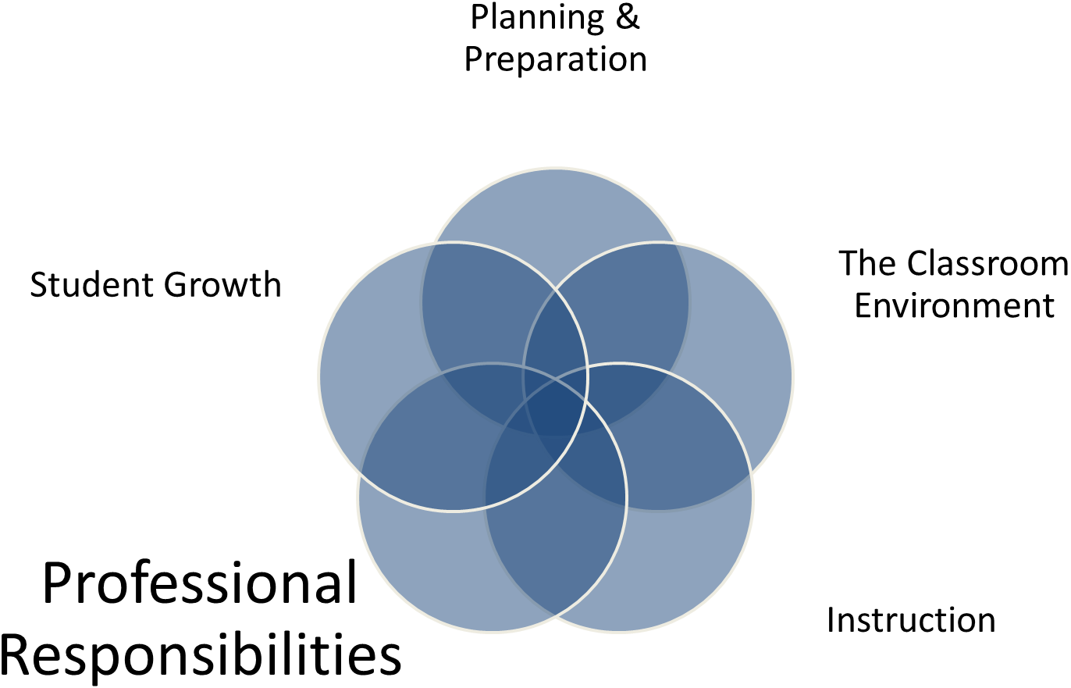
4A - Reflecting on Teaching  - Accuracy  - Use in Future Teaching | Reflecting on teaching encompasses the teacher’s thinking that follows any instructional event – an analysis of the many decisions made both in planning and implementation of a lesson. By considering these elements in light of the impact they had on student learning, teachers can determine where to focus their efforts in making revisions and what aspects of the instruction they will continue in future lessons. Teachers may reflect on their practice through collegial conversations, journal writing, examining student work, informal observations and conversations with students, or simply thinking about their teaching. Reflecting with accuracy, specificity, and ability to use what has been learned in future teaching is a learned skill; mentors, coaches, and supervisors can help teachers acquire and develop the skill of reflecting on teaching through supportive and deep questioning. Over time, this way of thinking and analyzing instruction through the lens of student learning becomes a habit of mind, leading to improvement in teaching and learning.  Domain 4: Professional Responsibilities
 | Ineffective | Developing | Accomplished | Exemplary
 | - Teacher does not know whether a lesson was effective or achieved its instructional outcomes, or he/she profoundly misjudges the success of a lesson  - Teacher has no suggestions for how a lesson could be improved. | - Teacher has a generally accurate impression of a lesson’s effectiveness and the extent to which instructional outcomes were met.  - Teacher makes general suggestions about how a lesson could be improved. | - Teacher makes an accurate assessment of a lesson’s effectiveness and the extent to which it achieved its instructional outcomes and can cite general references to support the judgment.  - Teacher makes a few specific suggestions of what could be tried another time the lesson is taught. | - Teacher makes a thoughtful and accurate assessment of a lesson’s effectiveness and the extent to which it achieved its instructional outcomes, citing many specific examples from the lesson and weighing the relative strengths of each.  - Drawing on an extensive repertoire of skills, teacher offers specific alternative actions, complete with the probable success of different courses of action.
Critical Attributes | - The teacher considers the lesson but draws incorrect conclusions about its effectiveness.  - The teacher makes no suggestions for improvement. | - The teacher has a general sense of whether or not instructional practices were effective.  - The teacher offers general modifications for future instruction. | - The teacher accurately assesses the effectiveness of instructional activities used.  - The teacher identifies specific ways in which a lesson might be improved. | In addition to the characteristics of “accomplished”:  - Teacher’s assessment of the lesson is thoughtful and includes specific indicators of effectiveness.  - Teacher’s suggestions for improvement draw on an extensive repertoire.
Possible Examples | - Despite evidence to the contrary, the teacher says, “My students did great on that lesson!”  - The teacher says: “That was awful; I wish I knew what to do!” | - At the end of the lesson the teacher says,  “I guess that went okay.”  - The teacher says: “I guess I’ll try X next time.” | - The teacher says: “I wasn’t pleased with the level of engagement of the students.”  - The teacher’s journal indicates several possible lesson improvements. | - The teacher says: “I think that lesson worked pretty well, although I was disappointed in how the group at the back table performed.”  - In conversation with colleagues, the teacher considers different group strategies for improving a lesson.

4B - Maintaining Accurate Records  - Student Completion of Assignments  - Student Progress in Learning  - Non-Instructional Records | An essential responsibility of professional educators is keeping accurate records of both instructional and noninstructional events. This record keeping includes student completion of assignments, student progress in learning, and records of noninstructional activities that are part of the day-to-day functions in a school setting, including such things as the return of signed permission slips for a field trip and money for school pictures. Proficiency in this component is vital because these records inform interactions with students and parents and allow teachers to monitor learning and adjust instruction accordingly. The methods of keeping records vary as much as the type of information that is being recorded. For example, records of formal assessments may be recorded electronically with the use of spreadsheets and databases that allow for item analysis and individualized instruction. A less formal means of keeping track of student progress may include anecdotal notes that are kept in student folders.  Domain 4: Professional Responsibilities
 | Ineffective | Developing | Accomplished | Exemplary
 | - Teacher’s system for maintaining information on student completion of assignments and student progress in learning is nonexistent or in disarray.  - Teacher’s records for noninstructional activities are in disarray, resulting in errors and confusion. | - Teacher’s system for maintaining information on student completion of assignments and student progress in learning is rudimentary and only partially effective.  - Teacher’s records for noninstructional activities are adequate but require frequent monitoring to avoid errors. | - Teacher’s system for maintaining information on student completion of assignments, student progress in learning, and noninstructional records is fully effective. | - Teacher’s system for maintaining information on student completion of assignments, student progress in learning, and noninstructional records is fully effective.  - Students contribute information and participate in maintaining the records.
Critical Attributes | - There is no system for either instructional or noninstructional records.  - The record-keeping systems are in disarray so as to provide incorrect or confusing information. | - The teacher has a process for recording completion og student work. However, it is out of date or does not permit students to gain access to the information.  - The teacher’s process for tracking student progress is cumbersome to use.  - The teacher has a process for tracking, but not all, noninstructional information, and it may contain some errors. | - The teacher’s process for recording student work completion is efficient and effective; students have access to information about completed and/or missing assignments.  - The teacher has an efficient and effective process for recording student attainment of learning goals; student able to see how they’re progressing.  - The teacher’s process for recording noninstructional information is both efficient and effective. | In addition to the characteristics of “accomplished”:  - Students contribute to and maintain records indicating completed and overdue work assignments.  - Students both contribute and maintain data files indicating their own progress in learning.  - Students contribute to maintaining noninstructional records for the class.
Possible Examples | - A student says, “I’m sure I turned in that assignment, but the teacher lost it!”  - The teacher says, “I misplaced the writing samples for my class, but it doesn’t matter—I know what the students would have scored.”  - On the morning of the field trip, the teacher discovers that five students have never turned in their permission slips. | - A student says, “I wasn’t in school today, and my teacher’s website is out of date, so I don’t know what the assignments are.”  - The teacher says “I’ve got all these notes about how kids are doing; I should put them into the system, but I don’t have time.”  - On the morning of the field trip, the teacher frantically searches all the drawers in the desk for permission slips and finds them just before the bell rings. | - The teacher creates a link on the class website that students can access to check on any missing assignment.  - The teacher’s grade book records student progress toward learning goals.  - The teacher creates a spreadsheet for tracking which students have paid for their school pictures. | - A student from each team maintains the database of current and missing assignments for the team.  - When asked about their progress in class, a student proudly shows her data file and can explain how the documents indicate her progress toward learning goals.  - When they bring in their permission slips for a field trip, students add their own information to the database.

4C - Communicating with Families  - Information About the Instructional Program  - Information About Individual Students  - Engagement of Families in the Instructional Program | Although the ability of families to participate in their child’s learning varies widely due to other family or job obligations, it is the responsibility of teachers to provide opportunities for them to both understand the instructional program and their child’s progress. Teachers establish relationships with families by communicating to them about both the instructional program and about individual students, and they invite families to be part of the educational process itself. The level of family participation and involvement tends to be greater at the elementary level when young children are just beginning school. However, the importance of regular communication with families of adolescence cannot be overstated. A teacher’s effort to communicate with families conveys an essential caring on the part on the part of the teacher, a quality valued by families of students of all ages.  Domain 4: Professional Responsibilities
 | Ineffective | Developing | Accomplished | Exemplary
 | - Teacher communication with families—about the instructional program, about individual students—is sporadic or culturally inappropriate.  - Teacher makes no attempt to engage families in the instructional program. | - Teacher makes sporadic attempts to communicate with families about the instructional program and about the progress of individual students but does not attempt to engage families in the instructional program. Communications are one-way and not always appropriate to the cultural norms of those families. | - Teacher communicates frequently with families about the instructional program and conveys information about individual student progress.  - Teacher makes some attempts to engage families in the instructional program.  - Information to families is conveyed in a culturally appropriate manner. | - Teacher’s communication with families is frequent and sensitive to cultural traditions, with students contributing to the communication.  - Response to family concerns is handled with professional and cultural sensitivity.  - Teacher’s efforts to engage families in the instructional program are frequent and successful.
Critical Attributes | - Little or no information regarding the instructional program is available to parents.  - Families are unaware of their children’s progress.  - Family engagement activities are lacking.  - Communication is culturally inappropriate. | - School or district-created materials about the instructional program are sent home.  - Infrequent or incomplete information is sent home by teachers about the instructional program.  - Teacher maintains school-required grade book but does little else to inform families about student progress.  - Teacher communications are sometimes inappropriate to families’ cultural norms. | - Information about the instructional program is available on a regular basis.  - The teacher sends information about student progress home on a regular basis.  - Teacher develops activities designed to successfully engage families in their children’s learning, as appropriate. | In addition to the characteristics of “accomplished”:  - On a regular basis, students develop materials to inform their families about the instructional program.  - Students maintain accurate records about their individual learning progress and frequently share this information with families.  - Students contribute to regular and ongoing projects designed to engage families in the learning process.
Possible Examples | - A parent says, “I’d like to know what my kid is working on at school.”  - A parent says, “I wish I knew something about my child’s progress before the report card comes out.”  - A parent says, “I wonder why we never see any school work come home.” | - A parent says, “I received the district pamphlet on the reading program, but I wonder how it’s being taught in my child’s class.”  - A parent says, “I emailed the teacher about my child’s struggles with math, but all I got back was a note saying that he’s doing fine.”  - Weekly quizzes are sent home for parent/guardian signature. | - The teacher sends weekly newsletter home to families, including advance notice about homework assignments, current class activities, community and/or school projects, field trips, etc.  - The teacher creates a monthly progress report, which is sent home for each student.  - The teacher sends home a project that asks students to interview a family member about growing up during the 1970s. | - Students create materials for back-to-school night that outline the approach for learning science.  - Student daily reflection log describes learning and goes home each week for a response from a parent or guardian.  - Students design a project on charting family use of plastics.

4D - Participating in a Professional Community  - Relationships with Colleagues  - Involvement in a Culture of Professional Inquiry  - Service to the School  - Participation in School and District Projects | Schools are, first of all, environments to promote the learning of students. But in promoting student learning, teachers must work with colleagues to share strategies, plan joint efforts, and plan for the success of individual students. Schools are, in other words, professional organizations for teachers—organizations whose full potential is realized only when teachers regard themselves as members of a professional community. This community is characterized by mutual support and respect and by recognition of the responsibility of all teachers to be constantly seeking ways to improve their practice and to contribute to the life of the school. Inevitably, teachers’ duties extend beyond the doors of their classrooms and include activities related to the entire school and/or larger district. These activities include such things as school and district curriculum committees or engagement with the parent-teacher organization. With experience, teachers assume leadership roles in these activities.  Domain 4: Professional Responsibilities
 | Ineffective | Developing | Accomplished | Exemplary
 | - Teacher’s relationships with colleagues are negative or self-serving.  - Teacher avoids participation in a professional culture of inquiry, resisting opportunities to become involved.  - Teacher avoids becoming involved in school events or school and district projects | - Teacher maintains cordial relationships with colleagues to fulfill duties that the school or district requires.  - Teacher becomes involved in the school’s culture of professional inquiry when invited to do so.  - Teacher participates in school events and school and district projects when specifically asked to do so. | - Teacher’s relationships with colleagues are characterized by mutual support and cooperation; teacher actively participates in a culture of professional inquiry.  - Teacher volunteers to participate in school events and in school and district projects, making a substantial contribution. | - Teacher’s relationships with colleagues are characterized by mutual support and cooperation, with the teacher taking initiative in assuming leadership among the faculty.  - Teacher takes a leadership role in promoting a culture of professional inquiry.  - Teacher volunteers to participate in school events and district projects making a substantial contribution, and assuming a leadership role in at least one aspect of school or district life.
Critical Attributes | - The teacher’s relationship with colleagues is characterized by negativity or combativeness.  - The teacher purposefully avoids contributing to activities promoting professional inquiry.  - The teacher avoids involvement in school activities and school, district and community projects. | - The teacher has pleasant relationship with colleagues.  - When invited, the teacher participates in activities related to professional inquiry.  - When asked, the teacher participates in school activities, as well as school, district and community projects. | - The teacher has supportive and collaborative relationships with colleagues.  - The teacher regularly participates in activities related to professional inquiry.  - The teacher frequently volunteers to participate in school activities, as well as school, district and community projects. | In addition to the characteristics of “accomplished”:  - The teacher takes a leadership role in promoting activities related to professional inquiry.  - The teacher regularly contributes to and oversees events that positively impact school life.  - The teacher regularly contributes to and serves as head of significant school, district and community projects.
Possible Examples  Possible Examples (cont.) | - The teacher doesn’t share test-taking strategies with his colleagues. He figures that if his students do well, it will make him look good.  - The teacher does not attend PLC meetings.  - The teacher does not attend any school function after the dismissal bell.  - The teacher says, “I work from 8:30-3:30 and not a minute more. I won’t serve on any district committee unless they get a substitute to cover my class”. | - The teacher is polite but never shares any instructional materials with his grade partners.  - The teacher attends PLC meetings only when reminded by her supervisor.  - The principal says, “I wish I didn’t have to ask the teacher to “volunteer” every time we need someone to chaperone the dance.”  - The teacher contributes to the district literacy committee only when requested to do so by the principal.  Domain 4: Professional Responsibilities | - The principal remarks that the teacher’s students have been noticeably successful since her team has been focused on instructional strategies during their team meetings.  - The teacher has decided to take some of the free MIT courses online and to share his learning with colleagues.  - The basketball coach is usually willing to chaperone the 9th grade dance because she knows all of her players will be there.  - The teacher enthusiastically represents the school during the district social studies review and brings her substantial knowledge of U.S. history to the course-writing team. | - The teacher leads the “mentor” group, devoted to supporting teachers during their first years in the profession.  - The teacher hosts a book study group that meets monthly; he guides the book choices so that the group can focus on topics that will enhance their skills.  - The teacher leads the school’s annual “Olympics” day, which involves all students and faculty in athletic events.  - The teacher leads the school district’s wellness committee, which involves health-care and nutrition specialists from the community.

4E - Growing and Developing Professionally  - Enhancement of Content Knowledge and Pedagogical Skill  - Receptivity to Feedback from Colleagues  - Service to the Profession | As in other professions, the complexity of teaching requires continued growth and development in order to remain current. Conscientiousness about continuing to stay informed and increasing their skills allows teachers to become ever more effective and to exercise leadership among their colleagues. The academic disciplines themselves evolve, and educators constantly refine their understanding of how to engage students in learning; thus growth in content, pedagogy, and information technology are essential to good teaching. Networking with colleagues through such activities such as joint planning, study groups, and lesson study provides opportunities for teachers to learn from one another. These activities allow for job-embedded professional development. In addition, professional educators increase their effectiveness in the classroom by belonging to professional organizations, reading professional journals, attending educational conferences, and taking university classes. As they gain experience and expertise, educators find ways to contribute to their colleagues and to the profession.  Domain 4: Professional Responsibilities
 | Ineffective | Developing | Accomplished | Exemplary
 | - Teacher engages in no professional development activities to enhance knowledge or skill.  - Teacher resists feedback on teaching performance from either supervisors or more experienced colleagues.  - Teacher makes no effort to share knowledge with others or to assume professional responsibility. | - Teacher participates in professional activities to a limited extent when they are convenient.  - Teacher accepts, with some reluctance, feedback on teaching performance from both supervisors and colleagues.  - Teacher finds limited ways to contribute to the profession. | - Teacher seeks out opportunities for professional development to enhance content knowledge and pedagogical skill.  - Teacher welcomes feedback from colleagues—either when made by supervisors or when opportunities arise through professional collaboration.  - Teacher participates actively in assisting other educators. | - Teacher seeks out opportunity for professional development and makes a systematic effort to conduct action research.  - Teacher seeks out feedback on teaching from both supervisors and colleagues.  - Teacher initiates important activities to contribute to the profession.
Critical Attributes | - The teacher is not involved in any activity that might enhance knowledge or skill.  - The teacher purposefully resists discussing performance with supervisors or colleagues.  - The teacher ignores invitations to join professional organizations or attend conferences. | - The teacher participates in professional activities when they are required or when provided by the school district.  - The teacher reluctantly accepts feedback from supervisors and colleagues.  - The teacher contributes in a limited fashion to educational professional organizations. | - The teacher seeks regular opportunities for continued professional development.  - The teacher welcomes colleagues and supervisors into the classroom for the purpose of gaining insight from their feedback.  - The teacher actively participates in professional organizations designed to contribute to the profession. | In addition to the characteristics of “accomplished”:  - The teacher seeks regular opportunities for continued professional development, including initiating action research.  - The teacher actively seeks feedback from supervisors and colleagues.  - The teacher takes an active leadership role in professional organizations in order to contribute to the teaching profession.
Possible Examples | - The teacher never takes continuing education courses, even though the credits would increase his salary.  - The teacher endures the principal’s annual observations in her classroom, knowing that if she waits long enough, the principal will eventually leave and she will simply discard the feedback form.  - Despite teaching high school honors mathematics, the teacher declines to join NCTM because it costs too much and makes too many demands on members’ time. | - The teacher politely attends district workshops and professional development days but doesn’t make much use of the materials received.  - The teacher listens to his principal’s feedback after a lesson but isn’t sure that the recommendations really apply to his situation.  - The teacher joins the local chapter of the American Library Association because she feels she might benefit from the free book—but otherwise doesn’t feel it worth much of her time. | - The teacher eagerly attends the school district optional summer workshops, finding them to be a wealth of instructional strategies he can use during the school year.  - The teacher enjoys her principal’s weekly walk-through visits because they always lead to a valuable informal discussion during lunch the next day.  - The teacher joins a science education partnership and finds that it provides him access to resources that truly benefit his students’ conceptual understanding. | - The teacher’s principal rarely spends time observing in her classroom. Therefore, she has initiated an action research project in order to improve her own instruction.  - The teacher is working on a particular instructional strategy and asks his colleagues to observe in his classroom in order to provide objective feedback on his progress.  - The teacher founds a local organization devoted to literacy education; her leadership has inspired teachers in the community to work on several curriculum and instruction projects.
4F - Showing Professionalism  - Integrity and Ethical Conduct  - Service to Students  - Advocacy  - Decision Making  - Compliance with School and District Regulations | Expert teachers demonstrate professionalism in service both to students and to the profession. Teaching at the highest levels of performance in this component is student focused, putting students first, regardless of how this sense of priority might challenge long-held assumptions, past practices, or simply what is easier or more convenient for teachers. Accomplished teachers have a strong moral compass and are guided by what is the best interest of students. Such educators display professionalism in a number of ways. For example, they conduct their interactions with colleagues with honesty and integrity. They know their students’ needs and seek out resources in order to step in and provide help that may extend beyond the classroom. Teachers advocate for their students in ways that might challenge traditional views and the educational establishment, seeking greater flexibility in the ways school rules and policies are applied. These dedicated educators also display their professionalism in the ways they approach problem solving and decision making, with student needs in mind. Finally, teachers consistently adhere to school and district policies and procedures but are willing to work to improve those that may be outdated or ineffective.  Domain 4: Professional Responsibilities
 | Ineffective | Developing | Accomplished | Exemplary
 | - Teacher displays dishonesty in interactions with colleagues, students and the public.  - Teacher is not alert to students’ needs and contributes to school practices that result in some students’ being ill-served by the school.  - Teacher makes decisions and recommendations based on self-serving interests. Teacher does not comply with school and district regulations. | - Teacher is honest in interactions with colleagues, students and the public.  - Teacher attempts, though inconsistently, to serve students. Teacher does not knowingly contribute to some students’ being ill-served by the school.  - Teacher’s decisions and recommendations are based on limited but genuinely professional considerations. | - Teacher displays high standards of honesty, integrity, and confidentiality in interactions with colleagues, students and the public.  - Teacher is active in serving students, working to ensure that all students receive a fair opportunity to succeed.  - Teacher maintains an open mind in team or departmental decision-making.  - Teacher complies fully with school and district regulation. | - Teacher takes a leadership role with colleagues and can be counted on to hold the highest standards of honesty, integrity and confidentiality.  - Teacher is highly proactive in serving students, seeking out resources when needed. Teacher makes a concerted effort to challenge negative attitude or practices to ensure that all students, particularly those traditionally underserved, are honored in the school.  - Teacher takes a leadership role in team or departmental decision-making and helps ensure that such decisions are based on the highest professional standards.  - Teacher complies fully with school and district regulations, taking a leadership role with colleagues.
Critical Attributes | - Teacher is dishonest.  - Teacher does not notice the needs of students.  - The teacher engages in practices that are self-serving.  - The teacher willfully rejects school district regulations. | - Teacher is honest.  - Teacher notices the needs of students but is inconsistent in addressing them.  - Teacher does not notice that some school practices result in poor conditions for students.  - Teacher makes decisions professionally but on a limited basis.  - Teacher complies with school district regulations. | - Teacher is honest and known for having high standards of integrity.  - Teacher actively addresses student needs.  - Teacher actively works to provide opportunities for student success.  - Teacher willingly participates in team and departmental decision-making.  - Teacher complies completely with school district regulations. | In addition to the characteristics of “accomplished”:  - Teacher is considered a leader in terms of honesty, integrity, and confidentiality.  - Teacher is highly proactive in serving students.  - Teacher makes a concerted effort to ensure that opportunities are available for all students to be successful.  - Teacher makes a leadership role in team and departmental decision-making.  - Teacher takes a leadership role regarding school district regulations.
Possible Examples  Possible Examples (cont.) | - The teacher makes some errors when marking the last common assessment but doesn’t tell his colleagues.  - The teacher does not realize that three of her neediest students arrive at school an hour early every morning because their mother can’t afford day care.  - The teacher fails to notice that one of her kindergartners is often ill, looks malnourished, and frequently has bruises on her arms and legs.  - When one of his colleagues goes home suddenly because of illness, the teacher pretends to have a meeting so that he won’t have to share in the coverage responsibilities.  - The teacher does not file her students’ writing samples in their cum folders; doing so is time consuming, and she wants to leave early for summer break. | - The teacher says, “I have always known my grade partner to be truthful. If she called in sick, then I believe her.”  - The teacher, considering staying late to help some of her students in after-school day care, realizes doing so would conflict with her gym class and decides against staying.  Domain 4: Professional Responsibilities  - The teacher notices a student struggling in his class and sends a quick e-mail to the counselor. When he doesn’t get a response, he assumes the problem has been taken care of.  - When her grade partner goes out on maternity leave, the teacher says, “Hello” and “Welcome” to the substitute but does not offer any further assistance.  - The teacher keeps his district-required grade book up to date, but enters exactly the minimum number of assignments specified by his department chair. | - The teacher is trusted by his grade partners; they share information with him, confident it will not be repeated inappropriately.  - Despite her lack of knowledge about dance, the teacher forms a dance club at her high school to meet the high interest level of her minority students who cannot afford lessons.  - The teacher notices some speech delays in a few of her young students; she calls in the speech therapist to do a few sessions in her classroom and provide feedback on further steps.  - The English department chair says, “I appreciate when Jim attends our after-school meetings; he always contributes something meaningful to the discussion.  - The teacher learns the district’s new online curriculum mapping system and enters all of her courses. | - When the new teacher has trouble understanding directions from the principal, she immediately goes to the colleague who she can rely on for expert advice and complete discretion.  - After the school’s intramural basketball program is discontinued, the teacher finds some former student-athletes to come in and work with his students, who have come to love the after-school sessions.  - The teacher enlists the help of her principal when she realizes that a colleague has been making disparaging comments about some disadvantaged students.  - The math department looks forward to their weekly meetings; their leader, the teacher is always seeking new instructional strategies and resources for them to discuss.  - When the district adopts a new Web-based grading program, the teacher learns it inside and out so that she can assist her colleagues with its implementation.

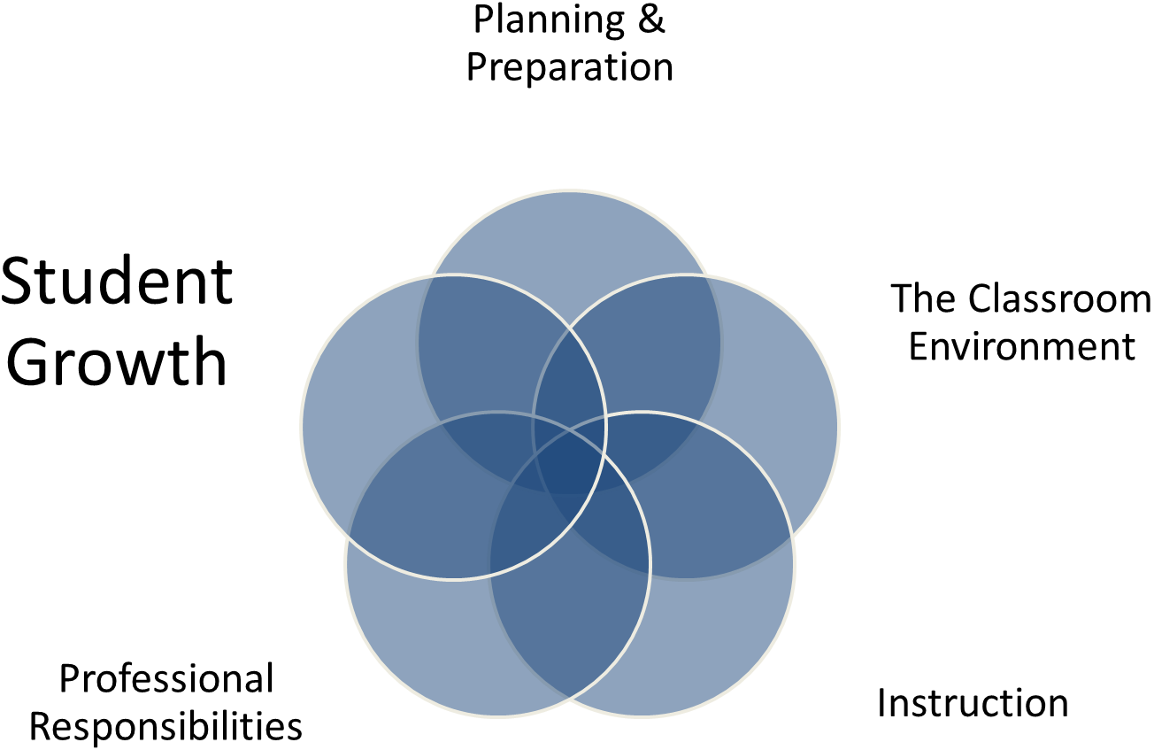

5A – Student Growth  - Student Growth Goal Setting Results  - Rigorous Student Growth Goals  - Student Growth Goal Setting Process Fidelity  - Student Growth Percentiles | The teacher contributes to the overall success of the school and the academic growth of each student, regardless of demographics (e.g., socioeconomic status, ethnicity, gender, disability, prior achievement). We know that teachers have a definite and powerful impact on student learning and academic performance. One approach to linking student growth to teacher performance involves building the capacity for teachers and their supervisors to interpret and use student data to set goals for student growth. The intent of monitoring student growth is to make explicit the connection between teaching and learning, make instructional decisions based on student data, provide a tool for school improvement, increase effectiveness of instruction through continuous professional growth, focus attention on student growth, and ultimately, increase student achievement.  Domain 5: Student Growth (For Consideration)
 | Ineffective | Developing | Accomplished | Exemplary
 | - The teacher demonstrates little or no student growth over the course of an academic year.  - The teacher makes no attempt to establish goals using the goal setting process.  - The teacher does not complete the goal setting process. | - The teacher demonstrates growth but does not meet the collaboratively established student growth goal.  - The teacher makes little effort to set rigorous goals as a part of the goal setting process.  - The teacher makes little effort to adjust strategies throughout the school year as a part of the goal setting process. | - The teacher demonstrates growth that meets or exceeds the collaboratively established student growth goal.  - The teacher sets rigorous goals as a part of the goal setting process.  - The teacher continuously monitors student progress, adjusting strategies as needed as a part of the goal setting process. | - The teacher develops and implements programs or initiatives based on student data that targets the overall success of the school.  - The teacher supports other staff in the setting of rigorous student growth goals.  - The teacher supports other staff to adjust strategies to achieve student growth goals.
Critical Attributes | - Student growth is limited.  - No evidence of goal setting process. | - Student growth is made but goal is not met.  - Student growth goal is not rigorous.  - Little evidence of strategy modification. | - Student growth is made and goal is met.  - Student growth goal is rigorous.  - Strategies to achieve student growth goal monitored and modified, as appropriate. | In addition to the characteristics of “accomplished”:  - Teacher supports other staff in their student growth goal setting process.
Possible Examples | - The teacher does not collaborate with his administrator to set a student growth goal for his World Civ class.  - The teacher sets a student growth goal that is not based on relevant data.  - The teacher says “this process is not fair for special ed students.” | - The teacher sets a goal for 80% of her students to move at least one level and score a “3” on her scoring rubric, but only 75% of her students achieve that goal.  - After reviewing mid-term data, the teacher maintains the original strategies despite the fact that students are not making adequate progress to meet the goal.  - The teacher’s goal is for 25% of his students to score a “3” or higher on the AP Chemistry assessment. | - The teacher sets a goal for 85% of her students to pass the computer programming certification assessment and 92% actually pass the assessment.  - The teacher realizes that he needs to add additional MAP math modules to meet the targeted needs of his student, John Smith. | - The teacher begins a student mentoring program that is driven by student data.  - The teacher works with colleagues through PLC’s to review and set rigorous goals.
* applies only to reading and math K-PREP assessment in grades 4-8

Teacher Name: |  | EPSB Number: |  | School:

 |  |  |  |  | Observation/Observable Domain Ratings
 | Formal Observation 1 |  |  |  | Mini Observation 1 |  |  |  | Formal Observation 2 |  |  |  | Mini Observation 2 |  |  |  | Optional Observation |  |  |  | Optional Observation |  |  |  | Overall Rating
 | Date: |  |  |  | Date: |  |  |  | Date: |  |  |  | Date: |  |  |  | Date: |  |  |  | Date:
Domain 2: The Classroom Environment
A: Creating an Environment of Respect and Rapport | I | D | A | E | I | D | A | E | I | D | A | E | I | D | A | E | I | D | A | E | I | D | A | E | I | D | A | E
B: Establishing a Culture for Learning | I | D | A | E | I | D | A | E | I | D | A | E | I | D | A | E | I | D | A | E | I | D | A | E | I | D | A | E
C: Managing Classroom Procedures | I | D | A | E | I | D | A | E | I | D | A | E | I | D | A | E | I | D | A | E | I | D | A | E | I | D | A | E
D: Managing Student Behavior | I | D | A | E | I | D | A | E | I | D | A | E | I | D | A | E | I | D | A | E | I | D | A | E | I | D | A | E
E: Organizing Physical Space | I | D | A | E | I | D | A | E | I | D | A | E | I | D | A | E | I | D | A | E | I | D | A | E | I | D | A | E
Overall Domain Rating: |  |  |  |  |  |  |  |  |  |  |  |  |  |  |  |  |  |  |  |  |  |  |  |  | I | D | A | E
Domain 3: Instruction
A: Communicating with Students | I | D | A | E | I | D | A | E | I | D | A | E | I | D | A | E | I | D | A | E | I | D | A | E | I | D | A | E
B: Using Questioning and Discussion Techniques | I | D | A | E | I | D | A | E | I | D | A | E | I | D | A | E | I | D | A | E | I | D | A | E | I | D | A | E
C: Engaging Students in Learning | I | D | A | E | I | D | A | E | I | D | A | E | I | D | A | E | I | D | A | E | I | D | A | E | I | D | A | E
D: Using Assessment in Instruction | I | D | A | E | I | D | A | E | I | D | A | E | I | D | A | E | I | D | A | E | I | D | A | E | I | D | A | E
E: Demonstrating Flexibility | I | D | A | E | I | D | A | E | I | D | A | E | I | D | A | E | I | D | A | E | I | D | A | E | I | D | A | E
Overall Domain Rating |  |  |  |  |  |  |  |  |  |  |  |  |  |  |  |  |  |  |  |  |  |  |  |  | I | D | A | E

Domain 1: Planning and Preparation |  |  |  |  |  | On-Going Evidence Collection
A: Demonstrating Knowledge of Content and Pedagogy | I | D | A | E
B: Demonstrating Knowledge of Students | I | D | A | E
C: Selecting Instructional Outcomes | I | D | A | E
D: Demonstrating Knowledge of Resources | I | D | A | E
E: Designing Coherent Instruction | I | D | A | E
F: Designing Student Assessment | I | D | A | E
Overall Domain Rating | I | D | A | E
Domain 4: Professional Responsibilities
A: Reflecting on Teaching | I | D | A | E
B: Maintaining Accurate Records | I | D | A | E
C: Communicating with Families | I | D | A | E
D: Participating in a Professional Community | I | D | A | E
E: Growing and Developing Professionally | I | D | A | E
F: Demonstrating Professionalism | I | D | A | E
Overall Domain Rating | I | D | A | E
Domain 5: Student Growth
A: Student Growth | I | D | A | E
Overall Domain Rating | I | D | A | E
Non-Observable Domain Ratings
Teacher Name:
EPSB Number:
School:

Framework for Teaching Component | Kentucky Teacher Standard  Important Document Crosswalk | Characteristics of Highly Effective Teaching and Learning | Interstate Teacher Assessment and Support Continuum (InTASC)
1A | Standard 1 Part 1, 1.2,1.3, 1.4, 2.1, 2.2 | Section 5 Characteristic A, 5B, 5D | Standard 4
1B | 1.2, 2.2, 3.3, 4.2, 5.4 | 1C, 4B, 4C | 1, 2, 7
1C | 1.1, 2.1, 2.3, 2.4, 2.5, 3.3, 4.1, 4.2, 4.5 | 1D, 2E, 3I | 1
1D | 4.3, 4.4, 6.1, 6.3, 6.4 | 1F, 3F, 4D, 4G
1E | 1.3, 2.4, 2.5, 3.3, 4.1, 4.2, 4.5, 5.6,6.1, 6.2 | 1H, 3A, 3B, 3D, 3E, 4A, 4D, 5C, 5F | 1, 4, 7
1F | 1.1, 1.5, 2.3, 3.1, 5.1, 5.2, 5.3, 5.4, 5.5, 5.6, 7.1, 7.2, 7.3 | 2A, 2B, 2C, 2D | 6
2A | 1.2, 3.1, 3.2, 3.3, 3.4, 3.5, 6.5 | 1B | 3
2B | 3.1, 3.2, 3.3, 3.4, 3.5, 4.1, 4.5 | 1A, 2F
2C | 3.2, 3.4, 3.5, 4.3, 4.4 | 1E, 1G
2D | 3.4, 3.5 | 1G
2E | 4.4, 6.2, 6.3, 6.4 | 1B
3A | 1.1, 1.2, 1.3, 1.4, 1.5,2.5, 3.2, 4.1, 4.3, 4.5 | 3B, 3I | 5
3B | 3.2, 3.3, 3.4, 3.5, 4.1, 4.5, 5.6 | 3C, 3E, 3G | 8
3C | 1.3, 2.4, 3.2, 3.3, 3.5, 4.1, 5.6 | 3H, 5E | 1, 3, 4, 5, 8
3D | 1.3, 2.3, 3.5, 5.2, 5.4, 5.5, 5.6 | 1D, 1I, 2A, 2B, 2C, 2D, 2I, 2J | 6
3E | 1.2, 1.3, 1.4, 2.2, 2.4, 2.5, 4.1, 4.2 |  | 5
4A | 7.1, 7.2, 7.3, 9.4 | 2A, 2B, 2C | 9
4B
4C | 5.5, 8.1, 8.2, 8.3, 8.4 | 2G | 10
4D | 10.1 |  | 10
4E | 9.1, 9.2, 9.3, 9.4, 10.1, 10.2, 10.3 | 4F | 9
4F | 8.1 |  | 9, 10
5A

