Making an Assignment “Live”
- Log into Google Classroom. (https://classroom.google.com/)
- Select your class.
- Click the Drop-Down to view Saved Posts.
- Tip: You may need to click “View All” to see the list of all assignments.
- Click on the assignment you wish to assign.
- Click the Blue Assign and now the assignment is live. 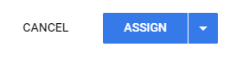
- Now go back and do the same for each class (if needed).

