|  |  |
| --- | --- |
| **1. First, go to** [**http://schools.mealviewer.com/**](http://schools.mealviewer.com/)  **Next, type your school, district, zip, or city name and hit the search button** | **2. Select a school to see the menus for that school. You can add schools to create a list of favorites.** |
| **3.** **This will bring you to the schools calendar view where you can view the entire month at a glance. You may toggle instantly between breakfast and lunch with one click. You may also click the print option to bring up a PDF option to print or save.** | **4. Click the star on the top left-hand side of the page to add this school to your favorites. Look for the star beside the magnifying glass on the top right-hand side of the page to access your list of favorite schools at any time.** |
| **5. You may also click any of the listed allergens to display the menu items in red that contain those ingredients. This is important for students with special dietary requirements.** | **6. Another neat option is to filter by which serving line you prefer. You can choose to show all options or only your preferred options.** |

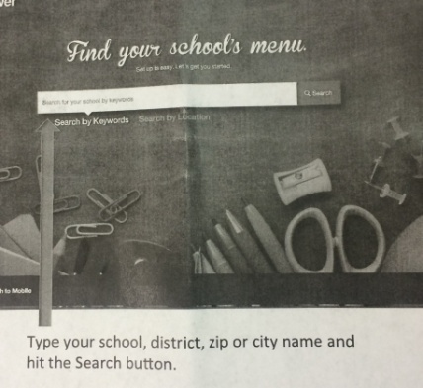

***Find out more about food and nutrition at Allen County Schools***

|  |  |
| --- | --- |
| **Now let’s learn how to access more information regarding your child’s school nutrition via the MealViewer phone app. It’s easy!** | **1. Just type the name of your city, state, or school in the search bar. Then hit the search button!** |
| **2. Next, select your school from the search results…** | **3. Click here to add this school to your favorites. Now it will be available on demand.** |
| **Other functions include:**  **Swipe left or right to view other calendar dates**  **Click breakfast to view the breakfast menu**  **Click the entrée items to view their description and nutritional information** | **You may also click a star next to any entrée item to mark it as a favorite. Favorites will be moved to the top whenever they are served** |