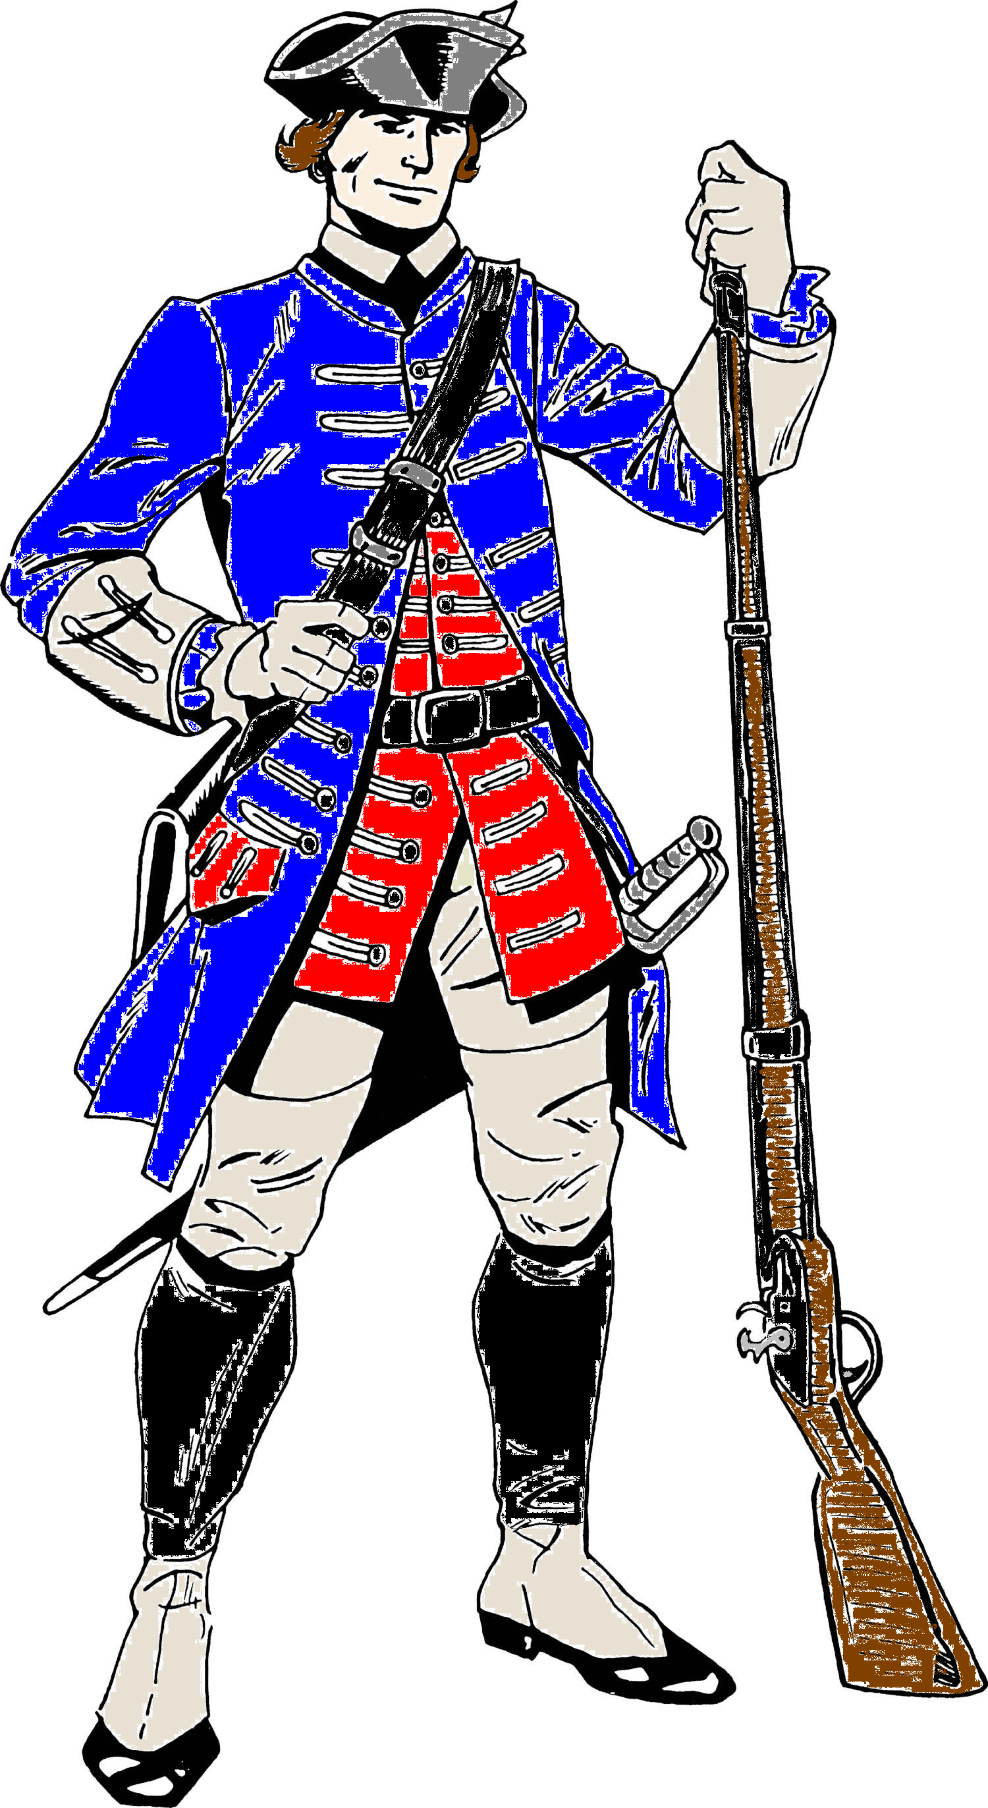

**Instructional Goals**

**Certified For Life**

**Patriots are**

**Allen County Schools**

**Windows of Common Practice**

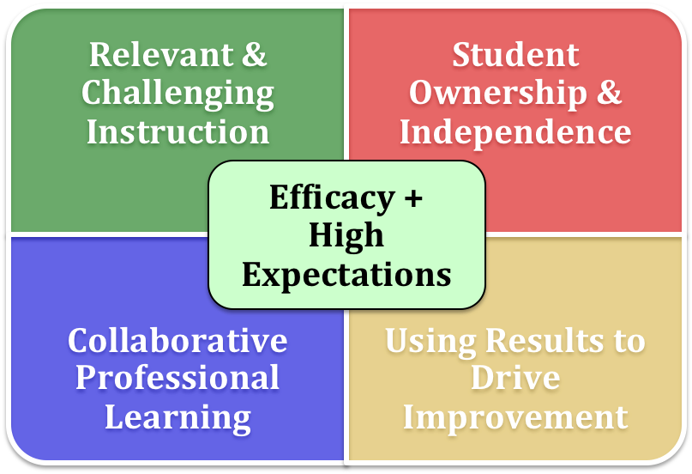

**[Type the company address]**

08

**Fall**

|  |  |  |
| --- | --- | --- |
| 1. Increase the level of knowledge and skill that the teacher brings to the instructional process. | 2. Increase the level and complexity of the content that students are asked to learn. | 3. Change the role of the student in the instructional process. |

|  |
| --- |
| District Performance Goals Biennium 2015-2017 |
| * 90% of all students increase successful mindset tendencies at least one level per year as measured by student and teacher responses on questionnaire. * 75% of all students are proficient or above in reading as measured by KPREP. * 75% of all students are proficient or above in math as measured by KPREP. * 75% of all students are proficient at making an argument supported by details as measured by the district rubric. * Students will average a minimum comprehension rate of 90% as measured by STAR/AR reading comprehension report. * Instruction provided by all teachers reaches a minimum effect size of .80 as measured by STAR, and or formative benchmark assessments. |

|  |  |  |  |  |  |
| --- | --- | --- | --- | --- | --- |
| Professional Learning and Application | | | | | |
| Cause | Danielson Framework Connection (Exemplary) | Strategy | Effect | Measurement | |
| Goal |  |  |  | Implementation | Impact |
| All teachers participate in collaborative planning, observing, and analyzing instructional practice using the ACS Lesson Study Protocol to study impact on student understanding and achievement. Monthly/Quarterly | 4D Teacher’s relationships with colleagues are characterized by mutual support and cooperation, with the teacher taking initiative in assuming leadership among the faculty. | Collaborative Learning – Lesson Study  (Micro Teaching) | .88 | Reflection Notes  (Notice/Learning Benefit/ Implications for Practice) | Teacher practice rating increases to exemplary (Domain 3).  Teacher effect increases.  Increased communication between grade levels. |
| 4D Teacher actively participates and or takes a leadership role in promoting a culture of professional inquiry. |
| 4D Teacher seeks out opportunities for professional development and makes a systematic effort to conduct action research. |
| 4D The teacher welcomes colleagues and supervisors into the classroom for the purpose of gaining insight from their feedback. |
| All students, teachers and administrators collect & use data* to collaboratively make instructional decisions that increase achievement as measured by meeting documents.  (STAR, Quarterly, Unit tests, exit slips, observations, student work) | 1F The approach to using formative assessment is well designed and includes student as well as teacher use of the assessment information. Teacher intends to use assessment results to plan future instruction for individual students. | Formative Evaluation  (Data Teams) | .90 | Data team collection charts & meeting notes. | Achievement gap closes & all sub groups’ score .80+ growth as measured by assessment effect size. |

|  |  |  |
| --- | --- | --- |
| 1. Increase the level of knowledge and skill that the teacher brings to the instructional process. | 2. Increase the level and complexity of the content that students are asked to learn. | 3. Change the role of the student in the instructional process. |

|  |  |  |  |  |  |  |
| --- | --- | --- | --- | --- | --- | --- |
| Student Ownership & Independence | | | | | | |
| Cause | Danielson Framework Connection (Exemplary) | Strategy | Effect | Mindset | Effect Measurement | |
| Goal |  |  |  |  | Implementation | Impact |
| Engaging questions are posed by the teacher and other students in 80% of classrooms on a given day as measured by observational data. | 3B Teacher uses a variety or series of questions or prompts to challenge students cognitively, advance high-level thinking and discourse, and promote metacognition. | Discussion/  Discourse  Questioning | .88  .46+ | Thinking  Communicate  Ask Questions  Curiosity | Observation rubric  Frequency Chart  Teacher & Student Questionnaire | Ask thought provoking questions as a means of understanding a concept or problem. |
| 3B Students formulate many questions, initiate topics, and make unsolicited contributions. |
| 3B Students initiate higher-order questions. |
| Students are engaged in authentic discussion with peers an average of 30% of classroom instruction time as measured by observational and survey data. | 2A Students exhibit respect for teacher and contribute to high levels of civil interaction between all members of the class. | Discussion/  Discourse | .88 | Thinking  Communicate  Ask Questions  Curiosity | Observation Rubric  Frequency Chart  Teacher & Student Questionnaire | Engage in meaningful discussions and use effective communication skills to work with others to identify and solve problems. |
| 3B Discussions enable students to talk to one another without ongoing mediation by the teacher. (A) |
| 3B Students themselves ensure that all voices are heard in the discussion |
| 3B Students extend the discussion, enriching it. |
| 3B Students invite comments from their classmates during a discussion. |
| 3A The teacher invites student to explain the content to the class or to classmates. |
| All classrooms exhibit a three part instruction cycle:  1. Use direct instruction to model and scaffold content and or skills to be learned. (1/4 of class time)*  2. Schoolwork is gradually released to promote productive struggle during independent and or group work time. *1/2  3. Time is given for reflection on what was learned. *(1/4)  Observed in 80% of classrooms on a given day as measured by observational and survey data.  *Based on average teacher talk time vs. student talk time. | 3C Virtually all students are intellectually engaged in challenging content through well-designed learning tasks and suitable scaffolding by the teacher and fully aligned with the instructional outcomes. | Productive Struggle  Direct Instruction – Gradual Release  Metacognition | .64  .59  .69 | Thinking  Focus  Strategies  Resilience  Persevere  Make a Plan  Self Awareness  Know/Need  Work Ethic | Observation Rubric  Frequency Chart  Teacher & Student  Questionnaire | Persevere through challenging problems and situations by using various strategies and techniques.  Are aware of how they learn best and use that knowledge to pursue personal success. |
| 3C Learning tasks and activities are designed to challenge student thinking. Lesson pace provides students the time needed to intellectually engage with learning. |
| 3C Students have the opportunity for both reflection and closure after the lesson to consolidate understanding. |
| 3A Teacher models process to be followed in task when appropriate. |

|  |  |  |
| --- | --- | --- |
| 1. Increase the level of knowledge and skill that the teacher brings to the instructional process. | 2. Increase the level and complexity of the content that students are asked to learn. | 3. Change the role of the student in the instructional process. |

|  |  |  |  |  |  |  |
| --- | --- | --- | --- | --- | --- | --- |
| Assessment for Learning | | | | | | |
| Cause | Danielson Framework Connection (Exemplary) | Strategy | Effect | Mindset | Measurement | |
| Goal |  |  |  |  | Implementation | Impact |
| 90% of students can identify the learning standard/target and criteria for success for a given task on a given day as measured by conferring data and questionnaire. | 1C The outcomes are clear, are written in the form of student learning, and permit viable methods of assessment. | Learning Intentions  (Clear Targets)  Success Criteria  Teacher Clarity  (Purpose/Method) | .41  .75 | Thinking  Focus  Self-Aware | Observation rubric  Conferring Data  Questionnaire | Find purpose in new learning situations and connect each new experience to their existing knowledge and skills.  Determine what must be done to complete a task/job successfully. |
| 3A The teacher states clearly, at some point during the lesson, what the students will be learning. (A) |
| 3A Students engage with the learning task, indicating that they understand what to do. |
| 3A The teacher links the instructional purpose of the lesson to the students’ interests; the directions and procedures are clear and anticipate possible student misunderstanding. |
| 90% of students can articulate what they know, need help with and next steps to learn content as measured by conferring data, data notebook and tracking documents. | 1F Students are actively involved in collecting information from formative assessments and provide input. | Assessment Capable  Learner | 1.44 | Self-Awareness  Know/Need | Conferring Data  Questionnaire  Student self assess.  & Test tracking | Set goals for improvement based on an understanding of individual strengths and weaknesses. |
| 3D Students appear to be aware of, and there is some evidence that they have contributed to the assessment criteria. |
| 3D Students self-assess and monitor their progress. |
| 3D Students monitor their own understanding, either on their own initiative or as a result of tasks set by their teacher. |
| Formative Assessment Process:  1. Formative assessment data* is collected regularly from a variety of sources by all students, teachers and administrators.  *(STAR, Quarterly, Unit tests, exit slips, observations, student work) | 1F Formative assessment includes student as well as teacher use of the assessment information. Teacher uses assessment results to plan future instruction for individual students. | Formative Assessment | .70 | Self-Awareness  Chart Progress | Conferring Data  Data team meeting records  Data examples | Assess their progress toward goals and adjust accordingly. |
| 3D Questions, prompts, & assessments are used regularly to diagnose evidence of learning by individual students. |
| 3D Teacher monitoring of student understanding is continuous: The teacher is constantly “taking the pulse” of the class. |
| 3D Teacher makes frequent use of strategies to elicit information about individual student understanding. |
| 2. Feedback drives continuous improvement for all members of the learning community as measured by observations and survey data from all educators.  3. All teachers use common assessments, aligned to the rigor of standards and teaching strategies as measured by analysis of verbs/intentions between the three documents. DOK /Bloom | 3D A variety of feedback, from both their teacher and their peers, is accurate, specific, and advances learning. | Feedback  Guaranteed & Viable Curriculum | .73  .88 | Self-Awareness  Reflect  Thinking  Apply to New. | Questionnaire  Observation data  Samples from unit assessment measured using protocol. | Provide situation specific feedback to others that helps them move forward and use feedback they receive to improve themselves.  Instruction is congruent to standard/target/assess. |
| 3D Feedback to students is specific and timely, and is provided fom many sources including other students. |
|  |
| 4. All summative student grades are based solely on academic performance and are tied to standards. | 1F Teacher's plan for student assessment is fully aligned with the instructional outcomes and has clear criteria and standards that show evidence of student contribution to their development. |  |  |  | Grade book has no non academic scores. | No grade records contain non-academic data. |

|  |  |  |
| --- | --- | --- |
| 1. Increase the level of knowledge and skill that the teacher brings to the instructional process. | 2. Increase the level and complexity of the content that students are asked to learn. | 3. Change the role of the student in the instructional process. |

|  |  |  |  |  |
| --- | --- | --- | --- | --- |
| Students as Customers of Challenging Instruction | | | | |
| Cause | Strategy | Effect | Measurement | |
| Goal |  |  | Implementation | Impact |
| Non-fiction writing in all content classes is used throughout every unit and assessment. Examples: constructed response, lab reports, argument, & writing to learn | Writing | .82 | Observation Data  Student/Teacher Questionnaire | Effectively communicate through writing for a variety of purposes. |
| Systematic vocabulary instruction is provided to all students in each subject area for each unit of study. | Vocabulary Instruction | .67 | Observation Data  Student Questionnaire | Comprehension will increase. (AR/STAR report)  Students will read more.  Student ability to summarize and make inferences will increase. |
| Learning experiences include high cognitively demanding tasks (DOK 3+ and Bloom Apply+) and other high impact strategies as measured by classroom observations. | Cognitive Demand  Instructional Strategies | .60 | Observation Data  Student/Teacher Questionnaire | Display confidence in their ability and are not afraid of mistakes or the need to struggle in a quest for improvement.  The learning gap is reduced. All students engaged. |
| 90% of students use literacy strategies to make sense of a text or problem and can identify how the strategy helps them learn as measured by conferring data. | Comprehension Strategies | .72 | Observation Data  Conferring Data | Comprehension will increase. (AR/STAR report)  Prioritize information and make inferences that lead to new understandings |
| Each classroom focuses on developing mindsets of good workers/learners. | Self Efficacy (Marzano) | .80 | Rubric/Questionnaire | Students will show growth toward exhibiting good worker actions. |

|  |  |  |  |
| --- | --- | --- | --- |
| High Impact Instructional Strategies | | | |
| Questioning | Classroom Discussion | Literacy | Marzano |
| Question Formulation Technique (QFT) | Reciprocal Teaching | Vocabulary C.O.D.E | Similarities and Differences |
| SQ3R | Think, Pair, Share | Reading for Meaning | Non-Linguistic Representations |
| No Opt Out | Knee to Knee | Fix-Up Strategies | Summarizing & Notemaking |
| Questions in Style | Cooperative Learning |  | Generating and Testing Hypothesis |
|  | Talk Moves |  | Advanced Organizers |
|  | Socratic Seminar |  |  |
| Formative Assessment | General | Writing | Thinking/Problem Solving |
| Right Chat | Worked Examples | 4-2-1 | Determine Importance |
| My Favorite No | Workshop |  | Make Inferences |
| Teach/Assess/Pause/Show Learning | Think Aloud |  | Ask Questions |
|  |  |  | Synthesize |
|  |  |  | Visualize |
|  |  |  | Make Connections |

|  |  |  |
| --- | --- | --- |
| 1. Increase the level of knowledge and skill that the teacher brings to the instructional process. | 2. Increase the level and complexity of the content that students are asked to learn. | 3. Change the role of the student in the instructional process. |

|  |  |
| --- | --- |
| Glossary | |
| Workshop | A teaching cycle, characterized by a mini lesson, which scaffolds, models, and explains new content, followed by independent student or group work on a high cognitively demanding task, and a reflection time where the new learning is discussed and deep processed. Within the student work time, the teacher may pull the group back together for clarification of a topic - often called catching and releasing. Closely connected to direct instruction. |
| Gradual Release of Responsibility | A framework that gives teachers a structured way to think about how to best support students in becoming independent thinkers. It is characterized by six stages: Direct Instruction, Modeling (I do, you watch), Guided Practice (I do, you help), Collaborative Work (You do with peers), Independent Work, Sharing and Reflection. (You do, I watch) |
| Direct Instruction | A seven step process including the gradual release of responsibility. It includes the identification of the learning target and success criteria and establishing student interest and commitment through the “hook” Also involves the modeling and content development by teacher. |
| Productive Struggle | Instruction that embraces students’ struggles as they strive to learn new concepts and attempt to make sense of them and their relationship to other ideas within the overall content. Preferred over just seeking correct answers. |
| Cognitive Demand (Challenge) | Tasks that students perform that require deeper thinking such as analyzing, creating, evaluating. |
| High Order Questions | Questions that may have more than one answer, require thinking, and usually reside in the higher levels of Bloom’s Taxonomy. (Apply, Analyze, Evaluate, Create) |
| Authentic Discussion | Students talking to each other about an assigned task. (Sharing ideas, proposing solutions, asking questions to gain insight) |
| Formative Assessment Process | Pre test: Begin with clear learning targets and success criteria, teach, check for understanding, provide timely feedback as leaning occurs, allow students to self assess and set learning goals, track and reflect on their learning. Post Assess |
| Engagement | Engagement is happening when students develop their understanding through what they do. Examples include: Discussing, debating, making decisions, hypothesizing, struggling, reflecting on thinking and learning. |
| Learning Target | A simplified standard written in student friendly language, which defines what students will learn and be able to do. |
| Learning Intentions | A learning target |
| Criteria for Success | A tool that gives the student information on the requirements, of a learning task, that must be achieved in order to be considered mastery. “I know I have learned it when I can…” |
| Engaging Questions | Questions that are open and prompt students to evaluate, analyze, or synthesize an idea or concept. |
| Open Questions | Questions that have multiple ways to answer. Answers may involve opinion backed by supporting details. |
| Closed Questions | Questions that have a finite number of answers. Answers are usually right or wrong. |
| Metacognition | An awareness of what you know and don’t know: (i.e. making a plan to approach a learning task, choosing the best strategy to solve a problem, knowing why and how to use a strategy, monitor your comprehension of a text, self correction based on self assessment, being aware of things that distract you) |
| Teacher Clarity | The extent to which a teacher clearly communicates the learning intentions (targets) and success criteria to students. |
| Assessment Capable Learner | A student who can assess his or her learning and answer three ongoing questions: What do I know well and what am I struggling with? How will I go about improving? What is my next goal? Student can also give feedback to the teacher and other peers that help move learning forward. |
| Feedback | Information provided to a learner that helps him or her to confirm, add to, overwrite, adjust, or restructure information in their mind. Most powerful when its from student to teacher. |
| Guaranteed Curriculum | All students receive challenging instruction for all content that has been prioritized to be essential for students to know and be able to do. |
| Formative Evaluation  (Data Teams) | Routinely collected evidence, supported by data that provides feedback to the teacher depicting the effectiveness of his or her instruction. Data can be scores and or student work samples. Involves collaboration between grade level/content partners. Considers the cause, not just the result. |

