Review Periodic Table Test

- What are the 2 parts of an atom?
- What are the 3 particles of an atom?
- What are these particles charged and where are they found in the atom?
- What is the majority of an atom?
- How is an atom related to an element?
- How is an element different from a compound?
- Two elements are in the same “group” on the PT, what does this tell you?
- Two elements are in the same “period” on the PT, what does this tell you?
- How is the atomic number organized on the PT?
- What subatomic particle determines the chemical properties of an atom?
- How are the particles in #10 organized on the PT?
- An atom has 4protons and 5 neutrons. How many electrons does it have? What is its atomic number? What is its atomic mass? What element is it?
- Draw a picture of an element? Compound? Mixture?
- What is the difference in a metal, nonmetal, and metalloid?
- On the PT how do you distinguish between metals, nonmetals, and metalloids?
- As you move from left to right on the periodic table how does the atomic number change?
- As you move from left to right on the periodic table how does the atomic mass change?
- How are the electrons in the outer shell related to the periodic table?
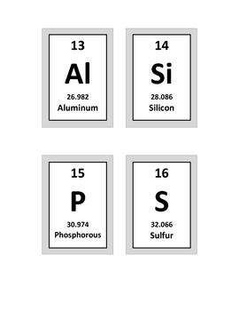I CAN read the periodic table.
- Al, Si, P, and S are called what?
- What is the atomic number of Al ?
- What is the atomic mass of S ?
- Which element (Al, Si, P, or S) has the most
parts needed to make it?
- What do you call the numbers in the blocks
13, 14, 15, and 16?

Use your periodic table for questions 26-31.
- Use the periodic table to identify the
symbol of Boron.
- Use the periodic table to identify the
atomic number of Boron.
- Use the periodic table to identify the
atomic mass of Nitrogen?
- How many protons does an atom of
Boron have?

