Save Assignment as Draft (and make active later)

Scenario: You want to create an assignment, but do not want it to be visible right now. You want to save it for later. So, how do I save my assignment as a draft?

- Upon logging into Google Classroom, and then your class, go to bottom right and click the plus sign. Choose Create Assignment.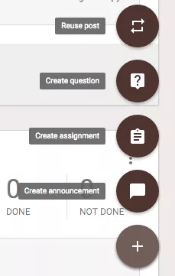
- Add your title, as well as instructions for your assignment.
- If needed, select the paper clip and upload the document.
- When finished, at the bottom right, click the drop down beside the Assign button.
- Select Save Draft.
- You now can later access the saved post, which will be located at the top of the page (within the class).
- From there, you may change it to an active post whenever you wish.

