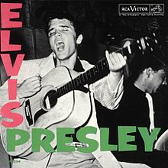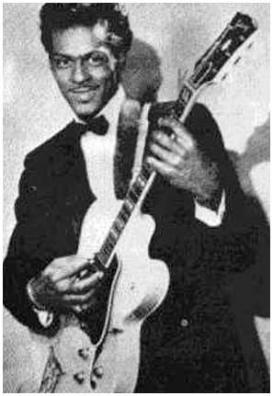
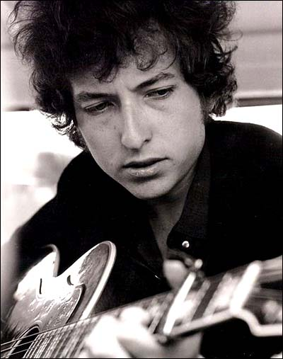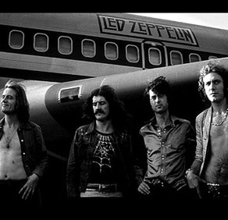

Social History of Rock & Roll: Course Syllabus
Fall Semester 2016
Mr. Johnston
Email: jake.johnston@allen.kyschools.us

Textbook
Rockin’ in Time: A Social History of Rock-And-Roll, by David P. Szatmary, 7th ed.

Prerequisites
There are no prerequisites for this course; however, students who do not enjoy music nor history courses are not recommended to take this class.

Course Description
This course is intended to help you think creatively and critically about Rock-and-Roll music. We will study how rock music reflects society and the effects of rock music on society, beginning with the roots and continuing through the present day. We will explore several recurring themes throughout the course:
- The interaction of European American, African American, and Latin American musical traditions
- The influence of mass media and technology (printing, recording, radio, video, Internet)
- The role of rock and popular music as a symbol of identity (race, class, gender, generation)

Goals
- The course will enhance your enjoyment and understanding of the music you already know, as well as introduce you to less familiar styles and genres.
- You will develop critical listening skills and become more informed consumers of popular music.
- You will gain an understanding of the role that music can play in helping to change and shape society.

Learning Methods and Assessments
- Classroom lectures and discussions
- Recordings—listening and analysis, film and video examples, demonstrations
- Textbook readings and listening assignments
- Fieldwork—live performance attendance and review
- Group work and solo projects (Just pretend you’re Sting. If you don’t get that reference you will.)

Exams
There will be approximately five exams during each 9 week quarter. Exam questions will include material taken from lectures/discussions, reading/listening assignments, work outside class, and videos shown in class. The exams will consist of listening identification, multiple choice, true/false, and written questions.

Course Requirements
Reading/Listening. Each week, you will need to complete reading and listening assignments before coming to class. The classroom lectures and discussions are designed to reinforce the reading and listening assignments, not replace them. Be prepared.

Review of a Live Performance You will be required to attend a live performance and write a review. Along with the review, include physical proof that you attended the performance (e.g., ticket stub, receipt, band autograph, drummer’s phone number, etc.). The performance can be any style or genre of popular music that relates to the material covered in this class. There are a number of venues in the surrounding area where you can see live music; many of them are free. Check the listings in the newspaper, discuss with your friends, or talk with your teacher. Should actual attendance of a live performance not be possible, see Mr. Johnston.

Grading Procedures
Standard 10 point grade scale in which 90-100 = A, 80-89 = B, etc.

Major Units of Study
♫ The Blues, Rock-and-Roll, and Racism ♫
♫ Elvis and Rockabilly ♫
♫ The Teen Market: From Bandstand to Girl Groups ♫
♫ Surfboards and Hot Rods ♫
♫ Bob Dylan and the New Frontier ♫
♫ Motown: The Sound of Integration ♫
♫ The British Invasion of America: The Beatles ♫
♫ The British Invasion and Garage Rock ♫
♫ Folk Rock ♫
♫ Psychedelic Rock ♫
♫ Fire from the Streets: Black Soul in White America ♫
♫ Militant Blues on Campus ♫
♫ Escaping into the Seventies ♫
♫ The Era of Excess ♫
♫ Punk Rock and the New Generation ♫
♫ I Want My MTV ♫
♫ The Generation X Blues ♫
♫ The Hip-Hop Nation ♫
♫ Rock in the Twenty-First Century ♫
♫ The Internet and the Future ♫

Expectations for classroom behavior:
- Be in the classroom and in your seat PRIOR TO the tardy bell.
- Come to class PREPARED and ready to learn. This includes your binder and writing materials.
- Do not talk while the teacher or another student is talking. Unless otherwise advised, raise your hand before speaking.
- No food or drinks are permitted in class, with the exception of water.
- Cell phones are not permitted to be out in class unless told otherwise.
- DO NOT pack up your things before the bell rings, unless advised to do so.
- Pick up after yourself – and others. If you see trash, pick it up. If something is out of place, return it to where it belongs.
- I expect you to act appropriately and maturely. Know that I am not here to pick on you, nor do I have time to nag you unnecessarily. If I give you a direction, I expect you to follow it without argument. Any questions or problems can be discussed privately before or after class.

Homework and Makeup Work Policy: All make-up/late work for a given unit is due by the day of the unit/chapter exam. Should a student not turn in a homework assignment they will receive a morning detention write-up. Upon the 3rd failure to turn in an assignment the student will receive an office referral to the principal and an afternoon detention.

Student Name (Please Print): __________________________________

Parent/Guardian Name (Please Print): __________________________________

