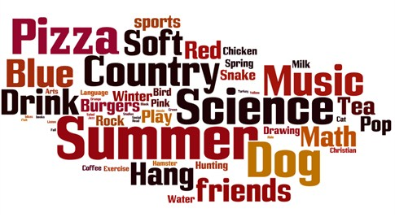

Using Eschoolview to Incorporate Web 2.0 Tools

The above word cloud is an example of how teachers can use Eschoolview’s features to create robust results. Here is the scenario:

Students entered the lab ready to work on an activity involving Word Cloud creation. The focal point of this activity is to create a cloud that comes directly from student data. So, in order for this to occur, I created a “Favorites” survey using my Eschoolview website.

The questions asked were:
- Of the following choices, what is your favorite COLOR?
- Of the following choices, what is your favorite SEASON of the year?
- Of the following choices, what is your favorite SUBJECT in school?
- Of the following choices, what is your favorite MUSIC genre?
- Of the following choices, what is your favorite DRINK?
- If you had a choice for a PET, which of the following would you pick?
- Of the following FOOD choices, which is your favorite?
- Of the following choices, what is your favorite HOBBY?

The questions within the survey included images/documents attached to help visualize each one.

The survey is located at http://www.allen.kyschools.us/StudentFavorites.aspx
*This survey was prepared before the students entered the lab.

Upon arrival, the students logged in and went to the above site. They were instructed to take the survey and submit responses. When all had completed the survey, I quickly went to a computer, logged into Eschoolview, specifically the survey management portion, and opened the responses. I chose the individual responses, and then proceeded to download the Excel file. I then opened the Excel file, highlighted the results. I then copied them.
I went back to the page where I inserted the favorites survey, added a text window component, then proceeded to paste the results, and clicked to save the page.
(The portion of the lesson where the results were downloaded, copied, pasted, and then created into Eschoolview sounds like it would take a long time. But, it took a maximum of two minutes.)

Now I directed the students to refresh the favorites page, locating the collection of words toward the bottom of the page. They were instructed to highlight, and copy the words.

We opened a new tab in our browser and went to http://wordle.net.
Students then were to select the “create” icon. Where the page states to paste in a bunch of text, student were prompted to paste the favorites results (that they copied). Then, they were to click GO.

Now, they have time to explore some creative fun. They had the opportunity to change font style, color, and layout. The page, http://www.allen.kyschools.us/StudentFavorites.aspx, also contains an example of a finished product.
When the students were finished with their choices, they used the snipping tool (in Windows 7) and captured the newly created image. FYI: The reason we did not save it, as JPEG is that it is tool small. The snipping tool does a better job.

Now, we had collaboration about the tech project. The word cloud distinguished the results according to the number of responses. The more of the same response made by students, the larger the word. So, we discussed (they did not know that at first) why SUMMER was the largest word and so on. Not only was it fun for students, it had a purpose and can be used in a variety of ways.

Eschoolview’s survey management made it possible to incorporate web tools and produce some creative examples of student work.

