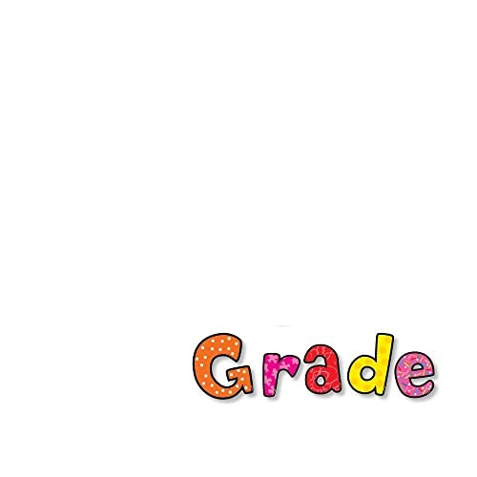
Supply List 1 Pencil Pouch
4 Boxes 24 Count Crayola Crayons 8 Elmer’s Glue Sticks
6 Black Expo Dry Erase Markers 1 Pair Blunt Tip Scissors (Fiskar) 1 Folder with Pockets 24 Ticonderoga Pencils
2 Rectangular Pink Erasers

2 Composition Wide Ruled Notebook 2 Highlighters Backpack (no wheels)
1 Set of Headphones (not earbuds)
The inexpensive headphones are fine. Please place in baggie with the student’s name.

Wish List Items

The following items are not required but would be very much appreciated!

Play—Doh

Small Toys for Treasure Box

Baby Wipes
Gallon Size Zip Bags

Quart Size Zip Bags

Post It Notes
Washable Markers

Band-Aids

Hand Sanitizer and Disinfectant Wipes will be provided by the Board of Education but addi-tional supplies are always welcome.

